**COMPARISON METRICS AND**

**PERFORMANCE ESTIMATIONS FOR**

**DEEP BEAMFORMING DNN ASR**

**SYSTEMS USING**

**MICROPHONE-ARRAYS**

**by**

**Aviad Ben-Haim**

**A thesis submitted to Johns Hopkins University**

**in conformity with the requirements for the degree of**

**Master of Science**

**Baltimore, Maryland**

**October 2021**

**© 2021 by Aviad Ben-Haim**

**All rights reserved**

End-to-End (E2E) solution. One that is robust, to some extent, to external in-

ii

complicated by itself.

and other possible micro-solutions, besides the ASR engine, which is very

and or microphone arrays, adaptive beamformer(s) for performance increase,

for robustness, noise cancelation and separation modules, multi-microphones

Such an E2E ASR solution may include, elements of speech enhancement

be compatible with new applications.

or for performance increase, and modular enough to conveniently reform and

terferences, flexible, in a way that it can be extended to adapt to new scenarios

**Abstract**

In time, the idea of ASR functionality evolved to a more comprehensive,

of challenges are what characterizes a realistic scenario for an ASR system.

ambient environment, multiple speakers, or faulty microphones. These kinds

be. That holds especially under some circumstances, such as having a noisy

ties performing decently, regardless of how sophisticated and advanced it may

and advanced that may be, will face difficulties performing decently, difficul-

scenarios, and applications. An ASR engine by itself will face as sophisticated

of speech into text, is on the rise today and is required for various use-cases,

Automatic Speech Recognition (ASR) functionality, the automatic translation

tween those metrics, plus the ability to forecast the impact of each variation in

iii

custom dedicated hardware acceleration in order to replace the traditional

changing algorithms and approximating complex computations, utilizing a

and robustness. Third, we present an approach of substituting architectures,

that can generalize and provide results of improved overall performance

we will present the effectiveness of applying machine learning techniques

Second,

as a result of a change in the system’s specifications or constraints.

emphasizing any bindings between the metrics and degree of impact derived

for each of the different domains, which spread over vast engineering subjects

limited devices. First, we describe the possible available evaluation metrics

designing a robust E2E-ASR system, possibly targeted for mobile, resources-

In this research, we present novel progress in the direction of optimally

one has on the others.

Being a comprehensive solution built of numerous micro-modules is tech-

Secondly, one needs to determine the extent of correlation be-

ASR system.

define the different metrics that are used for the evaluation of such an E2E

one should first

and the detection accuracy,

lowed for real-time analysis,

maximal computation time al-

SW (software) requirements or limitations,

To find the optimal trade-offs between performance, HW (hardware) and

connectivity to the cloud over the internet.

But that comes with the cost of giving up on real-time analysis and permanent

on the cloud, the system can fit more easily in less computing-capable devices.

limited mobile systems. By offloading the complex computations to a server

nologically challenging to implement and difficult to integrate into resource-

state-of-the-art SW based solutions,

and thus providing real-time analysis

capabilities to resource-limited systems.

iv

6

.

.

.

.

.

.

.

.

.

.

.

.

.

1.2

Proposed Work

.

.

.

.

.

.

.

.

.

.

.

.

.

.

.

.

.

5

1.1.1.3

Low Latency Beamformers .

.

.

.

.

.

.

.

.

.

.

5

1.1.1.4

Masking Operations .

.

.

.

.

.

.

.

.

.

.

.

.

.

.

.

.

.

.

.

.

.

7

**2**

**E2E Evaluation Metrics**

**13**

v

.

.

.

.

.

.

.

.

.

.

.

.

.

.

.

.

.

.

7

1.2.1

Project Outline

.

.

.

.

.

.

.

.

.

.

.

.

.

.

.

.

.

.

4

1.1.1

Recent Work .

.

.

.

.

.

.

.

1.1

**Abstract**

**ii**

**Table of Contents**

**v**

**List of Tables**

**xi**

**List of Figures**

**xiii**

**1**

**Introduction**

**1**

.

Literature Review .

.

.

.

.

.

.

.

.

.

.

.

.

.

.

.

.

.

.

5

1.1.1.2

Biasing

.

.

.

.

.

.

.

.

.

.

.

.

.

.

.

.

.

.

.

.

.

.

.

.

.

.

**Table of Contents**

.

.

.

.

4

1.1.1.1

ASR Engine Alternatives

.

.

.

.

Introduction .

.

.

.

.

.

.

.

.

.

.

.

.

.

.

.

3.1

**28**

**Audio Frequency Scaling methods**

**3**

24

.

.

.

.

.

.

.

.

28

.

.

.

.

.

.

.

.

.

.

.

Mel-Scaling

3.2

.

.

.

.

.

.

.

.

.

.

.

.

.

.

.

Internal Power

2.3.1.2

22

.

.

.

.

.

.

.

.

.

.

.

.

.

.

.

.

.

Leakage Power .

2.3.1.1

21

.

.

.

.

.

.

.

.

.

.

.

.

Switching Power .

2.3.1.3

23

.

.

.

.

.

.

.

.

.

.

.

.

.

.

.

.

.

.

.

.

.

.

.

.

.

.

.

.

.

.

.

.

.

.

.

.

.

.

.

.

.

.

.

Bark-Scaling .

3.3

30

.

vi

37

.

.

.

.

.

.

.

.

.

.

.

.

.

.

.

.

.

.

.

.

Bark Critical Bands .

3.3.1

37

.

.

.

.

.

.

.

.

.

.

Logarithm based Mel scale

3.2.1

29

.

.

.

.

.

.

.

.

.

.

.

.

.

.

.

.

.

.

.

.

.

.

.

.

.

.

.

.

.

.

.

.

.

.

Mel scale approximations

3.2.2

30

.

.

.

.

.

.

.

.

.

.

.

.

.

.

.

.

.

.

.

.

.

.

.

.

.

.

.

Segmental SNR .

2.1.3

15

.

.

.

.

.

.

.

2.1.5

.

.

.

.

.

.

.

ASR Metrics

2.2

18

.

.

PESQ — Perceptual Evaluation of Speech Quality .

.

17

.

.

.

.

.

.

STOI — Short-Time Objective Intelligibility .

2.1.4

15

.

.

.

.

.

.

.

.

.

.

.

.

.

.

.

.

.

.

.

.

.

.

.

.

.

.

.

.

.

.

Audio Metrics

.

.

.

.

.

.

SI-SNR — Scale Invariant SNR .

2.1.2

13

.

.

.

.

.

.

.

.

.

.

.

.

.

.

.

SNR - Signal to Noise Ratio .

2.1.1

13

.

.

.

.

.

.

.

.

.

.

.

.

.

.

.

.

.

.

.

.

.

.

HW Metrics

2.3

20

.

.

.

.

.

.

.

.

.

.

.

.

.

.

.

.

.

.

.

.

.

.

Power Estimation .

2.3.1

21

.

.

.

.

.

.

.

.

.

.

.

.

WER - Word Error Rate

2.2.1

19

.

.

.

.

.

.

.

.

.

.

.

.

.

.

.

.

.

.

.

.

.

.

.

.

.

.

.

.

.

.

.

.

CER - Character Error Rate

2.2.2

19

2.1

.

.

.

.

.

.

.

.

.

.

.

.

.

.

.

Windowing .

4.3.1.3

56

.

.

.

.

.

.

.

.

.

.

.

.

.

.

.

.

.

.

.

.

.

Framing .

.

.

.

.

.

.

DFT spectrum .

4.3.1.4

56

.

.

.

.

4.3.1.2

.

.

.

.

.

.

.

.

.

.

.

.

.

MFCCs — Mel-Frequency Cepstral Coefficients

4.3.1

55

.

.

.

.

.

.

.

.

.

.

.

.

.

.

.

.

.

.

.

.

.

.

.

55

.

.

.

.

.

.

.

.

.

.

.

.

.

.

.

.

.

.

Pre-emphasis .

4.3.1.1

55

.

.

.

.

.

.

.

.

.

.

.

.

.

.

.

.

.

.

.

.

.

.

.

.

Time-Domain Features

4.4

60

.

.

.

vii

60

.

.

.

.

.

.

.

.

.

.

.

.

.

.

.

.

.

.

Dynamic FCC features .

4.4.1

60

.

.

4.3.1.5

.

.

.

.

.

.

.

.

.

.

.

Mel-spectrum .

.

57

.

.

.

.

.

.

.

.

.

.

.

.

.

BFCCs — Bark-Frequency Cepstral Coefficients

4.3.4

59

GFCCs — Gammatone-Frequency Cepstral Coefficients

4.3.3

59

.

.

.

.

.

.

.

.

.

.

RFCCs — Root Cepstral Coefficients .

4.3.2

58

.

.

.

.

.

.

.

.

.

.

.

.

.

.

.

.

.

.

.

.

.

.

.

.

.

.

.

.

.

.

.

.

.

.

.

.

.

.

.

.

.

.

.

.

.

.

.

.

.

.

.

.

.

.

.

Spectral Features

4.2

50

43

.

.

.

.

.

.

.

.

.

.

Summary .

3.5

.

.

.

.

.

.

.

.

.

.

.

.

ERB - Equivalent Rectangular Bandwidth .

.

Introduction .

4.1

**50**

**Features**

**4**

46

.

.

.

.

.

.

.

.

.

.

.

.

.

.

.

.

.

.

.

.

.

.

.

.

.

.

.

.

.

.

.

.

54

.

.

.

.

.

.

.

.

Bark FB .

4.2.1.2

53

.

.

.

.

.

Cepstral Features

4.3

54

.

.

.

.

.

.

.

.

.

.

.

.

.

.

.

.

.

Gammatone FB .

4.2.1.3

.

.

.

.

.

.

.

.

.

.

.

.

.

.

.

.

.

.

.

.

FB — FilterBanks

4.2.1

52

.

.

.

.

.

.

.

.

.

.

.

.

.

.

.

.

3.4

.

.

.

.

.

.

.

Mel FB .

4.2.1.1

52

.

.

.

.

.

.

.

.

.

.

Masks Estimations

5.5.1

85

.

.

.

.

.

.

.

.

.

.

.

.

.

.

.

.

.

.

PSM — Phase Sensitive Mask .

5.5.2

.

.

.

.

.

.

.

.

.

.

.

.

.

Measurements

5.5

86

.

.

.

.

.

.

.

.

.

.

.

.

.

.

.

.

.

.

.

.

.

.

.

.

.

.

.

.

.

.

.

.

Masks Estimations

5.4.1

79

.

.

.

.

.

.

.

.

.

84

.

.

.

.

.

.

.

.

.

.

.

.

.

.

.

.

.

.

.

.

.

.

.

Measurements

5.4.2

82

.

.

.

.

.

.

.

Conclusions

5.7

92

.

.

.

.

.

.

.

.

.

.

.

.

.

.

.

.

.

.

.

.

.

.

.

viii

**96**

**Beamformers**

**6**

93

.

.

.

.

.

.

.

.

.

.

.

.

.

.

.

.

.

.

.

.

.

.

.

.

.

.

.

.

.

.

.

.

.

.

.

.

.

.

.

.

.

.

ORM — Optimal Ratio Mask

5.6

89

.

.

.

.

.

.

.

.

.

.

Measurements

5.6.2

91

.

.

.

.

.

.

.

.

.

.

.

.

.

.

.

.

.

.

.

.

.

Masks Estimations

5.6.1

90

.

**64**

.

.

.

.

.

.

.

.

.

.

.

.

Introduction .

5.1

.

**Time-Frequency Masking**

**5**

61

.

.

.

.

.

.

.

.

.

.

.

.

.

.

.

.

.

.

.

.

.

.

.

IBM — Ideal Binary Mask

5.2

64

.

.

.

.

.

.

.

.

.

.

.

.

.

.

.

.

.

.

Delta-Deltas

4.4.1.2

60

.

.

.

.

.

.

.

.

.

.

.

.

.

.

.

.

.

.

.

.

.

.

.

Deltas

.

.

.

.

.

.

.

.

.

.

Temporal Context .

4.4.2

61

.

.

.

.

.

.

.

.

.

.

.

.

.

.

.

.

.

.

.

SNR .

5.3.2.1

74

.

.

.

.

.

.

.

.

.

.

.

.

.

.

.

.

.

.

.

.

.

.

.

Measurements

.

.

.

.

.

.

.

cIRM — Complex Ideal Ratio Mask .

5.4

74

.

.

.

.

.

5.3.2

.

.

.

.

.

.

.

.

.

.

.

.

.

.

.

.

.

.

.

.

.

.

.

.

.

.

.

.

.

.

.

.

IRM — Ideal Ratio Mask .

5.3

66

.

.

.

.

.

.

.

.

.

.

69

.

.

.

.

.

.

.

.

.

.

.

.

.

4.4.1.1

.

.

.

.

.

.

.

Masks Estimations

5.3.1

67

.

.

.

.

.

.

.

.

.

.

.

Seq2Seq

7.2.4

108

.

.

.

.

.

.

.

.

.

.

.

.

.

.

.

.

.

.

.

.

.

.

.

.

Trained Engines .

7.2.5

108

.

.

.

.

.

.

.

.

.

.

.

.

.

.

.

.

.

.

.

.

.

.

.

.

.

.

.

.

.

.

Transformer

7.2.2

106

.

.

.

.

.

.

.

.

.

.

.

.

.

.

.

.

.

.

.

.

.

.

.

.

.

.

CTC

7.2.3

106

.

.

.

.

.

.

.

.

.

.

.

.

.

.

ASR Engine #101 — Approx. Mel-FCC,

.

.

.

.

.

.

.

.

.

.

.

Context(3, 3)

,

,

.

7.2.5.6

∆∆

∆

119

, Context(3, 3)

,

ASR Engine #100 — MFCC,

7.2.5.5

∆∆

∆

117

.

.

.

ix

124

.

.

.

.

.

.

.

.

.

.

.

.

.

.

.

Other ASR Engines

7.2.5.7

122

.

.

.

.

.

.

.

.

110

.

.

.

.

,

ASR Engine #5 — RMFCC(0.1),

7.2.5.1

∆∆

∆

110

.

.

∆

.

.

.

.

.

.

.

.

.

.

.

.

.

.

.

.

.

.

,

ASR Engine #72 — MFCC,

7.2.5.4

∆∆

∆

115

.

.

.

.

,

ASR Engine #12 — RBFCC(0.1),

7.2.5.3

∆∆

∆

113

.

.

.

,

ASR Engine #15 — RMFCC(0.08),

7.2.5.2

∆∆

.

.

.

.

.

.

.

.

.

.

.

.

.

.

.

.

.

.

Sum-and-Delay .

6.2.1

98

.

.

.

.

.

.

.

.

.

.

.

.

.

.

.

.

.

.

.

.

.

.

.

.

.

.

.

.

.

MVDR .

6.2.2

98

.

.

.

.

.

.

.

.

.

.

.

.

.

.

.

.

.

.

.

.

.

.

.

.

.

.

.

.

.

.

.

.

Introduction .

.

.

.

.

.

.

.

.

.

.

.

.

.

.

.

.

.

.

.

.

.

.

.

.

.

Types

6.2

96

.

.

.

.

.

.

.

.

.

.

.

The ASR Engine .

7.2

100

.

.

.

.

.

.

.

.

.

.

.

.

.

.

.

.

.

.

.

.

.

.

.

.

.

Front-End .

7.2.1

105

.

.

.

.

.

.

.

.

.

.

.

.

.

.

.

.

.

.

.

.

.

.

.

.

.

.

.

.

.

.

.

.

.

.

GEV .

6.2.3

99

.

.

.

.

.

.

7.1

.

.

.

.

.

.

.

.

.

.

.

.

Introduction .

6.1

**100**

**ASR — Automatic Speech Recognition**

**7**

99

.

.

.

.

.

.

.

.

.

.

.

.

.

.

.

CommonVoice .

8.2

132

.

.

.

.

.

.

.

.

.

CHiME Recording Scenarios .

8.1.1.1

131

.

.

.

.

.

.

.

.

x

**137**

**Conclusions**

**9**

133

.

.

.

.

.

.

.

.

.

.

.

.

.

.

.

.

.

.

.

.

.

.

.

.

.

.

.

.

.

.

.

.

.

.

.

.

.

.

.

.

.

.

.

.

CHiME 4/5

8.1

**131**

**Datasets**

.

.

.

.

.

.

.

.

.

.

.

.

.

.

**8**

.

.

.

Overview .

8.1.1

131

.

.

.

.

.

.

46

.

.

.

.

.

.

.

.

.

.

.

.

ERB vs. ERB approx Power consumption

3.10 Mel-Approx, log based Mel, Bark Scale .

.

.

.

.

.

.

.

.

.

.

Mel scaling methods resource utilization table

3.7

ERB and ERB approx performance comparison .

.

.

.

.

.

.

.

.

45

3.8

.

.

.

.

.

.

.

.

.

.

46

3.9

.

.

.

.

.

.

.

.

.

.

.

.

.

.

.

.

.

.

.

.

.

.

.

94

xi

size

.

.

46

3.11 Mel-Approx, log based Mel, Bark Scale Power consumption

.

47

3.12

Mel-Approx, log based Mel, Bark Scale performance comparison

47

5.1

T-F Masks models learnable parameters vs. Required memory

43

.

.

.

.

.

.

.

.

.

.

.

.

Traunmuller’s Bark scale implementations performance com-

parison .

.

.

.

.

.

.

.

.

.

.

3.4

.

.

.

.

.

.

.

.

.

.

.

.

3.1

Mel-Approx, log based Mel performance comparison .

.

.

.

.

36

3.2

Mel scaling methods resource utilization table

.

.

.

.

.

.

.

.

.

36

3.3

Mel-Approx, log based Mel, Bark Scale Power consumption

.

36

.

.

.

.

.

.

.

.

.

.

.

.

.

.

.

.

.

.

.

.

.

.

43

3.6

Traunmuller’s Bark scale implementations Power consumption

table .

.

.

.

.

.

.

.

.

42

3.5

Traunmuller’s Bark scale implementations resource utilization

**List of Tables**

.

.

.

.

.

.

.

.

.

.

.

.

.

.

.

.

.

.

.

.

.

.

.

.

.

.

CommonVoice dataset statistics .

8.1

110

.

.

.

xii

135

.

.

.

.

.

.

.

.

.

.

.

CommonVoice sets utterances distribution

8.2

134

.

.

.

.

.

.

.

.

.

.

.

.

.

.

.

.

.

.

.

.

.

ASR Engines Table

ASR engines #101, #72 comparison table .

.

.

.

.

.

.

.

.

.

7.1

7.2

109

.

.

.

.

.

.

.

.

.

.

.

.

.

.

.

.

.

.

.

.

.

Switching Power Illustration

2.6

24

.

.

.

.

25

3.1

Mel scale comparisons with Beranek & Umesh tables

.

.

.

.

.

32

3.2

LUT based Mel FPGA implementation results

.

.

.

.

.

.

.

.

.

23

2.5

Internal Power Illustration .

.

.

.

.

.

.

.

.

.

.

.

.

.

.

.

.

.

.

.

.

.

35

3.6

Traunmuller no fix

.

.

.

.

.

.

.

.

.

.

.

FPGA implementation results

.

.

.

.

.

.

.

.

.

.

.

.

.

38

xiii

.

.

.

.

.

.

.

.

.

33

3.3

Mel approx. #1 FPGA implementation results .

.

.

.

.

.

.

.

.

.

33

3.4

Mel approx. #1 optimized FPGA implementation results

.

.

.

35

3.5

Mel approx. #1

optimized, generic

.

.

.

.

.

.

.

.

.

.

.

.

.

.

.

Project Proposed Architecture .

1.3

8

.

.

.

9

2.1

STOI flow diagram .

.

.

.

.

.

.

.

.

.

Project Outline Summary Diagram .

1.1

General E2E ASR System Blocks Diagram .

.

.

.

.

.

.

.

.

.

.

.

2

1.2

.

.

.

.

.

.

.

.

.

.

.

.

.

.

.

.

.

.

19

2.3

Leakage Power Illustration

.

.

.

.

.

.

.

.

.

.

.

.

.

.

.

.

.

.

.

.

22

2.4

Leakage Power vs. Process Technology

.

.

.

.

2.2

.

.

.

.

.

.

.

.

.

.

.

.

.

.

17

**List of Figures**

PESQ Algorithm Blocks Diagram .

.

.

.

.

.

.

.

.

.

.

.

.

.

.

.

.

.

.

.

.

.

.

.

.

.

.

.

.

.

.

.

.

Noisy mixture spectrogram .

5.1

58

.

.

.

.

.

.

.

.

.

.

.

.

.

.

.

, *t*

*j*

IRM Speech Mask **M**

5.3

*ω*

)

(

65

.

.

.

.

.

.

.

.

.

.

.

.

.

.

Reference clean speech spectrogram .

5.2

65

.

.

.

.

.

.

.

.

Gammatone FB

4.3

54

.

.

.

.

.

.

.

.

.

.

.

.

.

.

.

.

.

.

.

.

.

.

.

.

.

.

.

.

.

STFT demonstration diagram .

4.4

55

.

.

.

.

.

.

.

.

.

.

.

.

.

.

.

.

.

.

.

.

(

*j*

,*t*

*j*

*ω*

*ω*

(c) and (d) are the “IRM” reference vs.

;

**M**

,

**M**

speech.

*s*

*s*

ˆ︂

)

,*t*

)

(

(a) and (b) are the “IRM” reference vs. estimation masks of the

5.7

72

.

.

.

.

.

.

.

Proposed DNN for IRM T-F masking estimations .

5.6

.

xiv

,*t*

*j*

,*t*

*j*

*ω*

*ω*

73

.

.

.

.

.

.

.

70

.

.

.

.

, **M**

**M**

estimation masks of the noise

*n*

*n*

ˆ︂

)

(

)

(

.

.

.

.

.

.

.

, *t*

*j*

IRM Noise Mask **M**

5.4

*ω*

)

(

*s*

68

.

.

.

.

.

.

.

.

.

.

.

.

.

.

.

*n*

.

.

.

.

.

.

.

.

.

.

.

.

.

IRM estimation DNN blocks diagram .

5.5

.

68

.

.

.

.

.

.

.

.

.

.

.

.

.

.

.

.

.

.

.

3.10 Zwicker .

41

.

.

.

.

.

.

.

.

.

.

.

.

.

.

.

.

.

.

.

.

.

.

.

.

.

.

.

3.11 Schroeder .

41

.

.

.

.

.

.

.

.

.

.

.

.

.

.

.

.

.

.

.

.

.

.

.

.

.

.

3.8

39

.

.

.

.

.

.

.

.

.

.

.

.

.

Bark comparisons .

.

.

.

.

.

.

.

.

.

.

.

.

.

Traunmuller fix

.

.

.

Bark comparison

3.9

40

.

.

.

.

.

.

.

.

.

.

.

.

.

.

.

.

.

.

.

.

.

.

.

.

.

45

.

.

.

.

.

.

.

.

.

.

.

.

.

Mel FB

4.1

.

.

.

.

.

3.14 LUT based ERB approx. FPGA implementation results

44

.

.

.

.

.

.

.

.

.

.

.

.

.

.

.

.

.

.

Bark FB .

4.2

53

.

.

.

.

.

.

.

.

.

.

.

.

.

.

.

.

.

.

.

.

.

3.12 Schroeder .

42

.

.

.

.

.

.

.

.

.

.

.

.

.

.

.

.

.

.

.

.

.

.

.

.

.

.

.

3.13 LUT based ERB FPGA implementation results

42

.

.

.

.

.

.

.

.

.

.

.

.

3.7

.

.

.

.

.

.

.

.

.

.

.

.

.

.

.

.

.

.

.

.

.

.

.

.

.

.

.

.

.

.

, *t*

.

.

.

.

85

*s*

(

)

*ω*

5.16 PSM Noise Mask **M**

*j*

, *t*

.

.

.

.

.

.

.

.

.

.

.

.

.

.

.

.

.

.

.

.

.

.

.

.

.

.

.

.

84

*r*

(

)

*ω*

5.15 PSM Speech Mask **M**

*j*

.

5.20

ORM beamformer SNR vs. Segmental-SNR vs. STOI vs. SI-SNR.

92

5.21 Ideal ORM beamformer enhancement SNR & Segmental-SNR.

93

7.1

(a) Traditional ASR system blocks diagram;

(b) End-to-end

ASR system blocks diagram.

.

.

.

.

.

.

90

.

.

.

.

.

.

.

.

.

.

.

.

.

102

xv

.

.

.

.

.

.

.

.

.

.

.

.

.

.

.

.

**M**

86

*n*

5.17 Proposed DNN for PSM T-F masking estimations.

.

.

.

.

.

.

.

88

5.18 PSM beamformer SNR vs. Segmental-SNR vs. STOI vs. SI-SNR.

89

5.19 Ideal PSM beamformer enhancement SNR & Segmental-SNR.

.

.

.

.

.

.

74

5.9

IRM beamformer PESQ vs. MOSLQ .

.

.

.

.

.

.

.

.

.

.

.

.

.

.

75

5.10 IRM beamformer SNR vs. Segmental-SNR vs. STOI vs. SI-SNR

78

5.11 Ideal IRM beamformer enhancement SNR & Segmental-SNR.

79

5.12

(a) and (b) are the cIRM real and imaginary references of the

(

)

.

(a) “IRM” enhanced SNR & Segmental-SNR degradation with

respect to the clean reference speech;

(b) The SNR & Segmental-

SNR ratios between the clean reference speech and the noisy

mixture.

.

.

.

.

.

.

.

.

.

.

(

.

.

.

.

.

.

.

.

.

.

.

.

.

.

.

.

.

.

.

.

81

*r*

*i*

5.13 Proposed DNN for cIRM T-F masking estimations

.

.

.

.

.

.

.

83

(

)

*s*

5.14

(a) Reference cIRM real speech mask

**M**

;

(b) The estimated

*r*

(

)

ˆ︂

*s*

cIRM real speech

*n*

)

*s*

*s*

speech

**M**

,

**M**

;

(c) and (d) are the cIRM real and imaginary

*r*

*i*

(

)

(

)

5.8

*n*

references of the noise **M**

, **M**

.

.

.

.

.

.

.

.

.

.

.

118

WER, CER evaluation plot. .

(b) ASR #100

(a) ASR #100 training accuracy and loss plot;

7.13

119

.

.

7.12 ASR #72 WER, CER vs. T-F masks, noisy and clean inputs

.

.

.

.

.

.

.

.

.

.

.

.

.

.

.

.

.

.

.

.

.

.

.

.

.

.

.

.

(a) ASR #72 training accuracy and loss plot;

7.11

117

.

.

7.10 ASR #12 WER, CER vs. T-F masks, noisy and clean inputs

116

.

(b) ASR #72 WER,

.

.

.

.

.

.

.

.

.

.

.

.

.

.

.

.

.

.

.

.

.

.

.

.

CER evaluation plot.

.

125

.

.

.

.

.

.

.

7.18 ASR #22 WER, CER evaluation plot .

.

.

.

.

.

7.17 ASR #22 training accuracy and loss plot

124

.

.

xvi

125

.

.

.

.

.

.

7.16 ASR #101 WER, CER vs. T-F masks, noisy and clean inputs

.

.

.

.

.

.

.

.

CER evaluation plot.

.

.

.

.

.

.

.

.

.

(b) ASR #12 WER,

(a) ASR #12 training accuracy and loss plot;

7.15

122

.

7.14 ASR #100 WER, CER vs. T-F masks, noisy and clean inputs

121

.

.

123

.

.

.

.

.

.

.

.

.

.

.

.

.

.

.

.

.

.

.

.

.

.

.

.

.

.

.

.

.

.

.

.

.

.

.

.

.

.

.

.

.

.

.

.

.

.

CER evaluation plot.

(b) ASR #5 WER,

(a) ASR #5 training accuracy and loss plot;

7.5

107

.

.

.

.

.

CNN front-end general ConvBlock architecture.

7.3

104

.

.

.

.

.

.

.

.

.

Maas et al. [5] phonemes vs characters graphs

.

.

.

.

.

.

.

.

.

.

.

Transformer

7.4

106

.

.

.

.

115

.

.

ASR #15 WER, CER vs. T-F masks, noisy and clean inputs

7.8

114

.

.

7.9

.

.

.

.

.

.

.

.

.

.

.

.

.

.

.

.

.

.

.

.

.

.

CER evaluation plot.

(b) ASR #12 WER,

(a) ASR #12 training accuracy and loss plot;

.

.

.

.

ASR #5 WER, CER vs. T-F masks, noisy and clean inputs

7.6

111

.

.

112

.

.

.

.

.

.

.

.

.

.

.

.

.

.

.

.

.

7.2

.

.

.

CER evaluation plot.

(b) ASR #15 WER,

(a) ASR #15 training accuracy and loss plot;

7.7

.

.

.

.

.

.

.

132

8.2

CHiME-4 recording setup

.

.

.

.

.

.

.

.

.

.

.

.

.

129

8.1

CHiME-4 microphone-array .

.

.

.

.

.

.

.

.

.

.

.

.

.

.

.

.

.

.

.

.

.

.

.

.

.

.

.

.

.

133

xvii

.

.

.

.

.

.

.

.

.

.

.

.

132

8.3

CHiME-4 recording setup

.

.

.

.

.

.

.

.

.

.

.

.

.

.

.

.

127

7.21 ASR #70 training accuracy and loss plot

.

.

.

.

.

.

.

.

.

.

.

.

.

.

.

.

.

.

.

126

7.20 ASR #23 WER, CER evaluation plot .

.

.

.

.

.

.

.

.

.

128

7.23 ASR #13 WER, CER evaluation plot .

.

.

.

.

.

.

.

.

.

.

.

.

.

.

.

.

.

.

.

128

7.22 ASR #70 WER, CER evaluation plot .

7.19 ASR #23 training accuracy and loss plot

.

.

.

.

.

.

.

.

**Chapter 1**

**Introduction**

Speech recognition systems started several decades ago. It began with simple

decoding capabilities through keyword spotting to the modern Automatic

Speech Recognition (ASR) systems that are common nowadays[7].

Recent advances in the field of speech recognition and acoustic modeling

are due to the introduction of Deep Neural Networks (DNN) based alterna-

tives vice the traditional Hidden-Markov Models—Gaussian Mixtures Models

(HMM-GMM) approaches[5, 12].

The latest research interest in recent years is in End-to-End (E2E) ASR

systems[1].

The E2E approach consists of the “complete” pipeline process,

starting with the audio domain physical signal reception up to the recognition

engine.

1

respectively. Notwithstanding the acknowledgment that the later name refer-

2

On the other hand, audio-related performance, measured on the enhanced

Rate (WER) and Character Error Rate (CER) metrics.

Speech-recognition performance is typically evaluated using the Word Error

the two indicates the separation border concerning metrics characterizations.

Although overlap exists between the two domains, the distinction between

them. Therefore, “Audio-related” and “Speech-related” are more precise.

ences describe each domain’s primary intention, there is an overlap between

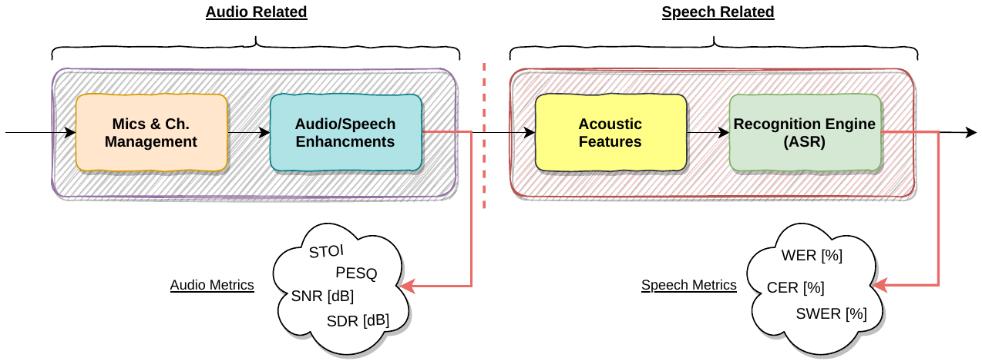

sometimes referenced as “Audio-Enhancement” and “Speech-Enhancement”,

These two domains are

of interest, “Audio-related” and “Speech-related”.

ever, most importantly, it emphasizes the distinction between the two domains

general form describes the internal partitioning and the pipeline process. How-

Figure 1.1 shows a general skeleton of an End-to-End ASR systems. This

**Figure 1.1:** General E2E ASR System Blocks Diagram

which are based on DNNs as well, improves the front-end performance in a

3

metrics like computation time and resources utilization can assist in having

stage. Furthermore, other performance metrics can be embraced. For example,

trade-off estimations should be performed before an E2E ASR system design

Hence, some cross-correlation and

can cause degradation in other metrics.

specific performance metric. On the other hand, performance in one metric

Each change might improve performance, compared to a reference and a

microphones, channel management, and beamformers.

the same NN that is used in the implementation of the front-end components,

of ASR engine building block. Usually, the NN used to train the ASR engine is

Different neural network (NN) architectures can be used in implementation

way that is eventually projected to lower WER results.

version of the input signal,

Integration with deep beamformers,

12].

speech recognition approach[5,

significantly improved compared to the conventional HMM-GMM based

With the introduction of DNN algorithms, E2E ASR systems performance

(NG) and more.

different sets of performance metrics as Directivity Factor (DF), Noise Gain

The first building block shown in Figure 1.1, in turn can be evaluated with

Ratio (SNR) and Signal to Distortion Ratio (SDR) are used.

Time (T50), and other standard signal processing metrics as Signal to Noise

cessing is applied, metrics like Clarity (C50), Definition (D50), Reverberation-

pressed sort, is evaluated using different metrics. If such audio enhancing pro-

whether it be a speech separated or noise sup-

of almost a complete E2E ASR pipeline.

4

NN architectures serve as the basis for the ASR engines.

Recently, new techniques have been introduced [4, 6, 8, 9, 11], such as, different

**Recent Work**

**1.1.1**

phone with multichannel inputs, and microphones array.

Naming few, a single microphone with single channel input, single micro-

expression of the system’s capabilities under different test-cases and inputs.

The experiments in [10, 12] focus on WER performance evaluations for

and beamformer filters.

baseline architecture but have different DNN-type beamformers, ASR engines,

These applications share a similar

a more comprehensive overview about how the system operates given a

In both papers, the researchers built the applications upon the principles

acoustic features extraction and recognition engine stages.

study of neural networks usages for beamforming in the front-end, before the

12] are two pioneering research papers that focus on the

References [10,

**Literature Review**

**1.1**

application requirements or resource limited platforms.

benefit from such metrics estimations especially in a case of dealing with strict

Thus, application developers can

static pipeline with different algorithms.

smaller blocks to ease the integration. Despite being very comprehensive, this

5

“audio related” performance for different beamformers and the number of

Low latency beamformers were studied in [9]. The research results show the

**Low Latency Beamformers**

**1.1.1.3**

masked frequency output.

addition, biasing information was fed into the system in combination with the

ASR system. Masking operations were applied in the frequency domain. In

explores the effect of biasing on a complete pipeline E2E

Reference [11],

**Biasing**

**1.1.1.2**

into account the front-end effect and its correlation to performance.

research paper concentrate on the “Speech related” domain, without taking

**1.1.1.1**

and thuse can be split into multiple

very complex systems by themselves,

ture shown in Figure 1.1, also refered as the Back-end (BE). BE engines are

AED. These architectures belong to right side of the extended E2E ASR struc-

and Transformer-

neural network-attention encoder decoder (RNN-AED),

engines include Recurrent neural network-transducer (RNN-T), Recurrent

In [8], the primary metric used for evaluation is WER. The different ASR

Classification (CTC) [3] recognition models.

both the Listen, Attend and Spell (LAS) [2] and the Connectionist Temporal

The recognition engines mentioned in this paper do not make use of

in [8].

Performance comparisons between different recognition engines are described

**ASR Engine Alternatives**

this paper does not include an E2E pipeline nor the recognition engine.

6

were plugged at the back-end stage.

of both the WER and SDR metrics measurements for different engines that

the “Audio related” domain. However, this research is unique in the presence

It mainly deals with the enhanced output signal, signifying that it is also in

scribed in [6]. In this paper, the architecture does not include the ASR engine.

Another comprehensive research that study masking operations is de-

metric set, as shown in Figure 1.1.

SNR belongs to the “audio-related” metric set rather than the “speech-related”

Indeed,

other words, this research focuses on the “Audio related” domain.

In

microphones in the array.

Memory (BLSTM) spectral masks with respect to the PSD and SNR. However,

sponse (MVDR) were tested with and without Bi-directional Long Short-Term

Generalized Eigenvector (GEV) and Minimum Variance Distortionless Re-

effects with neural networks based beamformers. Two different beamformers,

demonstrates experiments on estimations of spectral masks

Reference [4],

**Masking Operations**

**1.1.1.4**

were used in the experiment.

determine the time it takes to process and propagate. Two different datasets

Moreover, each setup’s latency was measured to

research project, the effects of changing different building blocks and applying

7

ure 1.3

Potential performance metrics that will be evaluated are shown in Fig-

specifications.

process for a specific application, platform, requirement, feasibility, and other

deduce the trade-offs that can be selected to optimize the implementation

one will be able to

Based on the results,

to different performance metrics.

The effects of such replacements and fine-tunes will be presented with respect

various enhancement techniques in a given E2E ASR system will be evaluated.

**1.2**

towards fast setup constructions for different HW platforms. As such, in this

and rapidly developed applications or setups. That is a significant advance

E2E ASR architecture by careful trade-off selections can lead to more robust

by their platform or available hardware. Therefore, optimizations of a given

platforms. Applications have requirements and limitations that are dictated

on other speech or audio related metric sets can be useful to developers of such

A way to estimate Hardware (HW) requirements for speech applications based

**Project Outline**

**1.2.1**

**Proposed Work**

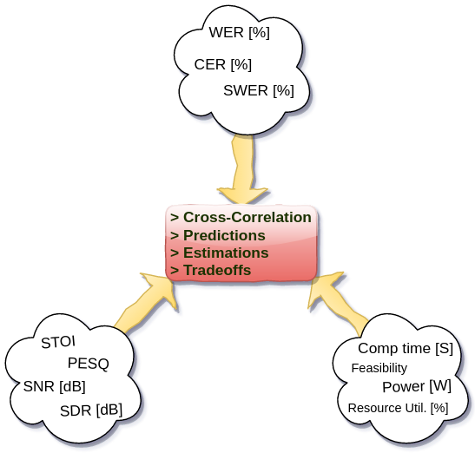

**Figure 1.2:** Project Outline Summary Diagram

The approach is to set up an architecture that follows architecture presented

in Figure 1.3.

8

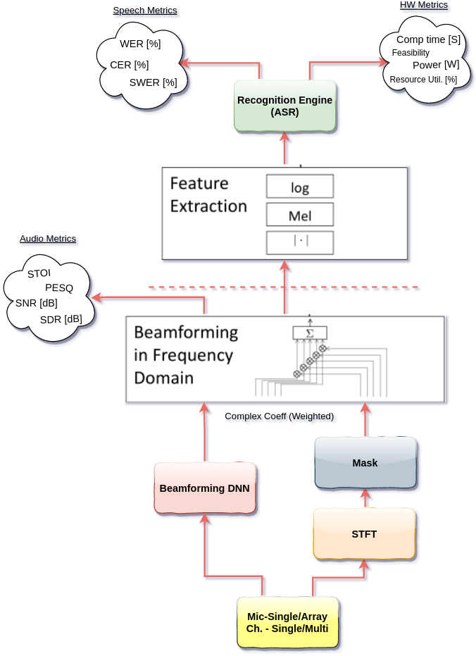

**Figure 1.3:** Project Proposed Architecture

9

A comprehensive performance metrics table that contains the Audio,

Speech,

and HW characteristics of an E2E ASR system,

will be composed.

Such tables make it easier to detect cross-correlations between the metric sets.

Consequently, deducing some estimation methods based on the projection

that each set might have on the others.

10

:

spectral mask estimation for acoustic beamforming”. In: *2016 IEEE In-*

*ternational Conference on Acoustics, Speech and Signal Processing (ICASSP)*.

10.1109/ICASSP.2016.7471664

2016, pp. 196–200.

:

(cit. on pp. 4, 6).

DOI

[5]

G.

Hinton et al.

“Deep Neural

Networks for Acoustic Modeling in

Speech Recognition: The Shared Views of Four Research Groups”. In:

10.1109/

*IEEE Signal Processing Magazine* 29.6 (2012), pp. 82–97.

J. Heymann, L. Drude, and R. Haeb-Umbach. “Neural network based

DOI

MSP.2012.2205597

(cit. on pp. 1, 3).

[6]

W. Jiang, F. Wen, and P. Liu. “Robust Beamforming for Speech Recogni-

tion Using DNN-Based Time-Frequency Masks Estimation”. In: *IEEE*

10.1109/ACCESS.2018.2870758

*Access* 6 (2018), pp. 52385–52392.

:

DOI

(cit. on pp. 4, 6).

[7]

B. Juang and Lawrence Rabiner. “Automatic Speech Recognition - A

Brief History of the Technology Development”. In: (2005) (cit. on p. 1).

11

attend and spell:

[1]

Christoph Boeddeker et al. “Exploring Practical Aspects of Neural Mask-

Based Beamforming for Far-Field Speech Recognition”. In: *ICASSP 2018*.

https : / / www . microsoft . com / en - us / research /

IEEE,

2018.

:

URL

publication / exploring - practical - aspects - neural - mask - based -

beamforming-far-field-speech-recognition/

(cit. on p. 1).

[2]

W.

Chan et al.

“Listen,

**References**

A neural network for large

vocabulary conversational speech recognition”. In: *2016 IEEE Interna-*

*tional Conference on Acoustics, Speech and Signal Processing (ICASSP)*. 2016,

10.1109/ICASSP.2016.7472621

pp. 4960–4964.

:

(cit. on p. 5).

DOI

[3]

Awni Hannun. “Sequence Modeling with CTC”. In: *Distill* (2017).

:

DOI

10.23915/distill.00008

(cit. on p. 5).

[4]

10 . 1109 /

(cit. on p. 4).

DOI

[11]

Xiaofei Wang et al. *Exploring End-to-End Multi-channel ASR with Bias*

2011.03110 [eess.AS]

*Information for Meeting Transcription*. 2020. arXiv:

(cit. on pp. 4, 5).

[12]

X. Xiao et al. “Deep beamforming networks for multi-channel speech

recognition”. In: *2016 IEEE International Conference on Acoustics, Speech*

:

*and Signal*

*Processing (ICASSP)*.

2016,

pp.

5745–5749.

:

DOI

ICASSP.2016.7472778

(cit. on pp. 1, 3, 4).

12

:

Jinyu Li et al. *On the Comparison of Popular End to End Models for Large*

2011.03110 [eess.AS]

*Scale Speech Recognition*. 2020. arXiv:

(cit. on pp. 4,

5).

[9]

Y. Luo et al. “FaSNet: Low-Latency Adaptive Beamforming for Multi-

Microphone Audio Processing”. In: *2019 IEEE Automatic Speech Recog-*

10.

*nition and Understanding Workshop (ASRU)*. 2019, pp. 260–267.

[8]

DOI

1109/ASRU46091.2019.9003849

(cit. on pp. 4, 5).

[10]

Z. Meng et al. “Deep long short-term memory adaptive beamforming

networks for multichannel robust speech recognition”. In: *2017 IEEE In-*

*ternational Conference on Acoustics, Speech and Signal Processing (ICASSP)*.

10.1109/ICASSP.2017.7952160

2017, pp. 271–275.

(

(

)

(

)

Where

*x*

*t*

,

*n*

*t*

denote the speech signal and the interference noise re-

spectively.

Ideal speech separation of the mixture is characterized by a perfect match

(2.1)

)

ˆ︁

between the predicted speech signal,

*x*

*t*

, and the original (reference) speech

(

)

signal *x*

*t*

.

Such a problem can be modeled and optimized by the MSE (L2) (Mean

13

speech signal and some interferences, referred as noise. That mixture is given

**E2E Evaluation Metrics**

**2.1**

**Audio Metrics**

**2.1.1**

**SNR - Signal to Noise Ratio**

The signal-to-noise ratio (SNR) metric evaluates how distinct is the desired

signal out of the overall noise.

(

)

Let

*y*

*t*

denote a mixed time-domain signal consisting of both the desired

**Chapter 2**

by:

(

) =

(

) +

(

)

*y*

*t*

*x*

*t*

*n*

*t*

.

)

ˆ︁

sources presented in

*x*

*t*

and the

*e*

represents any other the artifacts that

*arti f*

cause distortions in the prediction of *x*

(

*s*

According to Parseval’s theorem, the residual energy in time equals the

sum of the power difference between the predicted magnitude and the target

speech magnitude in frequency domain[3].

[︂

]︂

*−*

*−*

*T*

represents the part of

stands for the part of

*x*

*t*

coming from the wanted source(s),

*s*

(

)

ˆ︁

and

*e*

1

*x*

*t*

coming from sensor’s noise.

Sensor can

*noise*

be the microphone itself or one of its counterparts.

*e*

notes the unwanted

*inter f*

=

*r*

*t*

*X*

, *f*

*X*

, *f*

(2.5)

*T*

=

*τ*

*τ*

*t*

0

*f*

0

Since the residual energy is referred as the noise, minimizing the residuals,

or in other words minimizing the MSE loss function, translates into an increase

in SNR.

14

)

*T*

1

2

1

(

)

=

(

)

(

*x*

ˆ︁

∑

∑

∑

*|*

*|*

*−*

2

*τ*

)

*t*

(2.2)

=

*t*

0

*−*

*T*

1

=

(

*x*

∑

*|*

*|*

2

*r*

*t*

(2.3)

=

*t*

]

*−*

*T*

1

(

) =

(

)

(

)

[

0

∑

2

*ℓ*

*−*

ˆ︁

ˆ︁

*x*, *x*

*x*

*t*

*e*

) =

+

+

+

ˆ︁

*x*

*t*

*x*

*e*

*e*

(

(2.4)

*s*

*noise*

*inter f*

*arti f*

(

)

ˆ︁

Where

is the total energy of the residual error between the

(

)

*|*

*|*

2

∑

The term

*r*

*t*

Square Error) loss function as follows:

*t*

predicted signal and the target speech, which translate to additive noise.

(

)

ˆ︁

First, let’s break

*x*

*t*

to its fundamental components[8].

10 log

(︃

)︃

*∥*

*∥*

2

*x*

=

*AC*

*s*

*∥*

*−*

*∥*

ˆ︁

10

2

ˆ︁

10

2

*−*

*−*

*−*

*∥*

*∥*

ˆ︁

*x*

*x*

**E**

*x*

*x*

**E**

*x*

*s*

where there are gaps between phonemes, articulation stops and air aspiration

10

2

*r*

*AC*

**2.1.3**

**Segmental SNR**

An SNR evaluation is basically the ratio between the overall energies of the

signal and those in the noise. However, especially in the case of speech signals,

breaks,

some portion of the signal are actually of almost pure noise.

As a

result, the SNR calculation may be impacted, and it actually depends on the

length of the empty sections with respect to the length of the other sections

where speech is present.

15

*∥*

*∥*

(2.7)

10 log

*AC*

=

*x*

2

*∥*

*∥*

)︃

(︃

*AC*

*AC*

*x*

2

2

*x*

*x*

*s*

(︃

)︃

*∥*

*∥*

10

*x*

=

*s*

10 log

(2.6)

*∥*

*∥*

ˆ︁

*∥*

*−*

*∥*

10 log

*SNR*

*s*

=

*x*

2

*∥*

*∥*

)︃

(︃

*SNR*

*x*

**E**

*x*

=

*−*

*s*

*s*

*SI*

*∥*

10 log

(

[

])

(

[

])

The SNR is therefore given by:

*∥*

*−*

2

]

[

)︄

(︄

and estimated signals are normalized to zero-mean.

To ensure that the SNR is susceptible to scale invariance[6], both the target

**SI-SNR — Scale Invariant SNR**

**2.1.2**

*r*

2

10

from a limitation that can affect the actual results severely. In speech enhance-

10

*∥*

*∥*

2

*M*

*r*

=

(

)

*m*

1

*m*

Where *M* denotes the number of segments the signal is divided by.

Segmental SNR despite being more accurate for speech signals, suffers

ment evaluations, the predicted (enhanced) version of the signal is compared

to a reference clean signal with respect to the noisy mixture.

In the process

of transforming a time-domain speech signal to the frequency domain, ma-

nipulating the signal and then reconstructing it with the inverse-transform

technique, the predicted signal is then not fully aligned with the clean refer-

ence nor the noisy signals.

Therefore, without any alignments, extraction of the Segmental-SNR is

meaningless and most probably inaccurate.

Due to that limitation an align-

ment process should be applied prior taking the Segmental SNR calculation.

These alignments usually have a small marginal error that spans over few

sampling points.

16

*M*

segmented to relatively small chunks (segments), each in a length usually set

to 25

*ms*

long with the option of setting an overlap between segments. Then,

each SNR of each segment is extracted and finally, are averaged. If the energy

of the speech reference in a segment is negligible, that segment is excluded,

thus limiting the evaluation only to sections where speech is present.

Equation 2.6 can be extended to:

(︄

)︄

*∥*

*∥*

2

*x*

With Segmental SNR[4], instead of taking the entire signal, the signal is

(

)

1

=

*s*

*m*

∑

*−*

*SEG*

*SNR*

10 log

(2.8)

convention *Short-Time*.

17

*j*,*m*

. This clipped normalized

*X*

short-time temporal envelop of the clean speech

and normalized before the extraction of the correlation coefficient with the

*j*,*m*

is clipped

*Y*

The short-time temporal envelop of the degraded speech

in Figure 2.1.

The STOI algorithm structure is demonstrated in the blocks diagram shown

**Source:** Adapted from [7]

**Figure 2.1:** STOI flow diagram

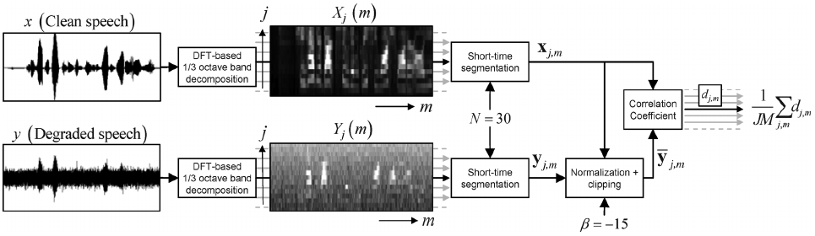

**2.1.4**

time frame, which indicates the naming

*ms*

segments, each spannig over a 384

Since the correlation coefficient is extracted out of overlapping

mixture.

nevertheless considered as an enhanced version of the noisy

a degraded,

But, relatively to the clean speech it is indeed

and T-F maskings front-end.

term degraded might be confusing since it is the outcome of the beamformer

In our case the

the temporal envelopes of the clean and degraded speech.

The intelligibility is measured by taking the correlation coefficient between

STOI[7] is a metric that is used to evaluate the intelligibility of a speech sigal.

**STOI — Short-Time Objective Intelligibility**

*j*,*m*

entire signal, we can take the average of *d*

Extending it to form a definition for the complete

time frame.

*m*

for the

*th*

Also defining the intermediate intelligibility measure, Equation 2.10, it stands

*j*,*m*

*j*,*m*

*j*,*m*

*j*,*m*

*X*

*X*

as in Equation 2.11.

¯

*||*

*− Y*

*|| · ||Y*

*−*

*||*

¯

*d*

(2.10)

*j*,*m*

*j*,*m*

*j*,*m*

*J*

18

assesing the speech quality in an E2E communication channel, that takes into

The motivation behind the development of the PESQ metric was a need of

System (PAMS), and Perceptual Speech Quality Measure (PSQM).

niques as Bark Spectral Distortion (BSD), Perceptual Analysis Measurement

This measuring metric evolved from different previous measuring tech-

munication Union) to test the speech quality of telephony and mobile stations.

PESQ[5] is a measuring method adopted by the ITU (International Telecom-

**PESQ — Perceptual Evaluation of Speech Quality**

**2.1.5**

averaging overlaps *M* number of time frames.

and the

presents the total number of one-third octave bands,

*j*,*m*

Where

*j*,*m*

*JM*

*j*,*m*

(2.11)

*d*

*d*

∑

=

1

*j*,*m*

[

1

,

*n*

*Y*

min

*n*

20

*β*

/

*Y*

*−*

*j*,*m*

]

10

)

+

(

]

[

] =

[

*X*

*||*

*||*

}︄

{︄

(

=

*X*

*X*

*tr*

¯

*− Y*

*Y*

*·*

*−*

¯

)

(

)

version then be:

tion 2.10.

Thus, correlation coefficient can be noted as the distance given in Equa-

*j*,*m*

*Y*

*j*,*m*

*j*,*m*

*||*

*||*

(2.9)

*n*

*X*

**2.2.1**

19

However, in some cases the predicted sentences differ in size compared

reference are then divided by the total counted words in the reference.

The sum of mismatches between the predicted sentence and the

terpart.

engine output, each annotated word is then matched with its reference coun-

Taking the predicted translated text, segmented to sentences, at the ASR

recognition systems.

WER[2] metric is probably the most used evaluation technique for speech

**WER - Word Error Rate**

account the entire link rather than particular parts.

**ASR Metrics**

**2.2**

**Source:** Adapted from PESQ paper[5] and redesigned

**Figure 2.2:** PESQ Algorithm Blocks Diagram

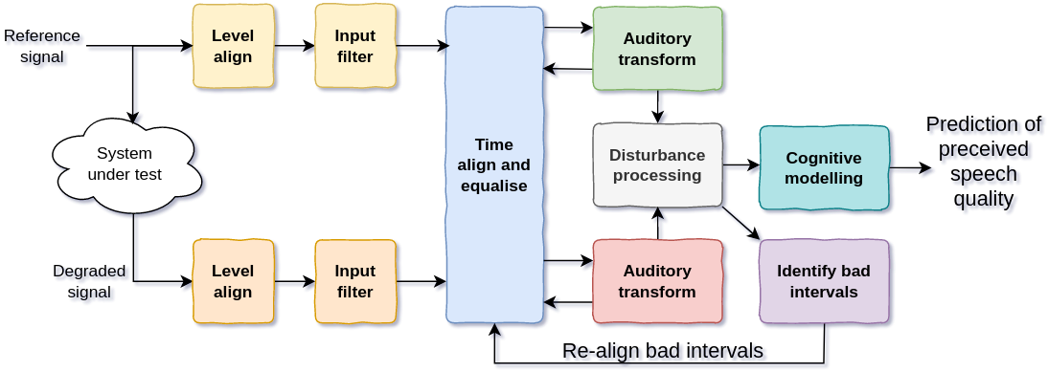

signal, with respect to the clean reference.

Figure 2.2 shows the data flow of the PESQ computation for a predicted

1 to 5 by a group of listeners.

Opinion Scores) model, where the actual speech quality is ranked in-between

The evaluation of a speech signal quality by PESQ follows the MOS (Mean

(2.13)

**CER - Character Error Rate**

CER is another metric that is very similar to the WER evaluation metric but

with a smaller resolution of comparing characters instead of words.

Same rules of “Substitutions”, “Deletions” and “Insertions” apply, and

therefore, the CER is calculated the same:

+

+

*S*

*D*

*I*

=

*CER*

**2.2.2**

*N*

In many cases, the CER[9] is a complementary measuring metric to the

WER metric.

This extra measure shines when there is a need to get a full

perspective with a greater resolution about the *Substitutions* in the complete

sentence hypothesis, the suggested predicted transcript. While WER counts a

mismatch between the reference and the predicted word even in cases where

only single characters or worse, punctuation marks are not correctly placed,

CER can lead to more accurate grading per word.

20

Therefore, a special care for “Insertions”, and “Deletions”

should be carried as well in addition to the *Substitutions* detected.

The WER is then can be described by:

+

+

*S*

*D*

*I*

=

*WER*

(2.12)

to the reference.

*N*

Where

*N*

is the total counted number of words in the reference, and

*S*

,

*D*

,

*I*

are the number of *Substitutions* (wrong word detection), *Deletions* (Omitting

words), *Insertions* (Wrong words insertions).

Power dissipation is a side effect of the resistive nature of conductors,

21

But overall in general can still be

when speaking of digital logic designs.

Electrical circuits power dissipation depends on many arguments, mainly

under different working conditions.

ensure efficiency and correctness, while maintaining robustness over time and

Therefore, power analysis is a crucial step in any system design phase to

for the main functionality of the system but dissipated and converted to heat.

want to mitigate as much as possible any power consumption that is not used

dation in performance of electronic systems at high temperatures, engineers

Since dissipated power is a waste of energy, and the main cause of degra-

result, part of the energy convert to heat energy.

As a

small as it may be, that “resists” to the transition of current through.

**2.3**

and some of the energy is lost and wasted as a result of power dissipation.

energy. However, the total supplied energy over time is not purely consumed,

tor. The current that flows in the system feeds the different components with

between the conductor’s terminals, electrical current goes through the conduc-

Due to the nature of conducting materials, whenever a potential is applied

source to the device or vice versa.

various parameters and mainly describes the rate of energy delivery from the

amount of power a device consumes from the power sources is subject to

The

Electrical circuits, components and systems require power to function.

**Power Estimation**

**2.3.1**

**HW Metrics**

device, where a gate is isolated by a thin layer of metal oxide that forms a

22

leakage.

rent of the diode (p-n junction), sub-threshold current leakage, and the gate

the reverse bias cur-

In Figure 2.3 three current leakages are described,

**Source:** Adapted from Synopsys PrimePower Suit documentation[1]

**Figure 2.3:** Leakage Power Illustration

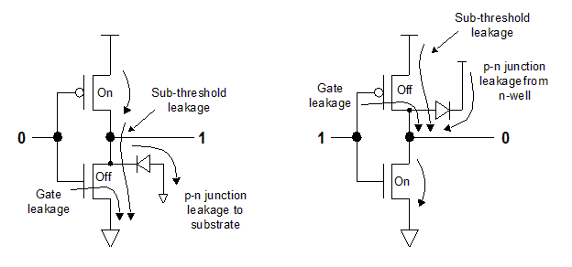

whether it is in active state or in off state (idle).

small capcitor. That power dissipates statically regardless of the device state,

modeled accurately according to three scenarios divided to two main groups:

Leakage power is the power that dissipates due to the structure of a CMOS

**Leakage Power**

**2.3.1.1**

• Switching Power

• Internal Power

Dynamic Power

2.

Static Power (Leakage)

1.

two complementary MOS transistors.

(2.14)

*leak*

*DD*

*th*

*L*

**2.3.1.2**

**Internal Power**

Internal power, is caused by the nature of a CMOS device which is built by

,

Whenever a transition in the CMOS

gate occurs,

for a relatively small

duration of time,

both the NMOS and

the PMOS drivers are active and as a result a short circuit directly from the

power rail to ground is formed. Although not lasting for long periods of time,

overtime in highly toggled designs, the amount of internal dissipated power

23

*W*

are minimized in size, but as a side effect, the leakage power is increasing.

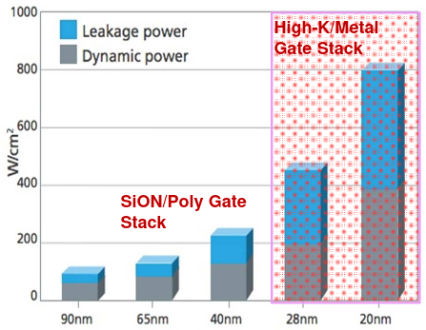

**Figure 2.4:** Leakage Power vs. Process Technology

**Source:** Adapted from Soitec FinFet presentation

The overall leakage power is therefore a function of the total number of

voltage sources and their voltage levels, the physical dimensions of the CMOS

device, and the threshold value set to switch between on-off states.

*µ*

*ε*

With the recent advancement in process technologies, the CMOS devices

=

(

)

*n*

*ox*

*F*

*P*

*V*

, *V*

Switching power, is the power dissipated as a result of charging and discharg-

24

currents are eventually dissipated and are not delivered to the external load.

device through the PMOS transistor to ground. The charging and discharging

tion at the output, the load capacitance is then discharged and sink into the

order to set the desired logic level voltage. Likewise, for a high-to-low transi-

output occurs, the driver pushes current to charge the capacitance load in

gates, due to their structure. Thus, whenever a low-to-high transition at the

ing loads during transitions. MOS devices introduce capacitance at their input

becomes significant. In order to minimize the internal dissipated power, or in

**Switching Power**

**2.3.1.3**

**Source:** Adapted from Synopsys PrimePower Suit documentation[1]

**Figure 2.5:** Internal Power Illustration

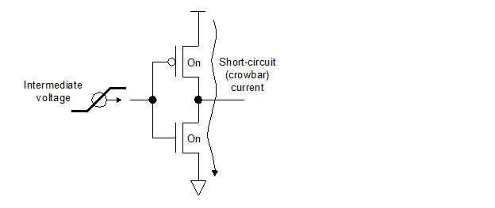

are set to be very fast.

current flows from Vdd to GND, the transition times (both rising and falling)

other words, minimizing the time duration where both devices are active and

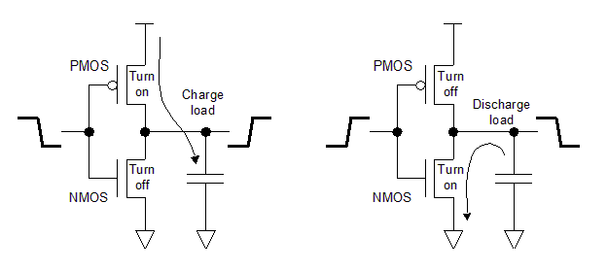

**Figure 2.6:** Switching Power Illustration

**Source:** Adapted from Synopsys PrimePower Suit documentation[1]

25

*on Acoustics, Speech and Signal Processing*. 2010, pp. 4214–4217.

*cessing. Proceedings (Cat. No.01CH37221)*. Vol. 2. 2001, 749–752 vol.2.

:

DOI

10.1109/ICASSP.2001.941023

(cit. on pp. 18, 19).

1811.

[6]

Jonathan Le Roux et al. *SDR - half-baked or well done?* 2018. arXiv:

02508 [cs.SD]

(cit. on p. 15).

[7]

Cees H. Taal et al. “A short-time objective intelligibility measure for time-

frequency weighted noisy speech”. In: *2010 IEEE International Conference*

10.

In: *2001 IEEE International Conference on Acoustics, Speech, and Signal Pro-*

:

DOI

1109/ICASSP.2010.5495701

(cit. on p. 17).

[8]

E. Vincent, R. Gribonval, and C. Fevotte. “Performance measurement in

blind audio source separation”. In: *IEEE Transactions on Audio, Speech,*

10.1109/TSA.

*and Language Processing* 14.4 (2006), pp. 1462–1469.

:

DOI

2005.858005

(cit. on p. 14).

26

10 . 1016 / j . specom . 2013 . 12 . 002

[1]

M. Keating et al. “Low power methodology manual: For system-on-chip

10.1007/978-0-387-71819-4

design”. In: (2007), pp. 1–300.

:

(cit. on

DOI

pp. 22, 24, 25).

[2]

Dietrich Klakow and Jochen Peters. “Testing the correlation of word

error rate and perplexity”. In: *Speech Communication* () (cit. on p. 19).

[3]

Shan Liang et al. “The analysis of the simplification from the ideal ratio

to binary mask in signal-to-noise ratio sense”. In: *Speech Communication*

**References**

59 (2014),

pp.

22–30.

:

(cit.

on

DOI

p. 14).

[4]

Schuyler Reynier Quackenbush. “Objective Measures of Speech Quality

(Subjective)”. PhD thesis. USA, 1985 (cit. on p. 16).

[5]

A.W. Rix et al. “Perceptual evaluation of speech quality (PESQ)-a new

method for speech quality assessment of telephone networks and codecs”.

[9]

Y. Wang, A. Acero, and C. Chelba. “Is Word Error Rate a Good Indicator

for Spoken Language Understanding Accuracy”. In: (2003) (cit. on p. 20).

27

*Hz*

28

different scaling system that mimics the human hearing as possible is therefore

speech analysis applications. Thus, a different spectral mapping based on a

the conventional linear spectral mapping is impractical for

Therefore,

additional frequencies in other distinctive regions.

in one distinction region does not equal to the spectral distance between two

not symmetric. The spectral distance between two distinguishable frequencies

The human ear ability to distinguish between two different frequencies is

maximum hearable frequency actually decreases with age.

[8]. That is, the

*KHz*

14

**Chapter 3**

decreases, and by middle-age are set at about 20

*÷*

As a result of aging, the dynamic range as to the detectable bandwidth

20*kHz*, starting at 20*Hz* to about 20*kHz* [7].

human ear, is referred as audio or sonic. That range spans over approximately

by the

The detectable range of frequencies,

are later translated to sounds.

The human hearing system is capable of detecting acoustic vibrations which

**Introduction**

**3.1**

**Audio Frequency Scaling methods**

Which can be simplified as:

1

1127 ln

*Mel*

+

=

*f*

)︃

(︃

700

1

ln

700

1000

700

(︃

)︃

*f*

=

+

*Mel*

2595 log

1

(3.2)

10

700

Then, the reverse equation, converting Mels back to Hz can be written as:

29

as rated by listeners.

One by

Two common tables were composed according to those curves.

the authors presented different curves that best describe the Mel-scaling.

Mel-scale has been described first in [4] by Stevens and Volkmann. In [4]

1000*Mels*.

reference point has been chosen to be 1000*Hz*

=

The

Beranek in 1949 [1] and the other by Umesh et al. in 1999 [**UmeshMel**].

chosen to be equal in distance from each other,

is that for different pitches, we assign varying bandwidth, such, that were

The basic idea that lays underneath

frequencies to perceived frequencies.

The Mel-scaling method, is a suggested solution to mapping normal audio

**Mel-Scaling**

**3.2**

applied as an alternative.

The most popular equation that models the Mel-scale is given by [2]:

(︃

)︃

*f*

1000

=

+

*·*

*Mel*

ln

1

(3.1)

(

+

)

*Mel*

] =

[

)︂

(︂

Then, the reverse equation, converting Mels back to Hz can be written as:

700

10

(3.5)

1

2595 log

*Mel*

+

=

*f*

)︃

(︃

700

1

1127 ln

*Mel*

frequencies to Mels.

30

Instead, other approximations that do not involve any trigonometric nor

which are very resources hungry.

computation might require special techniques or long LUTs (look-up tables)

natural logarithm or any other base is not very straight forward. This kind of

computing a logarithm whether it is the

for hardware devices,

However,

**Mel scale approximations**

**3.2.2**

+

These modeling equations became de-facto the default way to map audio

2595

(3.6)

1

10

700

*Hz*

*f*

*−*

(3.3)

=

1000

*f*

)︃

(︃

The most popular equation that models the Mel-scale is given by [2]:

**Logarithm based Mel scale**

**3.2.1**

2595

+

1

10

700

*Hz*

*f*

*−*

*Mel*

] =

[

)︂

1000

=

*f*

)︃

(︃

Which can be simplified as:

700

1

ln

700

(︂

)

+

(

(3.4)

1

ln

*Mel*

*·*

*f*

*a*

=

1000

*f*

,

0.000244

*≤*

{︄

while in Equation 3.8 *a*, *b* are:

1000

*>*

,

0.19

*>*

(3.9)

*b*

=

1000

*f*

,

1000

31

1000

*f*

,

0.603

*>*

(3.10)

*b*

=

0.9

*f*

,

0.741

*≤*

{︄

1000

*f*

,

0.0004

*Mel*

*·*

+

(3.8)

*Mel*

=

*f*

(3.7)

*f*

*b*

*a*

*·*

+

=

are the most prominent for target HW devices.

Multiple approximation methods were studied in [6]. Two approximations

accuracy.

so, one has the benefit of low resource utilization, while maintaining high

Doing

but only simple arithmetic structures can be applied.

1000

*≤*

{︄

1000

*f*

,

1322

*>*

*a*

=

logarithms,

*f*

,

127.7

*≤*

{︄

Where *a*, *b* in Equation 3.7 are defined as follows:

*b*

*f*

*a*

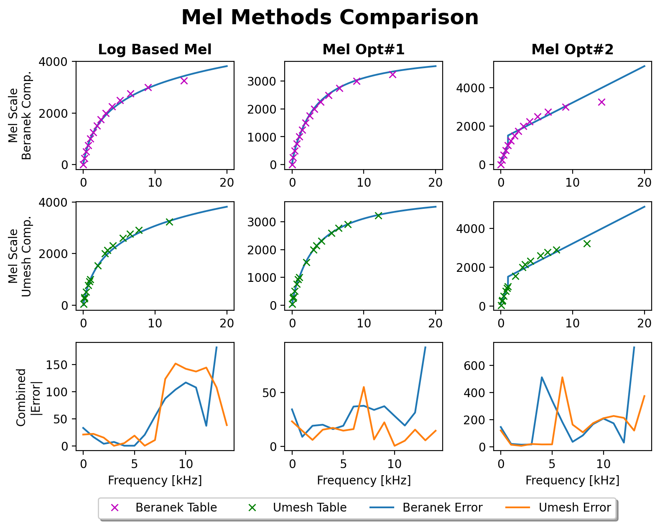

**Figure 3.1:** Mel scale comparisons with Beranek & Umesh tables

In Figure 3.1, each Mel scaling implementation is compared to the tables

suggested by Beranek & Umesh respectively.

The first column represents

O’Shaugnessy famous log based Mel modeling. The second and third columns

follows the suggested approximations given in Equations 3.8, 3.7 respectively.

From the last row graphs, it can be deduced that the approximation in

Equation 3.8 is the closest along the range of audio frequencies to the tables

provided by Beranek & Umesh. Saying that, the more simplified approxima-

tion seems to yield high margins of error.

32

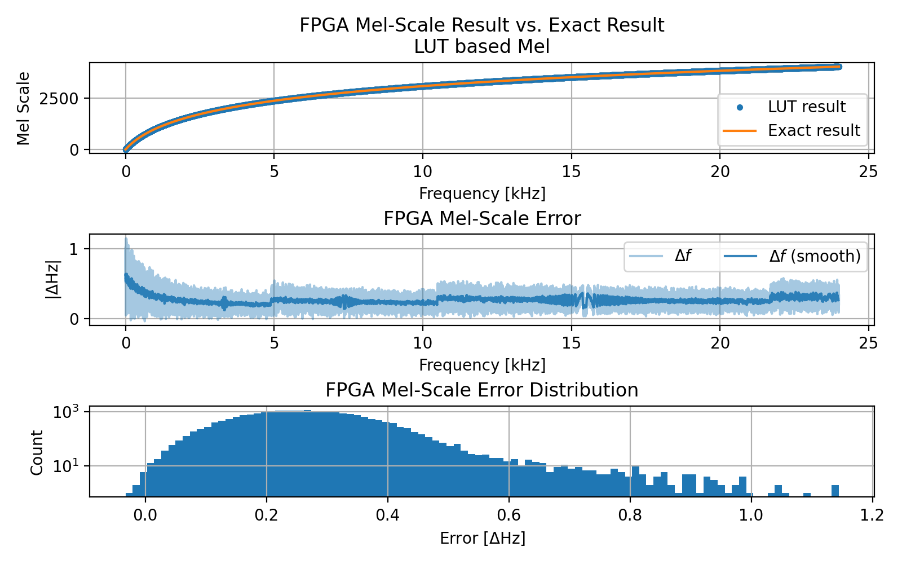

**Figure 3.2:** LUT based Mel FPGA implementation results

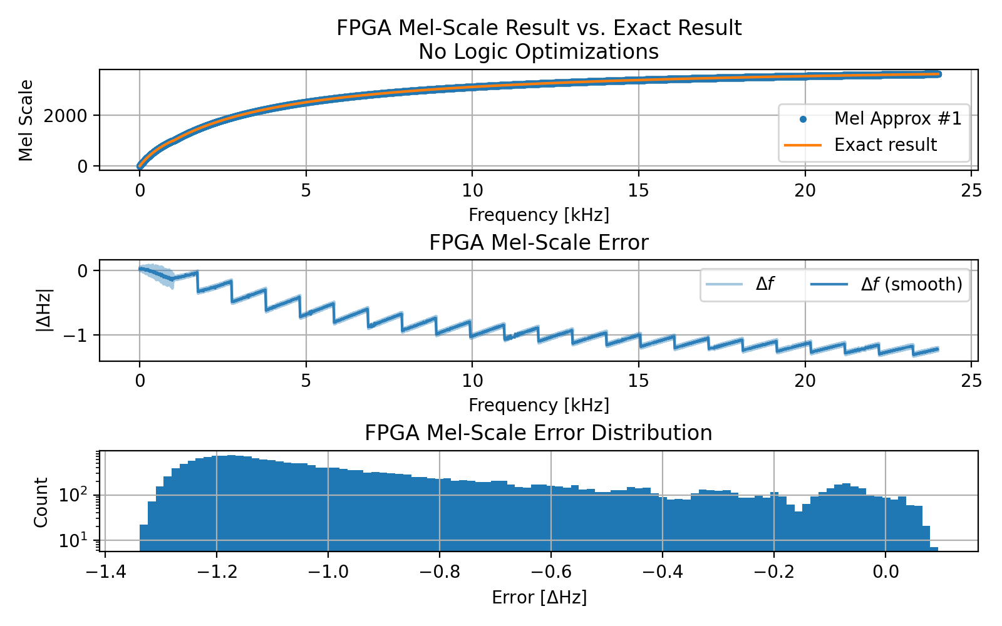

**Figure 3.3:** Mel approx. #1 FPGA implementation results

33

Selection of

they are multiplied by 1000, and thus reducing the required number of bits

for the fractional part. As a result, both the frequency shifting error and the

overall resources’ utilization are greatly improved. Yet, the split in frequency

band results in two multiplied sets of coefficients for each band calculation.

Choosing a more generalized set of coefficients for the entire audio band, can

help in the reduction of redundant LUTs and other combinational logic, as

selectors and multi-bus multiplexer cells.

=

=

coefficients in an effective precision and lower resolution,

*a*

0.24,

*b*

0.741, showed better results as can be seen in

figure 3.5.

The accuracy estimation for the non-generic implementation is

shown in Figure 3.4.

34

consumption which utilized 4 times higher wattage and 25

O’Shaugnessy’s Log based Mel, and Mel approximation #1.

Nonetheless, a

high precision quantization settings were chosen for the Mel approximation,

U32.22, the shifting error received is higher compared to the conventional

Log Mel scaling implementation.

Although, this error shift is compensated

just by selecting the approximation method, the straight forward approach

turned out to be non optimized solution in terms of HW resources and power

*÷*

In Figures 3.2, 3.3 presented are the results of FPGA implementations of

30% additional

resources.

Instead, two optimization workarounds were tested.

The first, by reor-

ganizing the

*a*

,

*b*

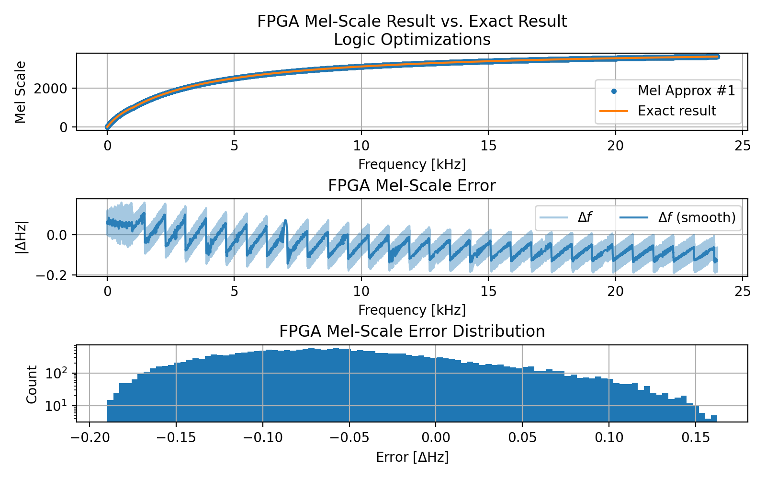

**Figure 3.4:** Mel approx. #1 optimized FPGA implementation results

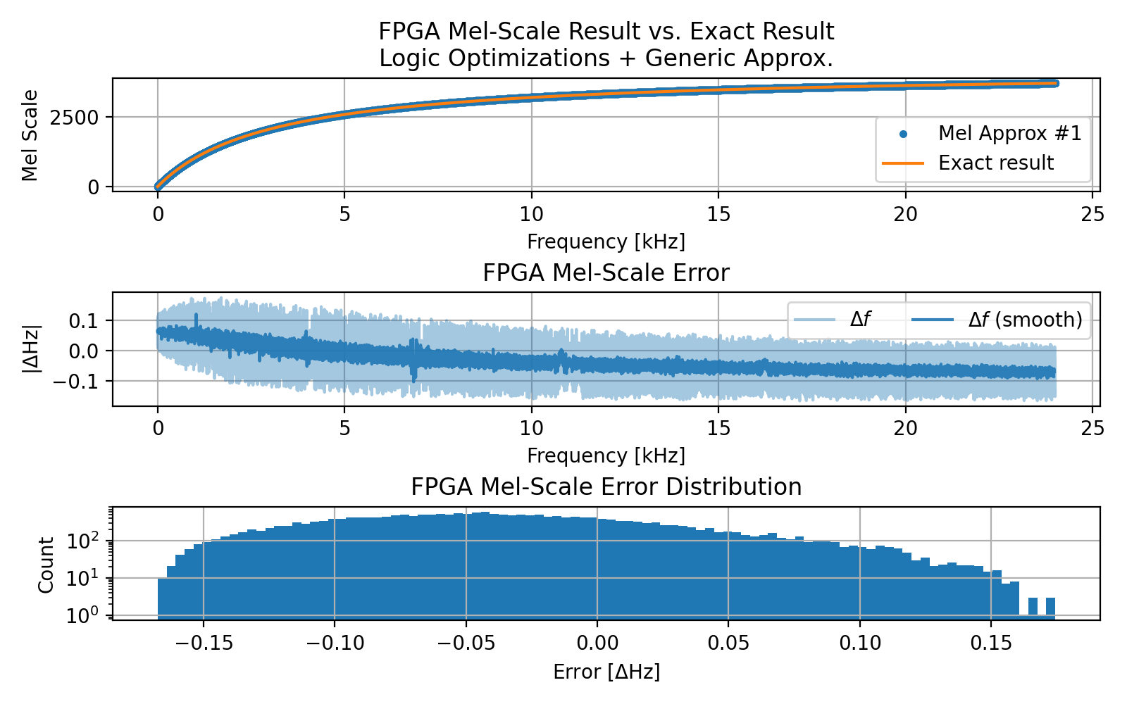

**Figure 3.5:** Mel approx. #1 optimized, generic FPGA implementation results

35

3.751

0.013

0.014

DSP

3.070

6.792

6.50

Logic

**29.697**

**P**

6.378

7.207

26.263

2.916

18.236

I/O

0.014

0.014

**Mel #1**

**Log LUT Mel**

**Parameter**

**Mel #1 Opt**

**Table 3.2:** Mel scaling methods resource utilization table

0(0%)

0(0%)

1(<1%)

3.011

5.221

4.947

Signals

**13.983**

**Dynamic Power [W]**

**Mel #1 Generic**

**Total Power [W]**

**0.517**

**0.519**

**static**

**2.537**

**2.432**

**P**

**14.502**

36

it is the natural logarithm or base 10 are constant, the LUT result is divided

or other log bases, an additional step is required. Since, the bases, whether

*ln*

2 look-up table. However, for

*log*

The LUT implementation makes use of an

**Table 3.3:** Mel-Approx, log based Mel, Bark Scale Power consumption

**40.827**

**total**

**12.896**

**32.13**

**P**

PL Static

**Static Power [W]**

2.364

**12.379**

**38.290**

**dynmic**

PS Static

0.018

0.020

0.071

0.068

0.499

0.499

2.466

1.338

Mel #1 Opt

-0.359

-0.873

U32/22

9 (2 C.C)

Mel #1

U16/4

9 (2 C.C)

Mel #1 Generic

0.065

-0.053

0.190

U16/4

9 (2 C.C)

*Hz*

**Max Err.**

**Quant.**

*ns*

**Latency**

**Algorithm**

**Mean Err.**

∆

]

[

]

14 (3 C.C)

0.106

0.268

1.146

U16/4

0.174

Log LUT Mel

**Std Err.**

0(0%)

0(0%)

1(<1%)

Mel #1 Opt

530(0.45%)

47(0.02%)

Mel #1

0(0%)

269(0.19%)

47(0.02%)

Mel #1 Generic

0(0%)

1(<1%)

271(0.23%)

47(0.02%)

**DSP**

**LUT**

**FF**

**Algorithm**

**Table 3.1:** Mel-Approx, log based Mel performance comparison

0.061

-0.035

1.5(1.04%)

10(0.02%)

1(<1%)

276(0.23%)

82(0.04%)

[

Log LUT Mel

**BRAM**

**LUTRAM**

Another scaling method is the bark scaling which is based on the same princi-

*x*

Table 3.1 summarizes the performance comparison between the different

Mel scaling implementation approaches. Latencies were simulated with Xilinx

Vivado Suit to a point where no timing violations were reported for a working

clock frequency of 225*MHz*.

Tables 3.2, and 3.3 shows the synthesis and implementation results plus the

power estimation reports taken from Xilinx Vivado Suit when target device

was set to the PYNQ-Z1 development board.

**3.3**

**Bark-Scaling**

*b*

pal of retaining same perceptual distances. The bark scale is divided to critical

bands that correspond to the critical hearing bands. Each band is ranked with

a number and has a bandwidth similar to the psychoacoustic band of the

corresponding “filter” in the human hearing system.

**3.3.1**

**Bark Critical Bands**

Like Mel scale, several equations were proposed to model best the Bark scale

and its critical bands.

37

) =

*log*

2 of that base.

This logarithm bases convention is described in

Equation 3.11.

(

)

log

*a*

(

by the

*x*

log

*a*

(3.11)

(

)

*b*

log

(3.13)

tan

0.00073 *f*

3.5 tan

(3.12)

7500

Another proposed equation by Traunmuller [5] is:

26.81 *f*

=

*−*

*Bark*

0.53

*Bark*

+

1960

*f*

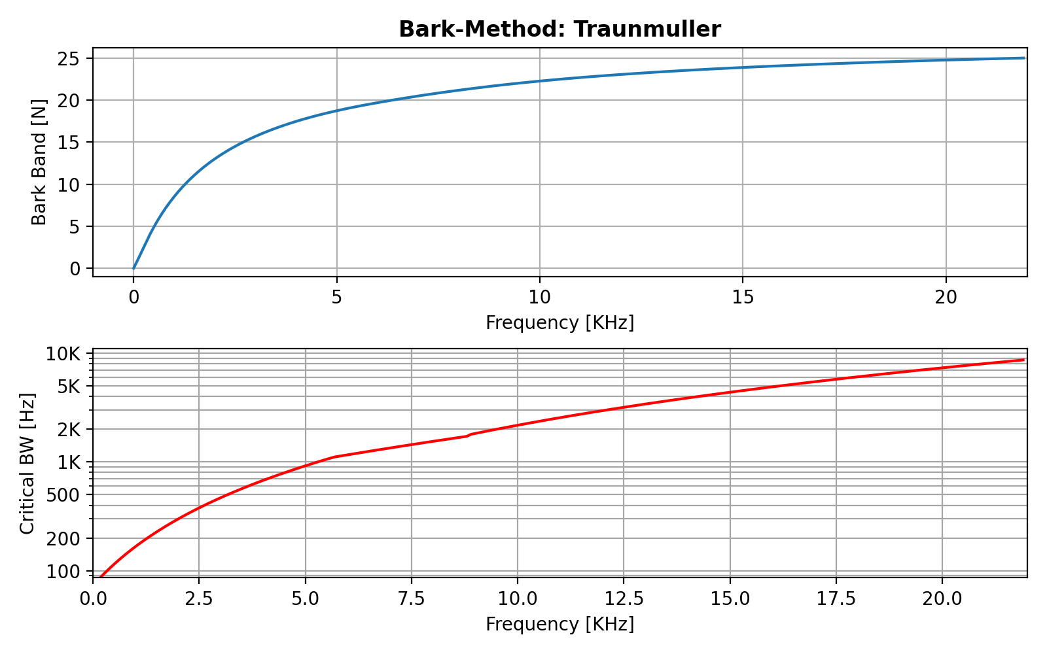

**Figure 3.6:** Traunmuller no fix

*′*

Denoting Traunmuller’s original Bark scale given in Equation 3.13 as

*Bark*

,

38

(︃

**doi:10.1121/1.1908630**

]. A proposed approxi-

mation to the bark scaling is described in [

**doi:10.1121/1.399849**

]. This paper

also introduces the correction of the band boundaries to ensure more correct-

ness with the original bark scaling.

Four different equations were proposed to model the Bark scale.

The first by Zwicker is well described in[9] and is given by the following

equation:

{︄

}︄

First method introduced in [

)︃

2

*f*

=

+

*−*

*−*

1

1

*{*

*}*

*f*

*Bark*

20.1

,

*Bark*

20.1

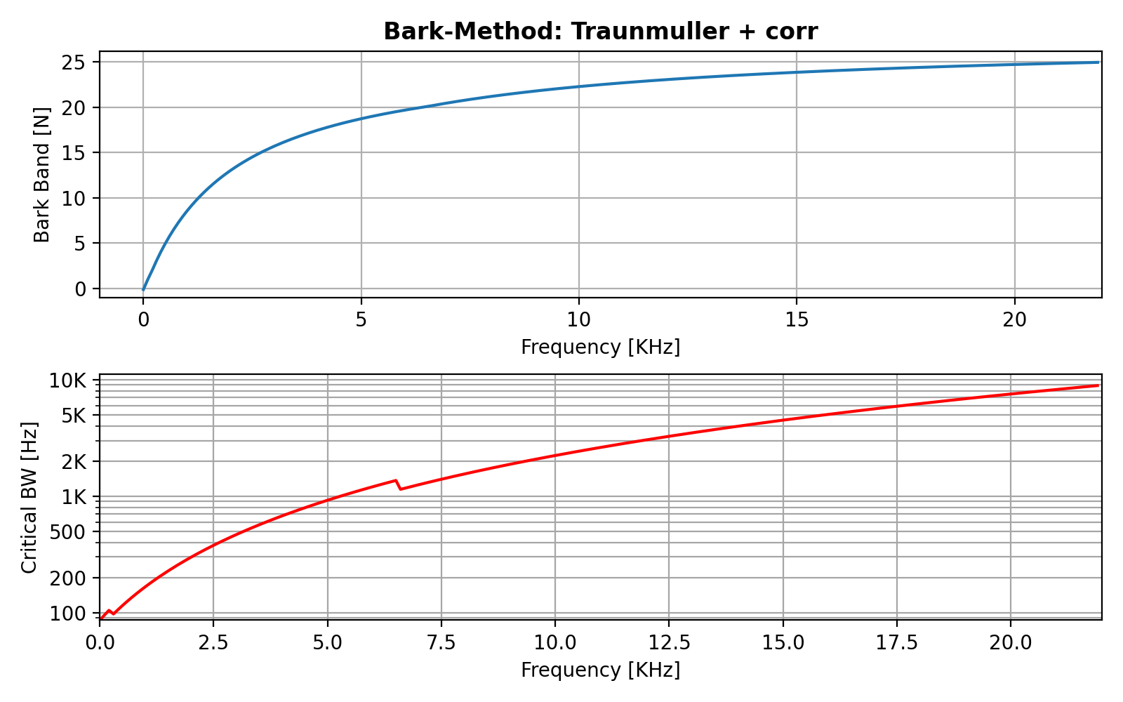

**Figure 3.7:** Traunmuller fix

The fourth possible modeling equation is proposed by Schroeder in [3]

and is as follows:

(︄

)︄

√︃

2

0.22

*f*

=

+

+

*Bark*

7 ln

1

(3.15)

650

422500

39

2

{︄

+

(

)

*′*

*′*

*·*

*<*

0.3

0.85

*Bark*

,

*Bark*

the fixed form for Traunmuller’s Bark equation is:

=

*Bark*

(3.14)

+

(

)

*′*

*′*

*′*

*·*

*−*

*>*

*Bark*

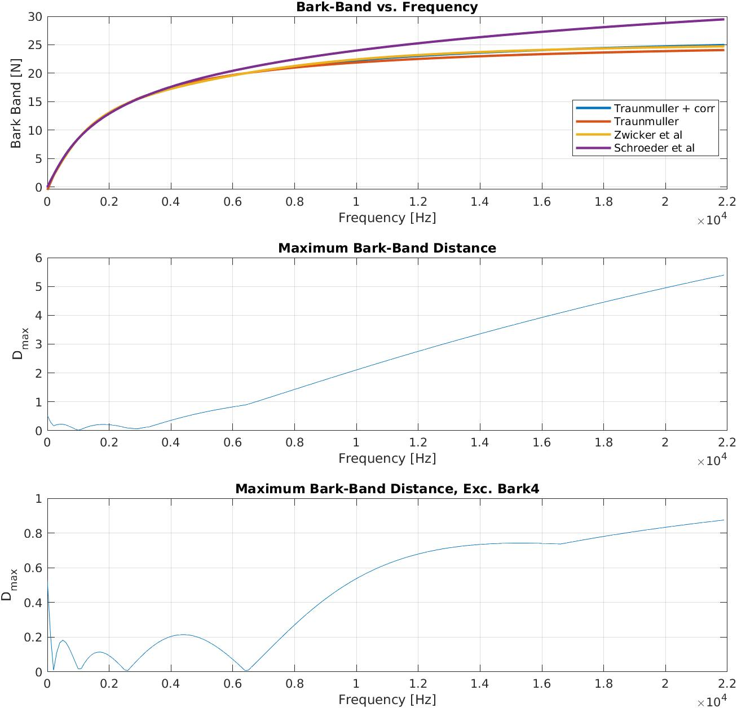

**Figure 3.8:** Bark comparisons

40

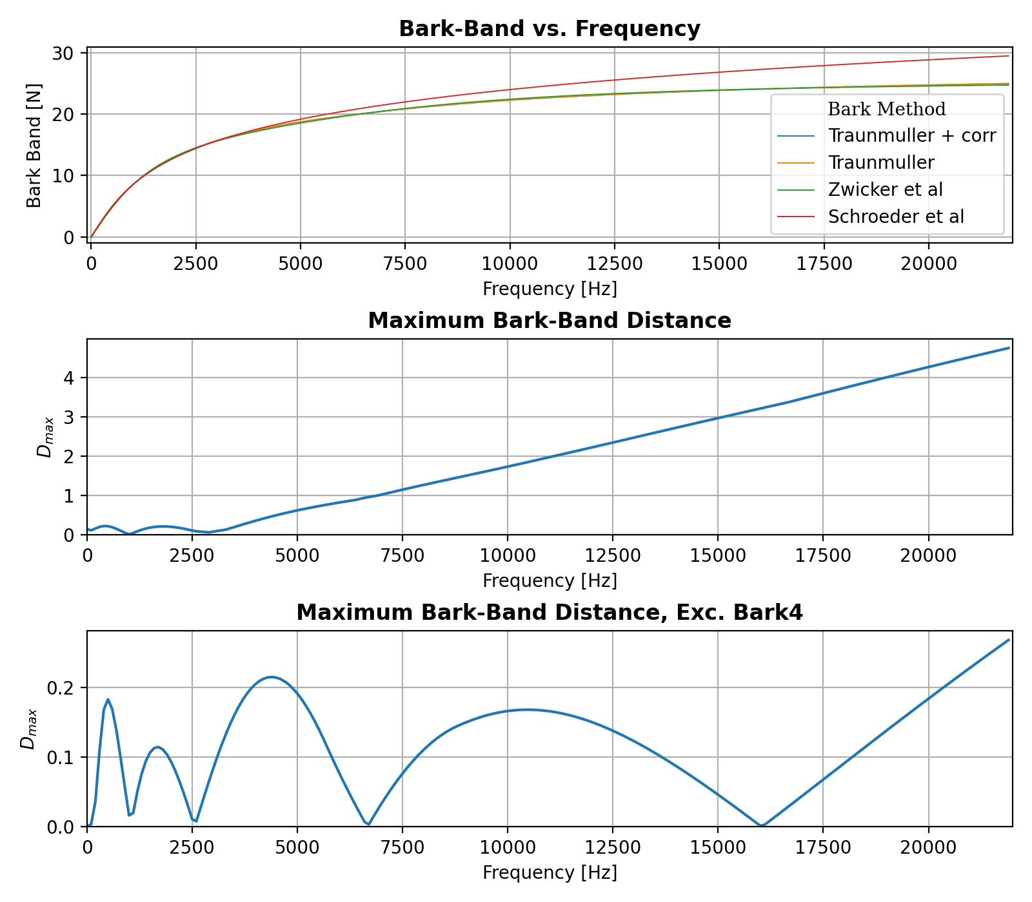

**Figure 3.9:** Bark comparison

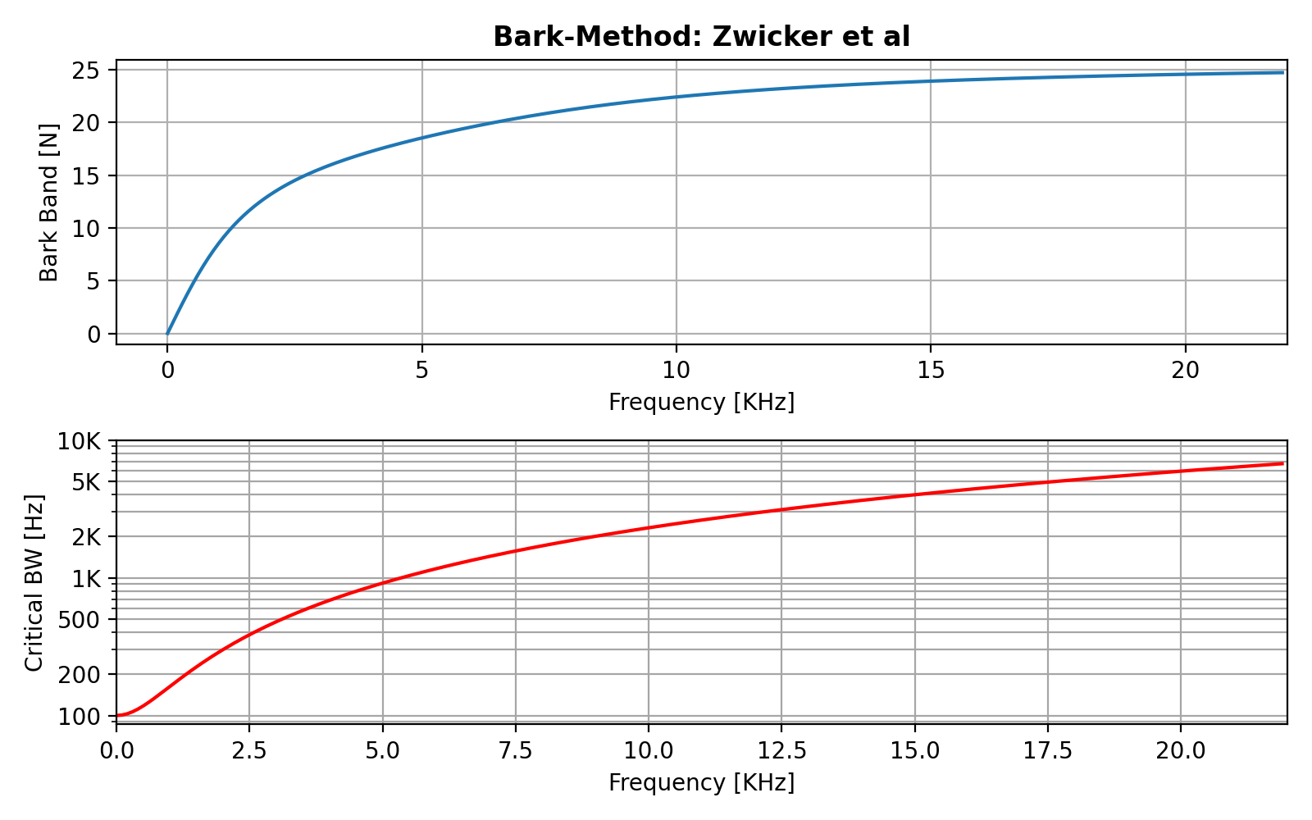

**Figure 3.10:** Zwicker

41

Traunmuller w/ Fix

14 (3 C.C)

U10/5

N.A

N.A

N.a

Traunmuller w/o Fix

9 (2 C.C)

U9/4

0.0443

0.0015

0.0180

**Table 3.4:** Traunmuller’s Bark scale implementations performance comparison

42

**Figure 3.11:** Schroeder

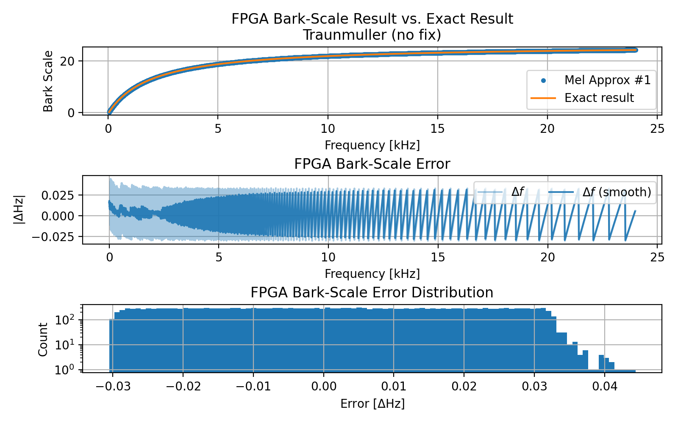

**Figure 3.12:** Schroeder

[

]

[

]

∆

**Algorithm**

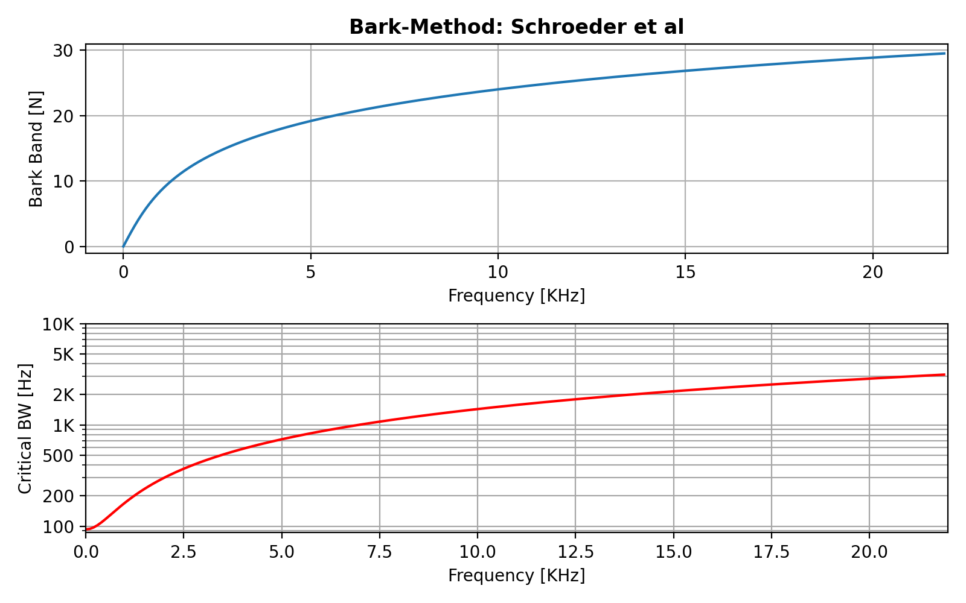

**Latency**

*ns*

**Quant.**

**Max Err.**

*Hz*

**Mean Err.**

**Std Err.**

**dynmic**

**Static Power [W]**

**9.186**

PL Static

0.469

0.437

I/O

DSP

1.445

0.014

4.022

4.022

**P**

**10.923**

**P**

**11.412**

**total**

**9.639**

**Total Power [W]**

**Table 3.6:** Traunmuller’s Bark scale implementations Power consumption

**3.4**

**ERB - Equivalent Rectangular Bandwidth**

Similarly to the Bark scaling method, the ERB scale aims to rescale the audio

spectrum in different bandwidthes that correspond to the human hearing

“filters”.

This approach slightly differs from the Bark scale in the way that the filters

are modeled according to a rectangular filter with an equivalent bandwidth.

43

**0.453**

PS Static

0.017

0.016

**P**

**0.486**

**static**

43(0.02%)

302(0.26%)

1(<1%)

0(0%)

0(0%)

Traunmuller w/ Fix

Traunmuller w/o Fix

27(0.01%)

284(0.24%)

**Algorithm**

**FF**

**LUT**

**DSP**

**LUTRAM BRAM**

**Dynamic Power [W]**

Signals

2.380

2.192

Logic

3.079

2.957

1(<1%)

0(0%)

0(0%)

**Table 3.5:** Traunmuller’s Bark scale implementations resource utilization table

**Parameter**

**Traunmuller w/ Fix**

**Traunmuller w/o Fix**

=

44

**Figure 3.13:** LUT based ERB FPGA implementation results

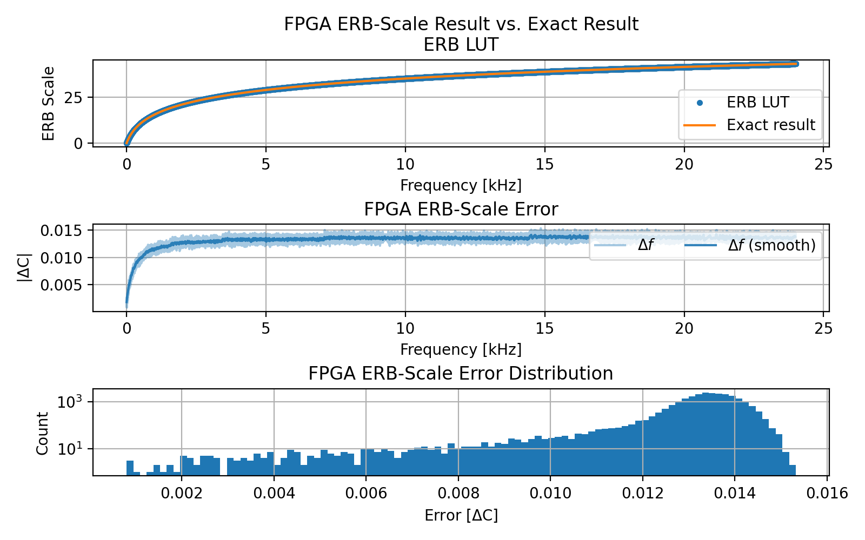

10

(3.17)

0.00437 *f*

1

log

21.4

*ERBs*

*·*

)

+

(

676170.42

A proposed approximation is given by:

14678.5

*f*

+

(3.16)

47.065

11.17 ln

*ERBs*

*−*

)

(

=

U16/10

Table 3.7 presents the performance comparison between the implementa-

**Table 3.7:** ERB and ERB approx performance comparison

0.657m

-0.408m

6.210m

tions of the pure ERB and the ERB approximation given by Equations 3.16,

14 (3 C.C)

ERB Approx

14678.5

45

*e*

47.065

*C*

0.0895

*−*

*·*

(3.18)

0.0018

*f*

*−*

=

676170.42

used to convert Cams to Hz.

cating the error in Cams rather in frequency units (Hz). Equation 3.18 can be

*C*, indi-

and 3.17 respectively. The error terms for the ERBs are measured in

∆

**Max Err.**

**Quant.**

*ns*

**Latency**

**Algorithm**

*C*

∆

]

[

]

[

**Figure 3.14:** LUT based ERB approx. FPGA implementation results

ERB

0.0130

0.0153

U16/10

23 (5 C.C)

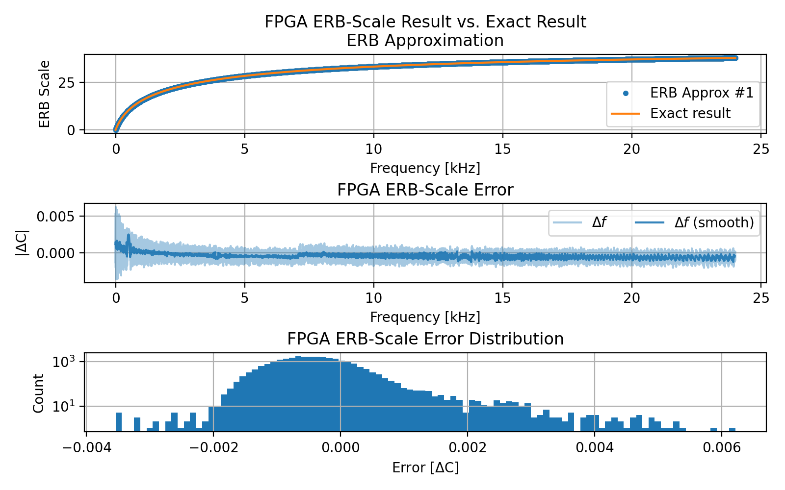

**Std Err.**

**Mean Err.**

**BRAM**

**LUTRAM**

**DSP**

**LUT**

**FF**

**Algorithm**

276(0.23%)

1.5(1.04%)

10(0.02%)

1(<1%)

82(0.04%)

Log Based Mel

**static**

**Total Power [W]**

**1.556**

**3.055**

**P**

0.046

**P**

**50.768**

**33.075**

**total**

**Table 3.9:** ERB vs. ERB approx Power consumption

**3.5**

**Summary**

1(<1%)

0(0%)

0(0%)

284(0.24%)

27(0.01%)

Bark Scale w/o fix

Approx. ERB

103(0.04%)

564(0.48%)

1(<1%)

1(0.01%)

1.5(1.04%)

**Table 3.10:** Mel-Approx, log based Mel, Bark Scale

46

0(0%)

0(0%)

1(<1%)

269(0.19%)

47(0.02%)

Mel #1 Generic

Bark Scale w/ fix

43(0.02%)

302(0.26%)

1(<1%)

0(0%)

0(0%)

1.5(1.04%)

1(0.01%)

1(<1%)

564(0.48%)

103(0.04%)

ERB Approx

**Table 3.8:** Mel scaling methods resource utilization table

**Parameter**

**ERB**

**ERB Approx**

**FF**

**BRAM**

**LUTRAM**

**DSP**

**LUT**

**Algorithm**

ERB

112(0.05%)

824(0.70%)

1(<1%)

1(0.02%)

1.5(1.04%)

**31.519**

**dynmic**

**Static Power [W]**

**47.713**

**P**

17.373

PL Static

2.971

1.510

PS Static

0.084

12.691

17.576

Logic

5.525

Signals

**Dynamic Power [W]**

7.478

DSP

0.067

0.049

I/O

17.379

**Latency**

**Mean Err.**

*Hz*

**Max Err.**

**Quant.**

*ns*

**Algorithm**

∆

0.268

1.146

U16/4

14 (3 C.C)

Log Based Mel

**Std Err.**

**P**

**Total Power [W]**

**32.13**

**1.556**

**0.453**

**0.486**

]

[

]

[

**Table 3.11:** Mel-Approx, log based Mel, Bark Scale Power consumption

0.106

**total**

**33.075**

**9.639**

**11.412**

**12.896**

0.0015

1.5m

0.0443

U9/4

9 (2 C.C)

Bark Scale w/o fix

0.292

47

**Table 3.12:** Mel-Approx, log based Mel, Bark Scale performance comparison

0.134

0.104

U16/10

14 (3 C.C)

ERB Approx.

9 (2 C.C)

0.061

-0.035

0.174

U16/4

Mel #1 Generic

N.A

N.A

N.A

U10/5

14 (3 C.C)

Bark Scale w/ fix

3.070

7.478

2.957

3.079

6.50

Logic

5.525

I/O

0.049

0.014

1.445

0.014

0.014

DSP

**Approx. ERB**

**Bark w/o**

**Bark w/**

**Mel Gen**

**Mel LUT**

**Parameter**

Signals

2.192

2.380

2.916

4.947

18.236

**Dynamic Power [W]**

0.437

0.068

PS Static

1.510

0.469

0.499

2.364

PL Static

**static**

**0.517**

**2.432**

**P**

0.046

0.016

0.017

0.018

17.373

**dynmic**

**12.379**

**29.697**

**P**

4.022

4.022

6.378

**Static Power [W]**

**31.519**

**9.186**

**10.923**

In:

(cit. on p. 38).

:

pp. 97–100.

10.1121/1.399849

*America* 88.1 (1990),

*Society of*

*the Acoustical*

*of*

*The Journal*

DOI

scale”.

Hartmut Traunmuller. “Analytical expressions for the tonotopic sensory

[5]

on p. 29).

URL

ISSN

(cit.

:

1999.758101

48

281–92, quiz 371 (cit. on p. 28).

older adults.” In: *Journal of the American Academy of Audiology* 19 4 (2008),

Terry L. Wiley et al. “Changes in hearing thresholds over 10 years in

[8]

(2015), Article 20 (cit. on p. 28).

Mike Wereski. “The Threshold of Hearing.” In: *The STEAM Journal* 2

[7]

(cit. on p. 31).

: 00029556.

DOI

ISBN

:

: 0-7803-5041-3.

vol. 1. 1999, 217–220 vol.1.

10.1109/ICASSP.

S. Umesh, Leon Cohen, and Douglas Nelson. “Fitting the Mel scale”. In:

[6]

//books.google.co.il/books?id=c84qMQAACAAJ

ISBN

:

: 9780201165203.

pany, 1987.

https://books.google.co.il/

Wesley series in electrical engineering. Addison-Wesley Publishing Com-

D. O’Shaughnessy. *Speech Communication: Human and Machine*. Addison-

[2]

(cit. on p. 29).

URL

URL

ISBN

:

: 9780883185902.

Acoustical Society of America, 1988.

https:

L.L. Beranek and Acoustical Society of America. *Acoustical Measurements*.

[1]

:

353.

http://www.jstor.org/stable/1417526

Revised Scale”. In: *The American Journal of Psychology* 53.3 (1940), pp. 329–

S. S. Stevens and J. Volkmann. “The Relation of Pitch to Frequency: A

[4]

(cit. on p. 39).

10.1121/1.383662

DOI

**References**

*Journal of the Acoustical Society of America* 66.6 (1979), pp. 1647–1652.

*The*

In:

coders by exploiting masking properties of the human ear”.

M. R. Schroeder, B. S. Atal, and J. L. Hall. “Optimizing digital speech

[3]

(cit. on pp. 29, 30).

books?id=mHFQAAAAMAAJ

[9]

E. Zwicker. “Subdivision of the Audible Frequency Range into Critical

Bands (Frequenzgruppen)”. In: *The Journal of the Acoustical Society of*

10.1121/1.1908630

*America* 33.2 (1961), pp. 248–248.

:

(cit. on p. 38).

DOI

49

Similarly, a supervised learning procedure of a machine, in order to take

50

saying holds true to a great degree when the data is not characterized by often

features the better accuracy a learning model can yield theoretically[3]. That

the learning or classification stages coming next. As a rule of thumb, the more

the feature selection and extraction process withal, are preparatory steps to

change drastically a given model’s outcomes quality. In a supervised learning

An intelligent choice of the learnable features [4] can

in a manual manner.

focus the learning algorithm on the same features that probably were selected

classifying decisions accurately, the need for such features arises as well to

**Chapter 4**

features on which conclusions and distinct deductions can be made.

that end, the input data being analyzed is reorganized according to selected

To

be noticeable and more easily discernible during the analysis process.

characterize the data in a way that variations in data characteristics would

In data analysis craftsmanship there is a prominence importance on how to

**Introduction**

**4.1**

**Features**

1.

51

input streams.

pronunciation of a single character making them distinguishable out of other

utterances. That means, a precise characterization of a word, utterance, or the

Speech features are selected to give the maximal accuracy in detecting

Spatial Features

4.

Time domain Features

3.

Cepstral Features

2.

Spectral Features

sudden fluctuations nor the case of extremely large number of features which

mainly from the following domains:

Speech (including audio) features are

or fulfilling a special unerring task.

less useful, different speech features may be a better fit to a certain use-cases

For speech signals, a wide variety of meaningful feature sets exist. More or

tension of processment times.

number of learnable parameters, longer training times, and unnecessary ex-

mance, enlarging the number of features leads to a bigger model, increased

as noise and vise versa by additional redundant features, in terms of perfor-

False-Positive (FP) mis-detections as a result of wrong classification of signals

Besides the possible reduction in accuracy due to False-Negative (FN) or

some of them have minor contributions to the classification part of the output.

spectral resolution.

52

according to the different scaling methods described in Chapter 3. In that way,

much as possible, the Filterbank set of filters are set with center frequencies

to emulate the same natural behavior and resemble the hearing “filters” as

to lower band frequencies as described in Chapter 3. Therefore, in an attempt

The human hearing system is less sensible to high frequencies in opposition

filters, characterize the speech over a finite defined duration of time.

the signal over time. Thus, the total sum of energy computed for each of the

computed per frequency bin, and remains the same for the entire length of

sum of energy bounded by the filter’s frequency response. A set of filters is

The most common feature extracted by a Filterbank set is the total

mean.

Filterbanks by themselves are not the desired speech feature, but only the

**4.2**

narrower allocated bandwidths for each individual filter, or in other better

means

assuming the audio bandwidth and the overlap ratio are constant,

and the overall processed audio bandwidth. Increasing the number of filters,

The resolution is then can be set as a function of the number of filters

the speech signal that corresponds to the filter’s specific range of frequencies.

by a set of band-pass filters, each frame contains the confined information of

level of overlap, the spectrum is “framed” in accordance to frequency. Thus,

By the division of the audio spectrum to multiple sub-domains, with a defined

FilterBanks is a very common technique to spectral mapping of speech signals.

**FB — FilterBanks**

**4.2.1**

**Spectral Features**

a set of Bartlett filters with those center frequencies are generated,

53

**Figure 4.1:** Mel FB

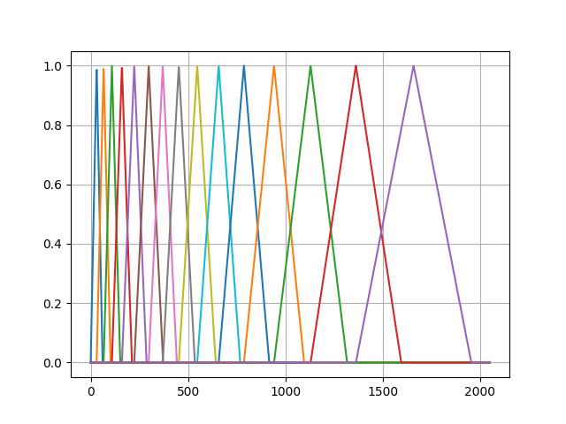

Figure 4.1.

ity. An example of a Mel Filterbank constructed by Bartlett filters is shown in

The amplitude of the filters is bounded to 1 to maintain NOLA compatibil-

overlapping each other with 50% overlap ratios.

while

narrower filters are assigned to lower frequency ranges and wider band filters

bandwidths are received by the transformation between Herz to Mels. Then

The center frequencies and the

scaling method is described in Chapter 3.

One way of mapping the audio spectrum is according to the Mel scale. This

**Mel FB**

**4.2.1.1**

for the higher band ranges.

*t*

*π*

*n*

1

2

*bt*

*α*

*π*

*ϕ*

*g*

*−*

*t*

*e*

cos

2

*f*

*t*

(4.1)

*c*

54

**4.2.1.3**

**Bark FB**

The Bark Filterbank is very similar to the Mel Filterbank except the fact it

follows the Bark scale instead of Mel Scale.

Different filter shapes are available but triangular filter shapes are the most

common as described in [7].

An example of the Bark Filterbank constructed by Bartlett filters is shown

in Figure 4.2.

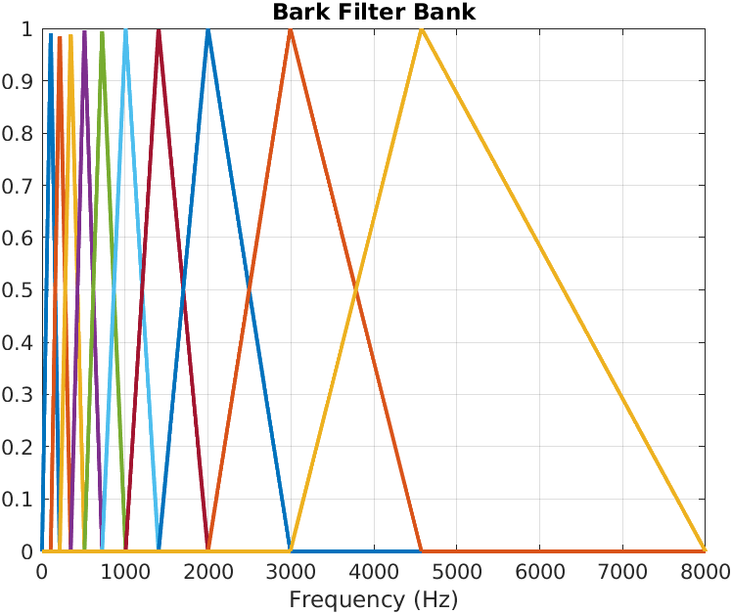

**Figure 4.2:** Bark FB

**4.2.1.2**

**Gammatone FB**

The Gammatone filter as described in [1] has a response function:

(

) =

+

(

)

*−*

**MFCCs — Mel-Frequency Cepstral Coefficients**

.

*c*

An example of a Gammatone Filterbank is shown in Figure 4.3.

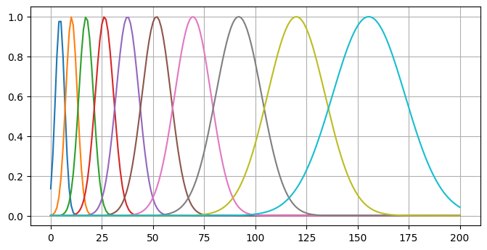

**Figure 4.3:** Gammatone FB

**4.3**

**Cepstral Features**

**4.3.1**

*f*

**4.3.1.1**

**Pre-emphasis**

Speech signals have a roll-off frequency resembling a low-pass behavior[5].

Due to that physical nature, higher frequencies decay faster than lower speech

frequencies.

To overcome that phenomena, a pre-emphasis filter applied to the incom-

ing speech signal compensates and boost the higher[2]

55

frequency,

Where

denotes the amplitude factor,

*n*

is the filter order,

*f*

is the center

*c*

*ϕ*

*α*

the phase factor, and

*b*

is the bandwidth that is set according to

(

)

*·*

the ERB scale mapping of 1.019

*ERB*

**4.3.1.3**

set to 6.25

*ms*

or 10

*ms*

that translate to 100 or 160 sampling points respectively.

Hopping length of 6.25

*ms*

gives a complete temporal context of 3 adjacent

frames by definition.

which equals to 400 sampling points, and the hopping length is

**Windowing**

In order to extract each frame only and to minimize the Gibbs effects as much

as possible a windowing function is applied.

As a result,

the information

confined in a given frame is extracted while the window response function

tapper the edges to reduce the effect that adjacent frames have.

56

The shifting in time between frames is referred as the hopping length and

**Framing**

Speech signals are varying in time, and nevertheless the variation over time is

relatively slow, it is non-pure stationary process but a quasi-stationary. Quasi-

stationary process analysis should be taken on small portions of the signal to

be less affected by randomness effects.

Therefore, a framing preliminary action is applied to speech signal in time

domain. Framing means, dividing the signal to small fragments (frames) with

some overlapping in between. Each time frame is assumed to be stationary,

and thus a measurement can be taken.

**4.3.1.2**

is set to contain sufficient amount of temporal context that characterizes the

natural characteristics of speech.

A very common sampling frequency of audio signals is 16

*KHz*

. As a result

and to work with round number of sampling points, the frame lengths are

set to 25

*ms*

[

*n*

*g*

*n*

*x*

*f*

*X*

*f n*

*j*2

*−*

∑

*π*

*−*

]

*mR*

]

[

) =

(

∞

The DFT is given by:

bins per time frame thus the STFT is a function of *f* , *t*.

The outcome of the STFT is called spectrogram, containing multiple frequency

framing and the DFT is referred as the Short-Time Fourier Transform (STFT).

ing the Discrete Fourier Transform (DFT). The composition of both windowed

Each one of the windowed frames is converted to frequency domain by apply-

**DFT spectrum**

**4.3.1.4**

denotes the DFT transformation of a given time frame win-

57

hopping size.

represents the

*R*

and

*M*

denotes the window function of size

*g*

dows signal,

*◦*

]

[

*m*

1

*f*

*X*

Where

)

(

*n*

∞

*−*

=

*m*

(4.4)

*e*

*≤*

*−*

(4.2)

1

*M*

*n*

0

0.46 cos

0.54

*n*

*W*

*−*

*≤*

*Hamming*

*−*

] =

[

*n*

2

*π*

)︃

(︃

respectively.

The Hamming and Hann windows are given by Eqautions 4.2 and 4.3

signals.

plicity, bandwidth and specral leakage that make them quite good for speech

function due to their relative decent tradeoff between edges tappering, sim-

*−*

*M*

*Hann*

*−*

(4.3)

1

*M*

*n*

0

0.5 cos

0.5

*n*

*W*

Usually a Hamming window or Hann window are selected as the window

*≤*

*≤*

*−*

] =

[

*n*

2

*π*

)︃

(︃

1

*M*

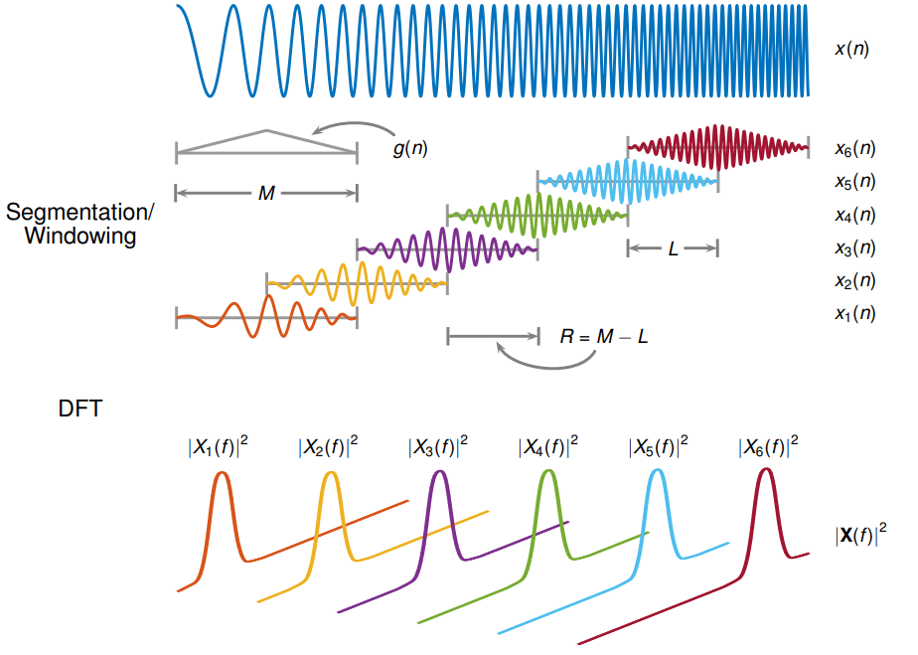

**Figure 4.4:** STFT demonstration diagram

**Source:** Adapted from Matlab’s STFT documentation

**4.3.1.5**

**Mel-spectrum**

Once the spectrogram is received, the frequencies are rescaled in accordance

to the Mel Scale. A comprehensive description about the Mel Scale is detailed

in Chapter 3.

Next, the cepstral coefficients are extracted from each bin, by taking the

58

suggested in [6] and [8]. The motivation of evaluating this proposed technique

*K*

*K*

=

*k*

1

**4.3.2**

**RFCCs — Root Cepstral Coefficients**

An alternative to the log-Mel extraction of the cepstral coefiicients has been

is the idea that root function can be less computationally demanding compared

to the traditional log function.

√︃

{︂

(︂

)︂}︂

*K*

*n*

(

+

)

(

)

∑

*·*

*MFCC*

*π*

log

*e*

*k*

cos

*k*

0.5

(4.6)

=

cos

*k*

0.5

(4.7)

*N*

*K*

*k*

*k*

1

**4.3.3**

**GFCCs — Gammatone-Frequency Cepstral Coefficients**

GFCCs follows the basic steps same as to the MFCCs extraction. But, instead

of translating the frequencies to Mels, the spectrum is translated to the ERB

scale. ERB scale implies a Gammatone Filterbank as described in Section **??**.

59

+

2

*n*

*γ*

[

] =

[

]

(

]

)

(

)

∑

*·*

*RCC*

*n*

*e*

√︃

*k*

*DCT*

*k*

*K*

=

*k*

1

*e*

{︂

(︂

)︂}︂

*K*

*π*

2

*n*

]

form (DCT).

√︃

*K*

2

[

] =

[

=

(

)

∑

*·*

*{*

*}*

*MFCC*

*n*

)︂}︂

=

*k*

1

It is very common to extract the log-Mel energies and then having Equa-

tion 4.5 written as:

√︃

{︂

(︂

*K*

*K*

*π*

2

*n*

[

] =

[

*k*

[

]

(

+

)

∑

*·*

*e*

sum energies of each filter and multiplying it with the Discrete Cosine Trans-

cos

*k*

0.5

(4.5)

*K*

*T*

[

+

]

∑

*k*

*c*

*n*

*i*

*m*

*i*

=

*−*

[

] =

*i*

*T*

∆

*n*

(4.8)

*T*

*|*

*|*

∑

*i*

=

*−*

*i*

*T*

60

the coefficients are to be extracted dynamically for the

**BFCCs — Bark-Frequency Cepstral Coefficients**

Like the Gammatone-FCCs (GFCCs) the BFCCs follow the Bark Scale.

**4.4**

**Time-Domain Features**

**4.4.1**

**Dynamic FCC features**

During the framing process, the speech signal is divided to small fragments

of the speech over time called frames.

Each frame spans over a finite time

duration.

The extracted cepstral coefficients are statically computed for a

given frame, however the original speech is framed to multiple number of

frames.

Therefore,

**4.3.4**

entire signal, i.e. all the frames.

An additional information about the temporal changes between adjacent

coefficients are also can be computed to include the dynamics and transitions

within a frame.

**4.4.1.1**

**Deltas**

∆

First derivate of the cepstral coefficients referred as

(Deltas) represents the

velocity of the mfcc dynamics and are a sub-set of the dynamics cepstral

coefficients.

∆

Deltas (

) are extracted by:

on a memory effect. Furthermore, different languages introduce contextual

]

∆

Equation 4.8 with the first-order derivatives

*n*

.

**4.4.2**

**Temporal Context**

Temporal context is an attachment of raw features from adjacent frames with

the current selected feature. Whether it is a spectral feature, cepstral or spa-

tial, the concatenation of past and future features can infer decisions based

[

constraints such as relative positions of adjectives or nouns to verbs, plurals,

affiliations, possessions, and so on.

Usually, the number of adjacent past and future frames to concatenate is

based on the framing and DFT parameters. One would not want to exaggerate

and excessively use redundant frames that do not have any significant impact

on the accuracy of detection. The downsides of overly using temporal context

frames, are obvious, multiple orders of magnitude larger information amounts

to process.

61

**Delta-Deltas**

*n*

denotes the frame time index,

*k*

marks the coefficient weight,

*T*

stands for the number of temporal adjacent frames used for the calculation,

and *c*

denotes the *m*th coefficient in the given frame *n*.

*m*

**4.4.1.2**

Where

∆∆

Delta-Deltas (

) is an extra layer of information that represents the accelera-

tion at which the dynamics changes within a given time frame. The extraction

of the Delta-Deltas follows the same principal as the first derivatives but in-

stead of taking the cepstral coefficients as the input feature, we replace

*c*

in

*m*

pp.

“Analysis of the root-cepstrum for

Ruhi Sarikaya and John Hansen.

[6]

(cit. on p. 55).

237532

DOI

:

1215–1247.

acoustic modeling and fast decoding in speech recognition.” In: 2001,

*the IEEE* 81.9 (1993),

*Proceedings of*

10 . 1109 / 5 .

J.W. Picone. “Signal modeling techniques in speech recognition”. In:

[5]

DOI

(cit. on p. 50).

:

*the Acoustical*

62

DOI

(cit. on p. 54).

:

pp. 97–100.

10.1121/1.399849

*America* 88.1 (1990),

*Society of*

172.

*of*

*The Journal*

In:

scale”.

Hartmut Traunmuller. “Analytical expressions for the tonotopic sensory

[7]

pp. 687–690 (cit. on p. 59).

(cit. on p. 54).

(cit. on p. 55).

:

pp. 160–164.

10.1109/INFOP.2015.7489370

In: *2015 International Conference on Information Processing (ICIP)*. 2015,

namic features with MFCC for text-independent speaker identification”.

Amol Chaudhari, Amol Rahulkar, and S. B. Dhonde. “Combining dy-

[2]

DOI

10.1007/BF00337015

DOI

:

natural stimuli”. In: *Biological Cybernetics* 38 (1980), pp. 223–234.

of auditory neurons in the grassfrog - I. Characterization of tonal and

Ad Aertsen and P.I.M. Johannesma. “Spectro-temporal receptive fields

[1]

15481603.2017.1408892

10.1109/INTECH.2016.7845025

*Conference on Innovative Computing Technology (INTECH)*. 2016, pp. 168–

*2016 Sixth International*

In:

hybrid based feature selection method”.

Shibli Nisar and Muhammad Tariq. “Intelligent feature selection using

[4]

(cit. on p. 50).

**References**

DOI

:

sensing object-based urban application”. In: vol. 55. 2017.

10.1080/

formance through feature selection in a very-high-resolution remote

Stefanos Georganos et al. “Less is more: optimizing classification per-

[3]

[8]

V. Tyagi and C. Wellekens. “On desensitizing the Mel-cepstrum to spuri-

ous spectral components for robust speech recognition”. In: *Proceedings.*

*(ICASSP ’05). IEEE International Conference on Acoustics, Speech, and Signal*

10.1109/ICASSP.

*Processing, 2005.* Vol. 1. 2005, I/529–I/532 Vol. 1.

:

DOI

2005.1415167

(cit. on p. 59).

63

reduction, speech corrections and more. With ASR systems, these abilities are

64

speech signal in time-frequency composition, where each T-F unit contains

is required for an accurate analysis. T-F representation means, presenting the

considered to be stationary as described in chapter 4, a special representation

Since speech signals are varying with time, they are not

ing (T-F Masking).

A common algorithm in CASA applications is the Time-Frequency Mask-

detection rates.

expressed in improved performance of precisely detecting words with higher

**Chapter 5**

among others the ability to apply speech enhancements, noise cancelation or

advantages of precisely distinction between speech and interference include

tinguish in one way or another between desired speech and interferences. The

Speech Separation (BSS)[3], makes use of various algorithms in order to dis-

such as the Computational Auditory Scene Analysis (CASA)[1] and Blind

Speech separation, in similarity to other common enhancement applications,

**Introduction**

**5.1**

**Time-Frequency Masking**

the spectral element at a certain time window bin. As described in chapter 4,

the T-F presentation of a signal is achieved by using the STFT or auditory

filtering[5].

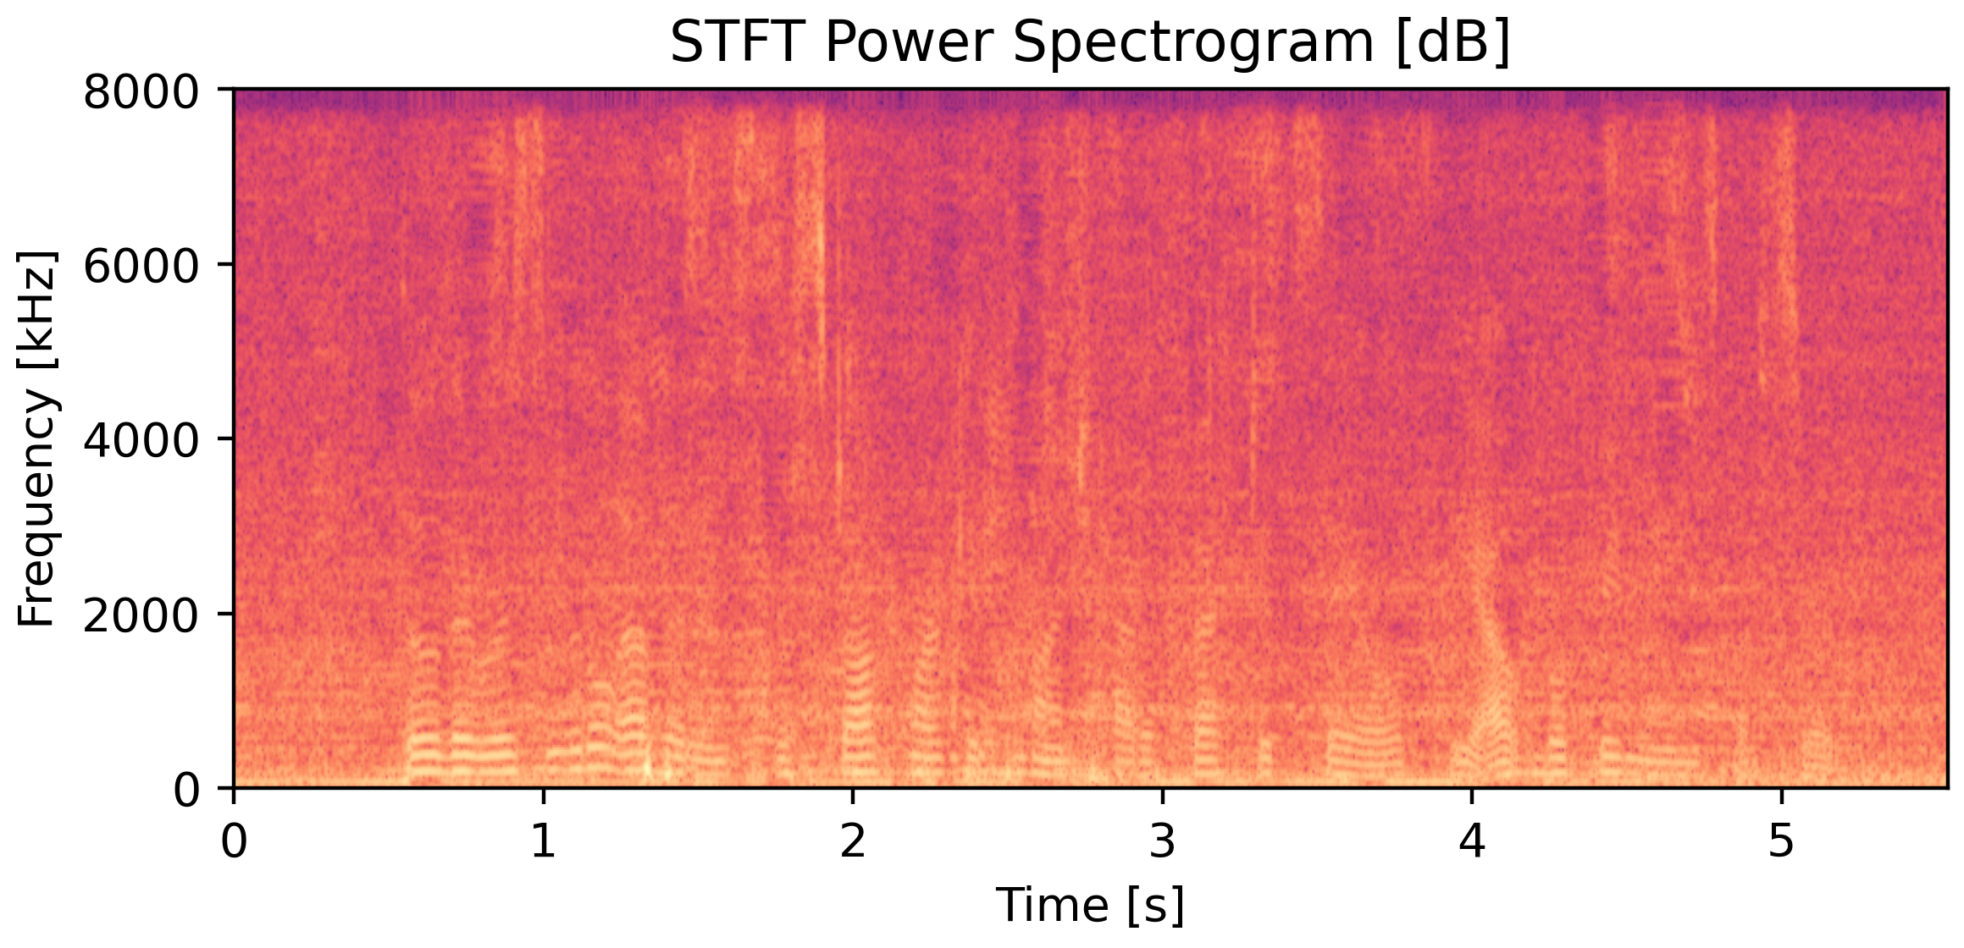

**Figure 5.1:** Noisy mixture spectrogram

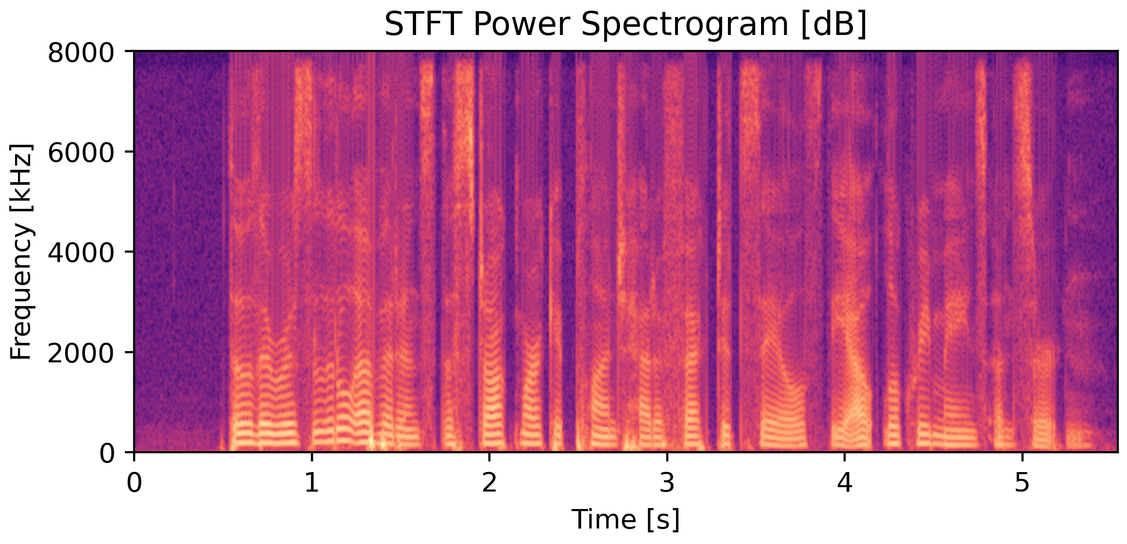

**Figure 5.2:** Reference clean speech spectrogram

Examination of the T-F units provides a possibility to classify an entire

65

**M**

*>*

*ω*

*ω*

*ϵ*

2

2

1,

*i f*

**S**

*t*, *j*

**N**

*t*, *j*

(

) =

*ω*

*|*

*j*

, *t*

(5.1)

*s*

0,

*otherwise*

*ϵ*

Where

marks a changeable threshold value for the speech activity detection

over the noise.

Equation 5.1 indicates that as a result of applying the IBM masks,

the

speech, and interference separated sources become complementary, in such a

66

operation.

(mainly noise). Based on this classification, appropriate weights are associated

to each segment bin. In that way, a speech elements can be extracted by the

separation of the classified speech out of the mixture,

or alternatively,

the

attenuation of non speech elements in certain activity areas along the audio

signal.

In general,

the association of weights for classification to different

elements in a signal is called T-F masking. This process of T-F masking takes a

major role in CASA, BSS applications and in recent years, they proved to be

very useful in E2E-ASR systems.

An additional use of T-F masking is to tie it as input to a beamformer that

in turn filters interferences based on the classification received by the masking

unit or parts of a unit as a speech centric bin or on the contrary as interference

**5.2**

**IBM — Ideal Binary Mask**

Assuming that a voice activity detection algorithm can separate speech from

noise effectively, the IBM technique is based on power differences. Whenever

the power spectral density (PSD) of the speech is higher than any of the

interferences PSD, the speech is binary masked to “1”.

{︄

(

)

(

)

*|*

*|*

*− |*

**N**

*n*

*|*

*|*

*|*

*|*

*ω*

*ω*

2

2

**S**

*t*, *j*

)

*t*, *j*

*β*

Where

is a tunable parameter that controls the strength of the mask

estimations.

A value of 0.5 is used for a fair trade off between speech and

noise mask estimations.

√︄

(︃

)︃

(

*t*, *j*

*t*, *j*

(︃

)︃

*β*

(

)

*|*

*|*

*ω*

2

**N**

)

(

) =

*ω*

(5.4)

**M**

*j*

, *t*

(

)

+

(

*≈*

*ω*

*ω*

2

2

**S**

*t*, *j*

**N**

*t*, *j*

(

)

*|*

*−*

*ω*

**M**

*j*

, *t*

1

**M**

(5.6)

*n*

*s*

67

*j*

*|*

*|*

*ω*

2

**S**

*t*, *j*

(

) =

*ω*

**M**

**N**

, *t*

(5.5)

(

)

+

(

)

*s*

*|*

*|*

*|*

[

ˆ

*x*

,

*i f*

**M**

0

*n*

*s*

**5.3**

**IRM — Ideal Ratio Mask**

Unlike the IBM where hard decisions are taken in the terms of boolean values,

“true” or “false” marking speech or noise elements, the Ideal Ratio Mask (IRM)

=

]

provides a soft decision mechanism with values in the range of

0, 1

[2]. The

(

)

(

)

*ω*

*ω*

IRM of the clean reference speech and noise,

*x*

=

*−*

**M**

1

**M**

*n*

*s*

and thus:

{︄

=

ˆ

**M**

,

*i f*

**M**

1

(

) =

*s*

*s*

*y*

*t*

(5.2)

*s*

) =

*ω*

**M**

*j*

, *t*

(5.3)

(

)

+

(

)

(

*|*

*|*

*|*

*|*

*ω*

*ω*

2

2

**S**

*t*, *j*

unit are given in Equations 5.3, 5.4 respectively.

*j*

,

*t*

,

**M**

*j*

,

*t*

for each T-F

*s*

*n*

way that

(︃

)︃

*β*

(

)

*|*

*|*

*ω*

2

**S**

*t*, *j*

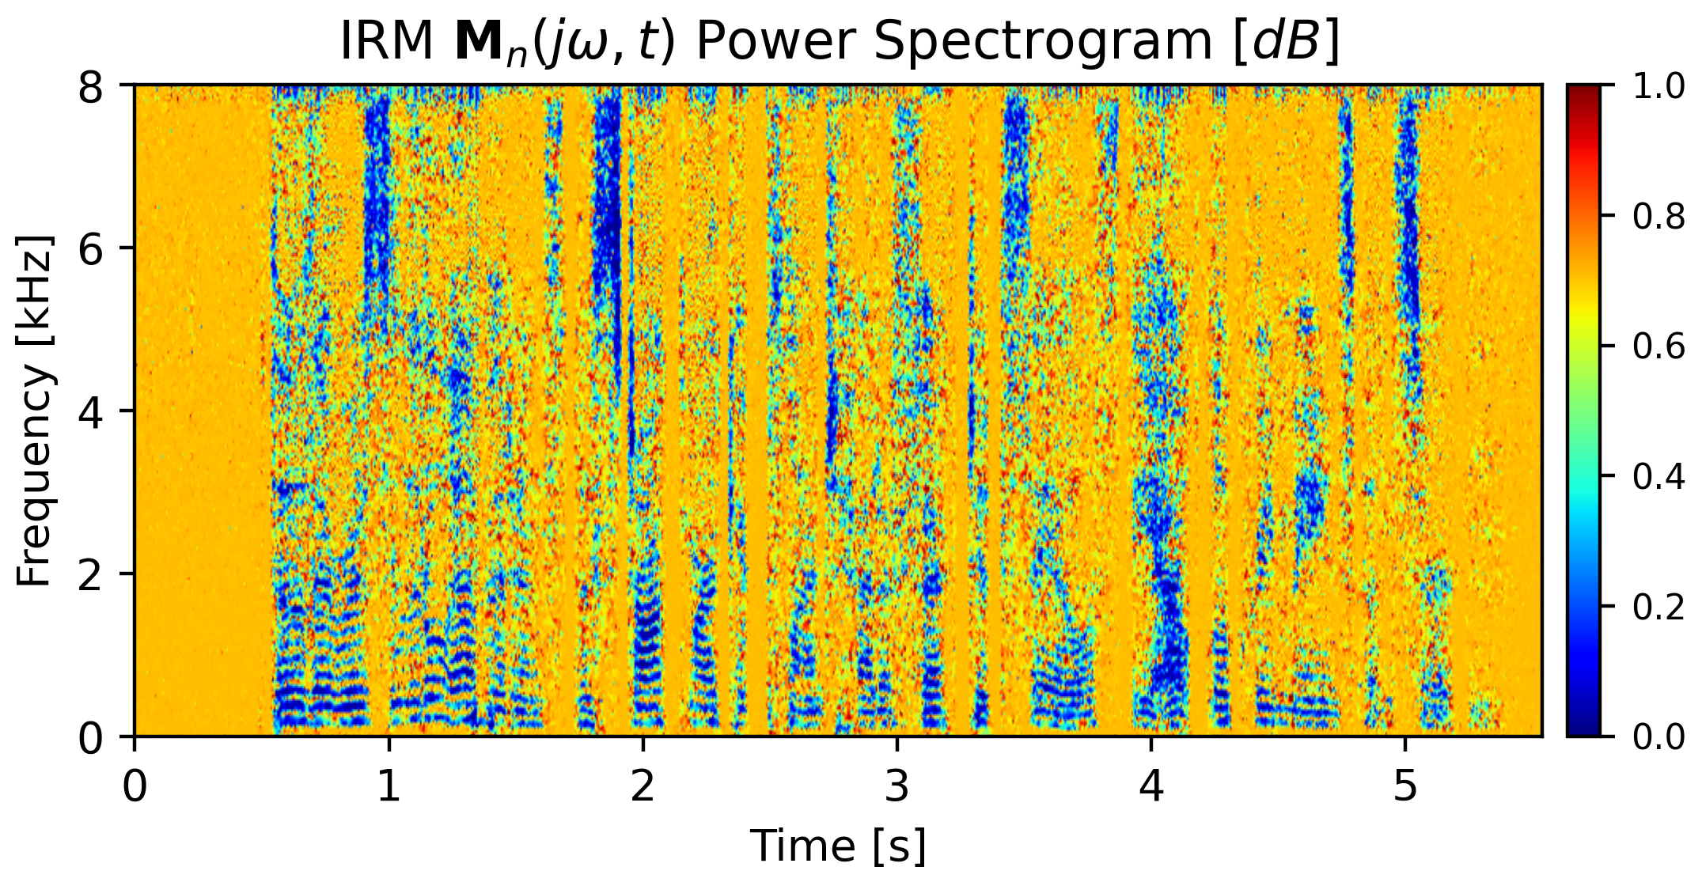

68

*n*

, *t*

*j*

**Figure 5.4:** IRM Noise Mask **M**

*ω*

)

(

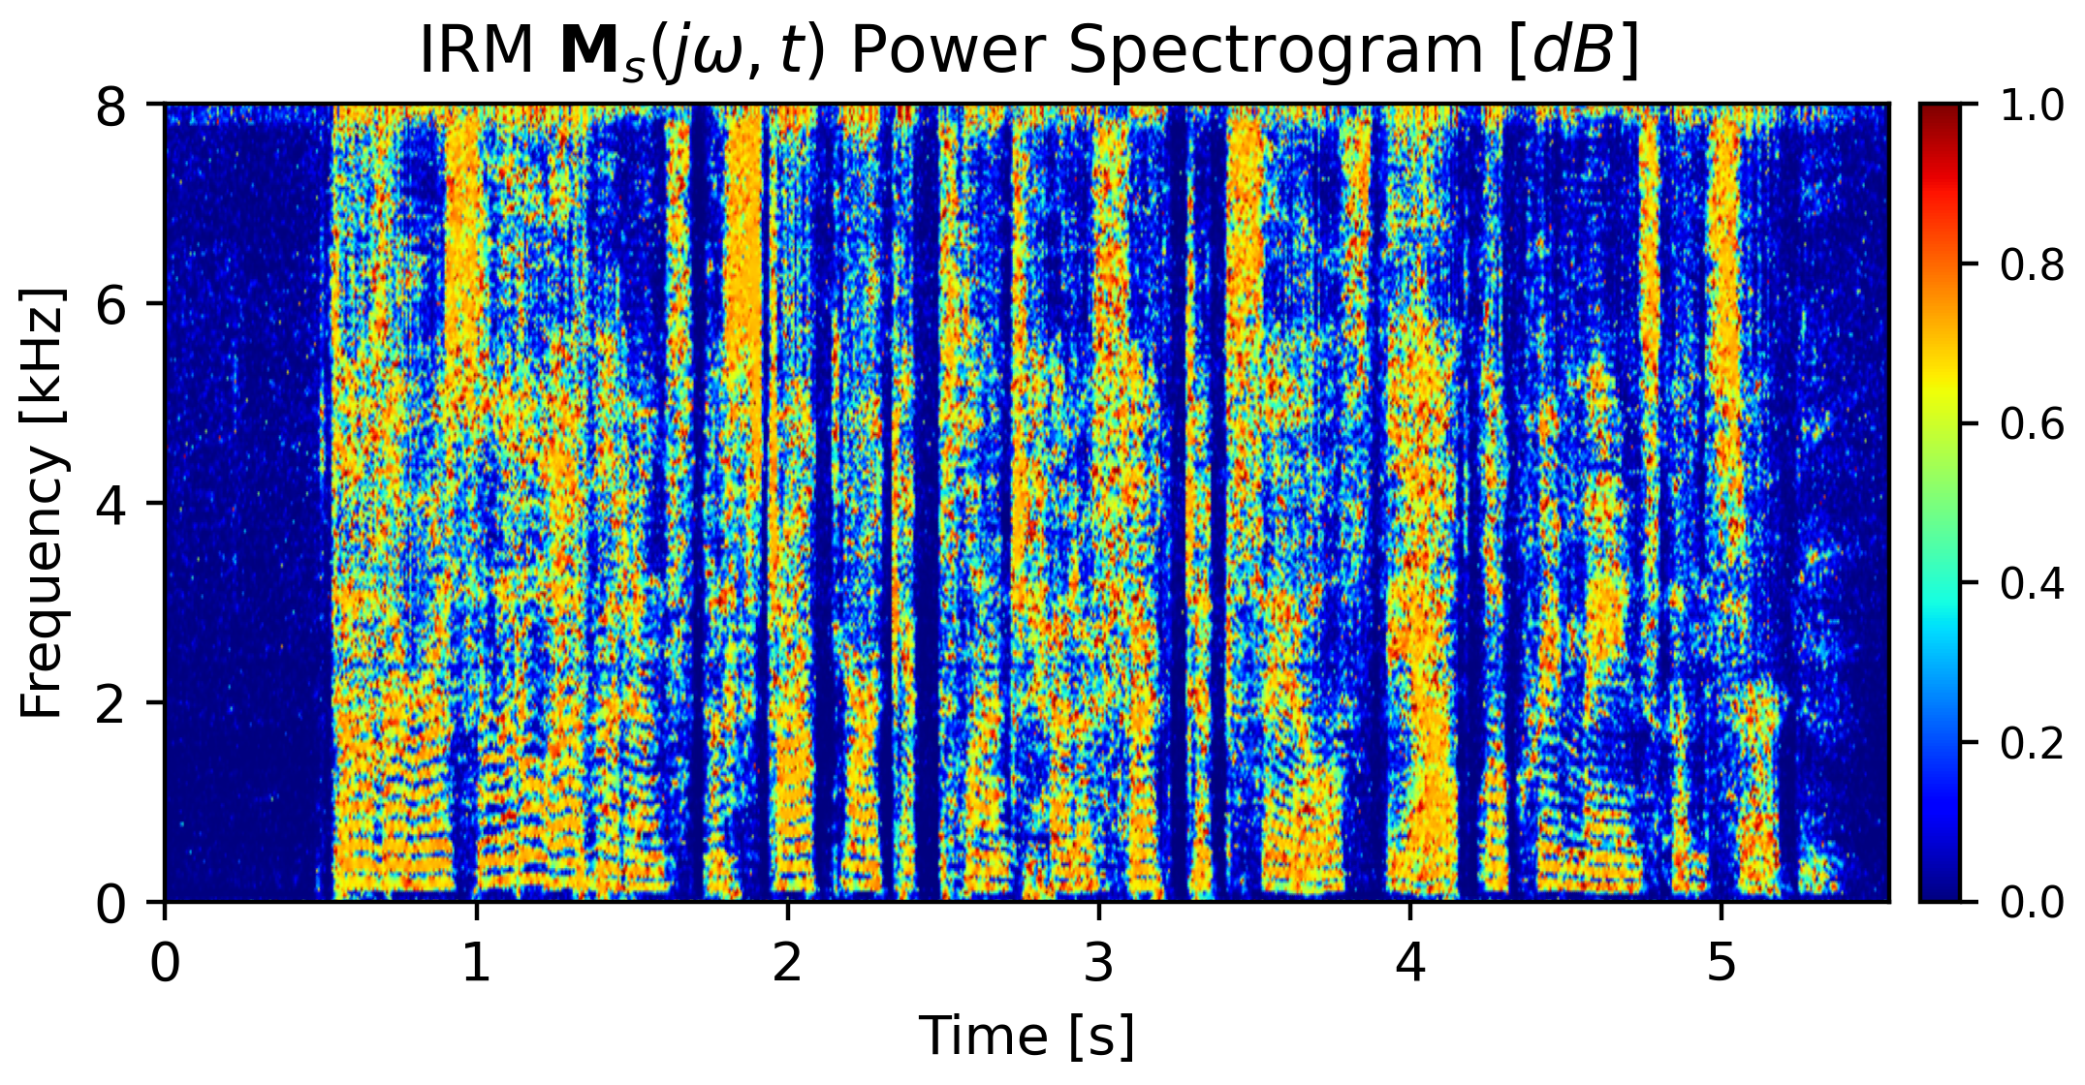

*s*

, *t*

*j*

**Figure 5.3:** IRM Speech Mask **M**

*ω*

)

(

**5.3.1**

**M**

,

*t*

,

*j*

**M**

The IRM masks,

*ω*

*ω*

)

(

)

(

**Masks Estimations**

*j*

1

*t*

=

*jw*,*t*

)

(

*s*

**M**

∑

1

*t*

=

*T*

*jw*,*t*

*ms*

69

functions in between.

then followed by number of fully-connected (FC) with the ReLU activation

from both sides to the current processed T-F unit feature map. The BLSTM is

as well. In that way, three additional adjacent feature maps are concatenated

first block in the network in order to take into account the temporal context

A BLSTM (Bidirectional Long Short-Term Memory) layer is placed as the

settings are 400 samples per frame with total of 300 samples overlap.

, the framing

*KHz*

. With a sampling frequency of 16

*ms*

hopping length of 6.25

long frames with a

*jw*,*t*

Each input signal is framed to 25

microphone-array.

the desired IRM masks. The network’s input features are the MFCCs of the

seen in Figure 5.5 is proposed for the classification of the input features to

A simple neural network of six to eight fully-connected (FC) layers as

output layer, thus ensuring the output indeed relies on in this range.

in that range, it is easier to make use of a Sigmoid activation function as the

Since both the speech and noise masks are bounded

in the range of [0, 1].

*n*

*s*

given in Equations 5.3, 5.4 are bounded

*t*

,

*n*

∑

1

*t*

=

*T*

*jw*,*t*

*jw*,*t*

)

(

)

(

*NN*

*x*

**M**

(5.7)

**R**

**M**

*j*

**R**

*ω*

2

*|*

*|*

∑

) =

(

1

*T*

2

)

(

)

(

*SS*

*x*

*s*

(5.8)

**R**

**M**

*j*

**R**

*ω*

Thus, the covariance matrices are extracted by:

*|*

*|*

∑

) =

(

1

*T*

1

*t*

=

*jw*,*t*

)

(

*n*

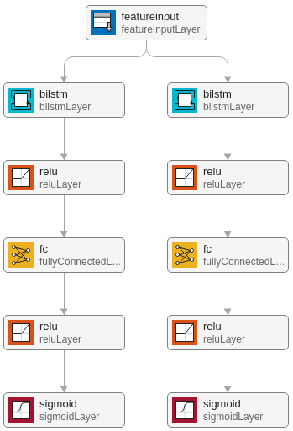

**Figure 5.5:** IRM estimation DNN blocks diagram

70

*j*

,*t*

*j*

*ω*

*ω*

*ω*

*ω*

,*t*

*j*

,*t*

*j*

*ω*

*ω*

**M**

**M**

1

**M**

**M**

**M**

,

(5.9)

71

ure 5.6.

The proposed IRM estimation network blocks diagram is shown in Fig-

is set to 0.5.

between the masks,

*β*

For a fair and evenly considering

is used as a weighing factor.

Where

*β*

**M**

,*t*

*j*

*ω*

2*N*

,*t*

*j*

,*t*

*j*

,*t*

(︂

2

)

(

)

(

)

(

)

(

)︂

2

)︂

(︂

]︃

[︃

defined as:

To that end the cost function is

minimization process of the error term.

thus the cost function should consider the two masks in the

the network,

∑

*β*

*β*

*−*

*−*

*−*

*ℓ*

*n*

*n*

*s*

*s*

Estimations of both the speech and noise are done at the same time by

ˆ︂

ˆ︂

ˆ︂

)

(

+

) =

(

1

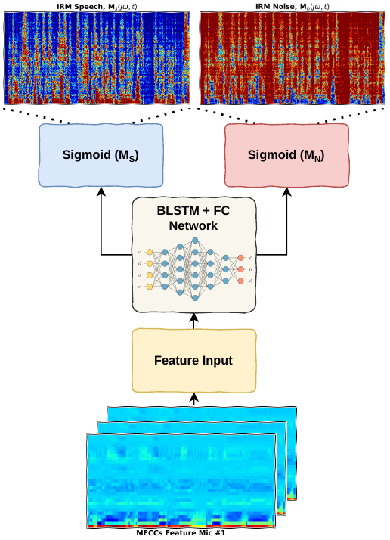

**Figure 5.6:** Proposed DNN for IRM T-F masking estimations

72

*n*

*ω*

*j*

,*t*

*j*

,*t*

(

)

(

)

ˆ︂

*n*

*ω*

**M**

, **M**

.

*ω*

*ω*

*j*

,*t*

*j*

,*t*

73

)

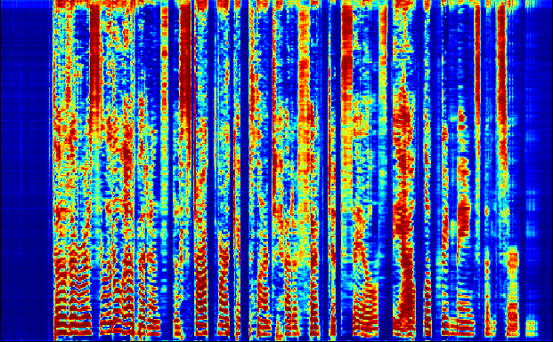

**(a)**

**(b)**

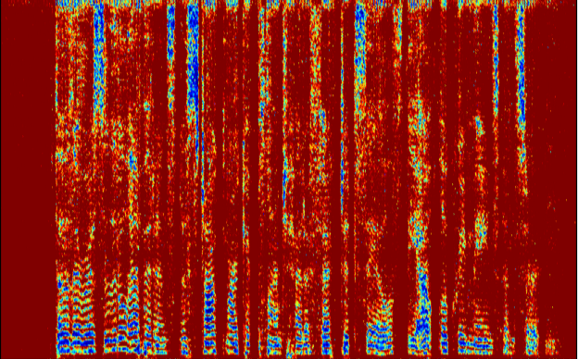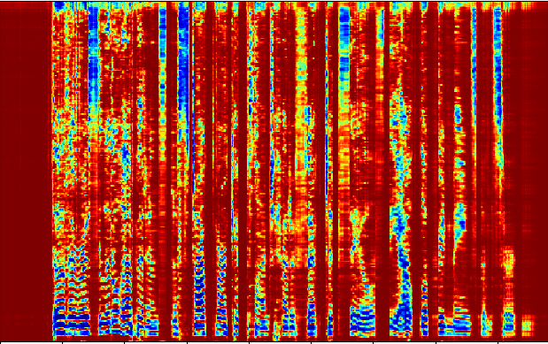

**(c)**

**(d)**

**Figure 5.7:**

(a) and (b) are the “IRM” reference vs.

estimation masks of the speech.

(

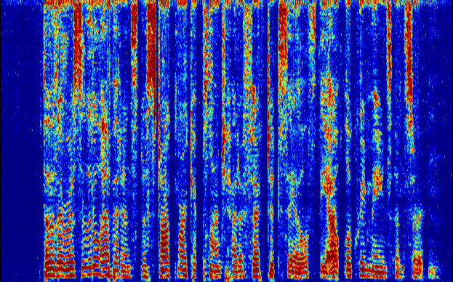

(

)

ˆ︂

*s*

*s*

**M**

,

**M**

;

(c) and (d) are the “IRM” reference vs. estimation masks of the noise

*dB*

*|*

*SNR*

*SNR*

5.1725

*dB*

*noisy*

*enh*

[

]

Likewise the improvement in Segmental-SNR is 9.2675

*| − |*

. It is important to

note that the enhanced beamformed signal is not perfectly aligned. The worst

[

]

*−*

case delay of

0.0014

*s*

, which equals to approximately 22 samples, has been

74

reference speech and the noisy mixture.

**Measurements**

**5.3.2.1**

**SNR**

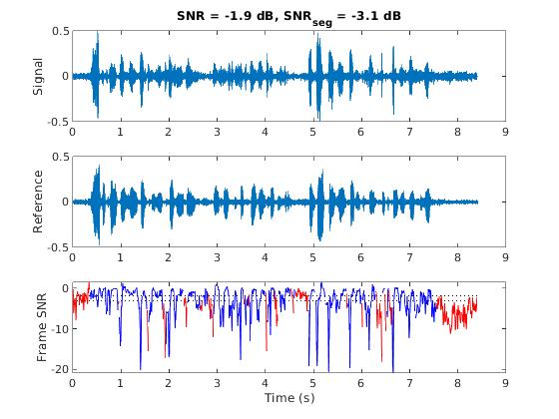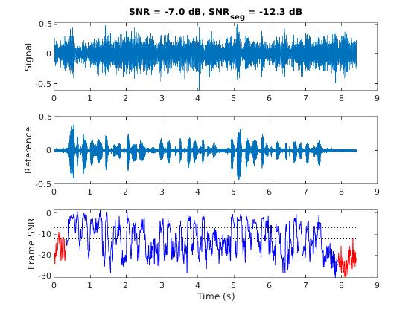

**(a)**

**(b)**

**Figure 5.8:** (a) “IRM” enhanced SNR & Segmental-SNR degradation with respect to

the clean reference speech;

(b) The SNR & Segmental-SNR ratios between the clean

**5.3.2**

Figure 5.8 shows two measurements of the SNR & Segmental-SNR metrics

for two subject signal, an “IRM” enhanced beamformed version of the noisy

mixture and the noisy mixture itself with respect to the clean reference speech.

The overall improvements in SNR and Segmental-SNR are the ratios between

the enhanced beamformed signal and the noisy mixture. Thus, from Figure 5.8

the total improvement in SNR is:

=

[

]

*|*

measured. A fully aligned comparison is assumed to be more accurate, but

since the frame length are much larger (400 samples) than the typical delay the

impact of misalignment is less acute. The Segmental-SNR calculation involves

a VAD (voice activity detection) algorithm of dropping segments where the

detected speech activity is negligible. These dropped segments are red colored

in Figure 5.8.

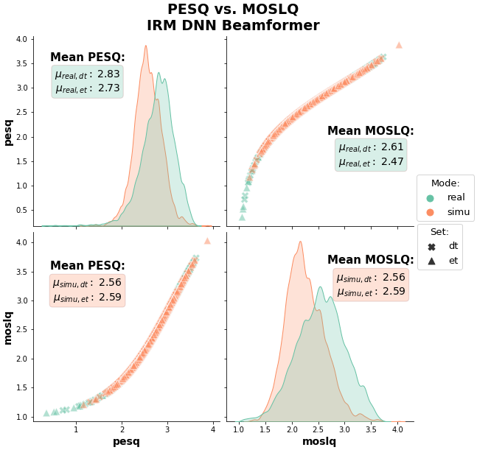

**Figure 5.9:** IRM beamformer PESQ vs. MOSLQ

75

in terms of performance.

76

With the “SI-SNR”, the measurements are taken regardless

measurements.

for those metrics are more sparsely distributed compared to the “real” subset

to match the booth recorded speech for the “simulation” subset, the results

compared to the noisy mixture, and since the background noises are truncated

Because the SNR and Segmental-SNR are measured as the improvement

booth) and an artificial mixture of the recorded background noises.

is composed of a recording taken in a relatively clean environment (recording

artificial room impulse response. On the other hand, the “simulation” subset

the ambient noise absorbed is characterized by a real scenario and a non-

the “real” subset are dropped prior taking the measurements. Nevertheless,

It is important to note that faulty microphones in

In Figure 5.9 presented the “PESQ” and “MOSLQ” metrics for the IRM

metrics is shown in Figure 5.10. The “simulation” subset yields better results

Another pair-plot for the SNR, “Segmental-SNR”, “SI-SNR” and “STOI”

metric is based on the “PESQ” measurement.

plot, and this behavior is understandable and desirable since the “MOSLQ”

A strong correlation between the “PESQ” and “MOSLQ” is seen in the

datasets are provided in Chapter 8.

tion subset and “dt” marks the development subset. More details about the

simulation datasets from the “CHiME4” dataset. “et” stands for the evalua-

values for both the “PESQ” and “MOSLQ” under the test cases of the real and

of the measured values is shown. On top of the plots also shown are the mean

tions between each pair of metrics are plotted. On the diagonal the distribution

beamformer. The results are shown in a pair-plot diagram, where the correla-

of the noisy mixture, thus the “simulation” results are far better and more

spatially dense in contrast to the “real” subset “SI-SNR” results differs by that

the clean speech is not the same for each scenario recording.

Likewise, in the same manner, the “STOI” is measured regardless of the

noisy mixture, but relatively to the clean speech. Therefore, the distribution of

the “simulation” subset are narrower with lower variance.

The results are summarized in Table **??**, side by side with the ideal masks

and the improvement ratios.

77

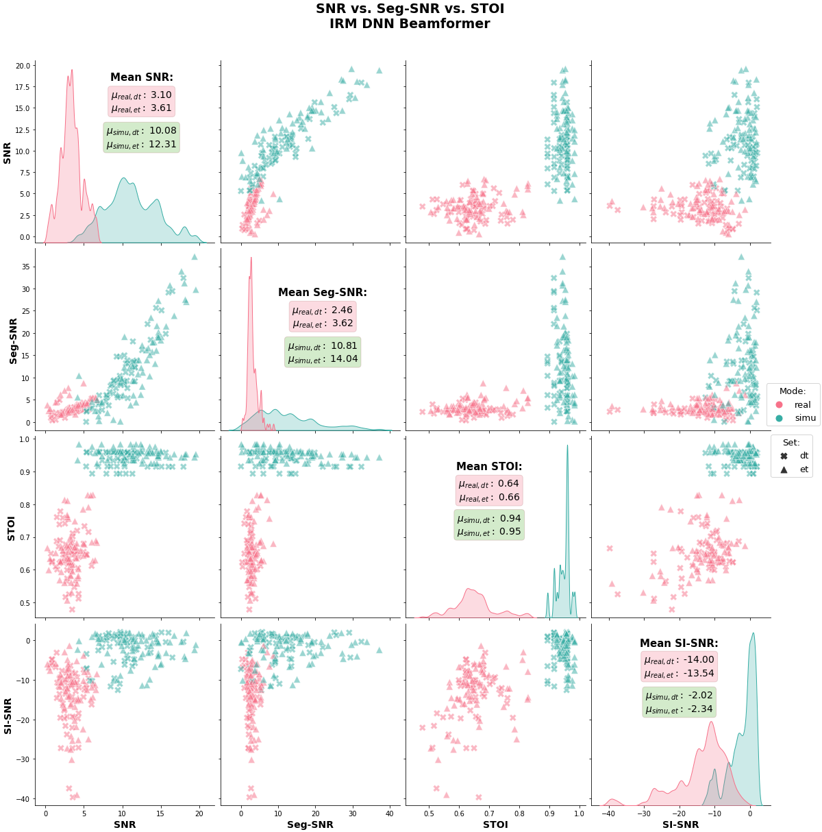

**Figure 5.10:** IRM beamformer SNR vs. Segmental-SNR vs. STOI vs. SI-SNR

In order to evaluate the generalization of the prediction model, the DNN

estimations are compared to the ideal mask enhancement.

In Figure 5.11,

shown is the measurements of the SNR and “Segmental-SNR” for an ideal

IRM mask. SNR measurement.

78

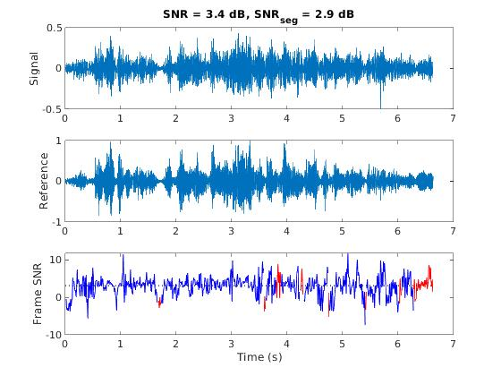

**Figure 5.11:** Ideal IRM beamformer enhancement SNR & Segmental-SNR.

**5.4**

**cIRM — Complex Ideal Ratio Mask**

Both IBM and IRM make use of the noise and speech magnitudes only while

neglecting the phase completely.

The outcome of the STFT operation is a

complex pair representation of each T-F unit.

Recent studies showed the

importance of the phase element in speech seperation[4, 5].

In that manner, further expanding the IRM mask to include the imaginary

part as well, gives the cIRM. Thus, instead of having a magnitude based only

mask matrix, a complex pair of masking matrices are given that make use of

the phase element too.

79

=

**Y**

{︄

}︄

(

)

*{*

*}*

T

*ω*

**Y**

*j*

, *t*

M

*−*

1

M

***θ***

tan

(5.15)

(

)

*{*

*}*

R

2

√︂

=

+

*|*

*|*

*{*

*}*

*{*

*}*

R

T

*ω*

2

**A**

**Y**

**Y**

(5.14)

*ω*

*ω*

*j*

,*t*

*j*

,*t*

C

*i*

**Y**

*r*

*i*

*−*

**Y**

**S**

**Y**

**S**

=

*r*

*r*

*i*

**Y**

**M**

(5.17)

+

*i*

2

2

**Y**

**S**

*r*

*i*

80

=

**Y**

**Y**

*j*

, *t*

C

Rearranging the equations above, the cIRM mask real and imaginary parts

can be written as:

+

**Y**

**S**

**Y**

**S**

done by the following set of Equations5.14,5.15:

*r*

*r*

*i*

*i*

**M**

(5.16)

+

*r*

2

2

cos

=

(

) +

(

)

*|*

*|*

*|*

*|*

***θ***

***θ***

**A**

,*t*

*j*

**A**

sin

(5.10)

**Y**

**Y**

**Y**

**Y**

=

+

**Y**

*j***Y**

*ST F T {*

)

The mixture

*y*

*t*

after being processed by the STFT operation can be de-

scribed as a complex sum whether in polar coordinates as seen in Equation5.10

or in the general form as in Equation5.11.

(

) =

(

)

=

(5.11)

*}*

*ω*

**Y**

*j*

, *t*

*y*

*t*

:

**Y**

*ω*

*j*

:

**Y**

=

=

(

)

*{*

*}*

*|*

*|*

T

***θ***

**Y**

**Y**

**Y**

**A**

sin

(5.13)

*ω*

*i*

*j*

,*t*

M

**Y**

**Y**

Extraction of the magnitude and phase out of the complex representation is

***θ***

*r*

*i*

The real and imaginary parts can be summarized as:

=

=

(

)

*{*

*}*

*|*

*|*

R

(

**Y**

:

**Y**

**A**

cos

(5.12)

*ω*

*r*

*j*

,*t*

C

2

*j*

(5.19)

+

+

2

2

2

*i*

**Y**

**Y**

**Y**

**N**

*r*

*r*

*i*

*i*

Therefore, applying a cIRM T-F masking requires a complex multiplication

=

*−*

**Y**

**N**

**Y**

**N**

**Y**

**N**

**Y**

**N**

for separation in opposed to the more basic IBM and IRM where magnitudes

+

*r*

*r*

*r*

*r*

*i*

*i*

*i*

(c) and (d) are the cIRM real and imaginary references of the noise

(

)

(

)

*s*

*n*

*n*

**M**

;

)

**M**

,

**M**

.

*r*

*i*

*i*

81

**(d)**

multiplications are taken in the real domain only.

The reference compressed cIRM masks are shown in Figure 5.12;

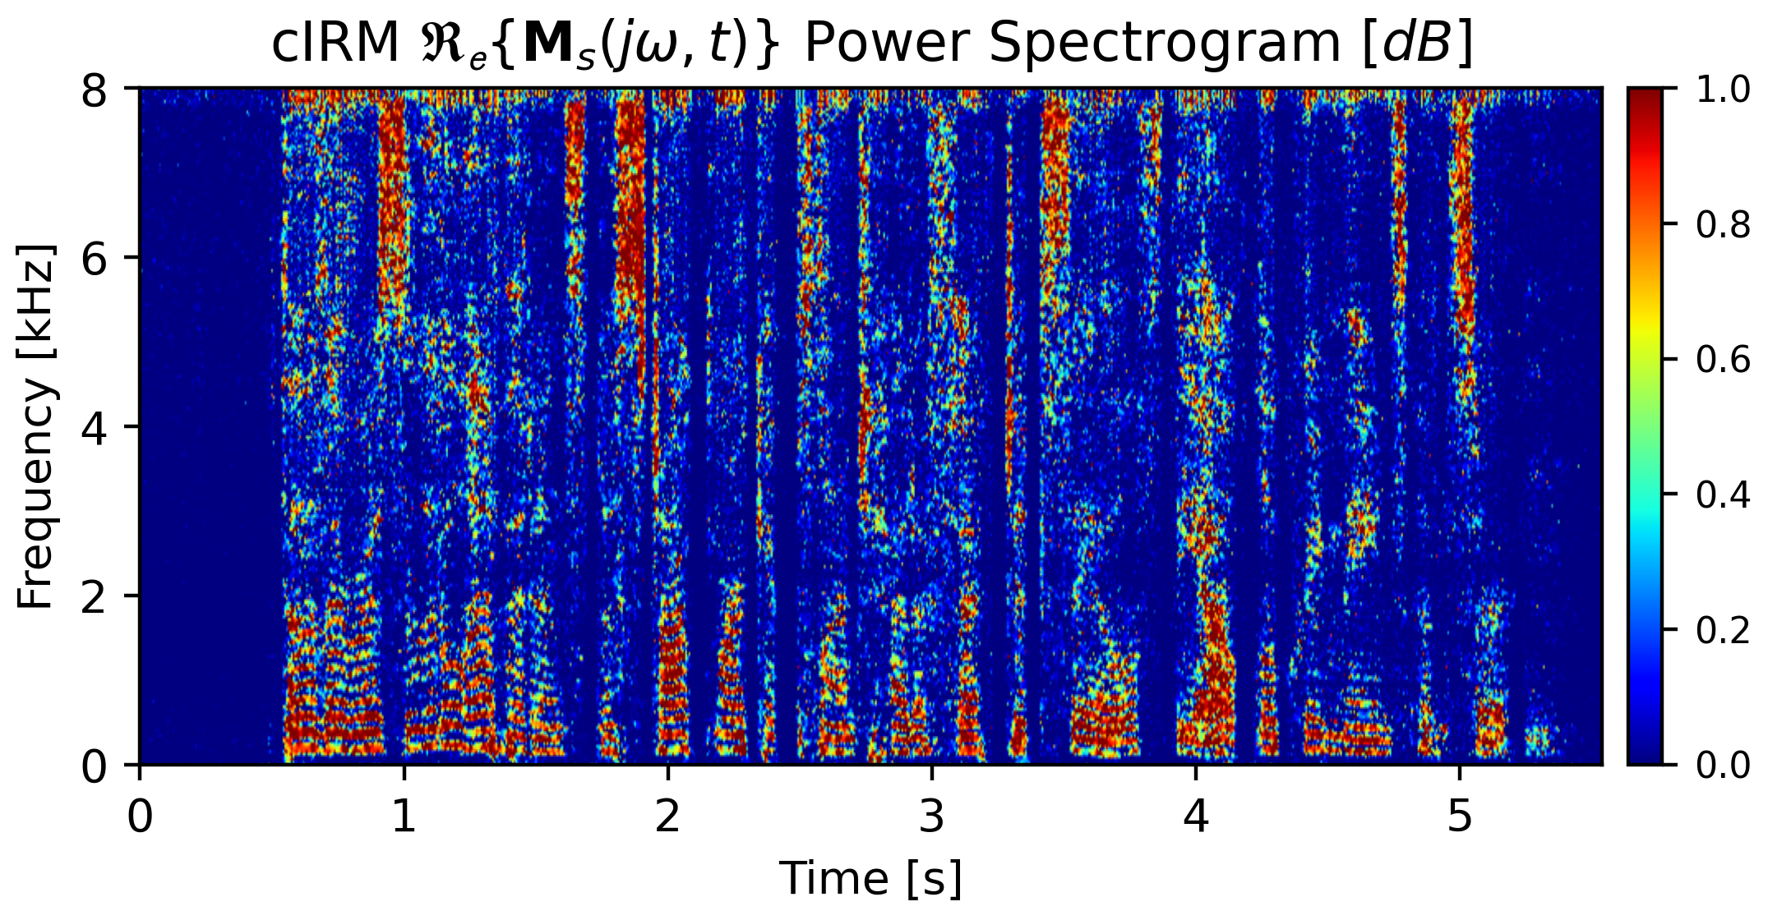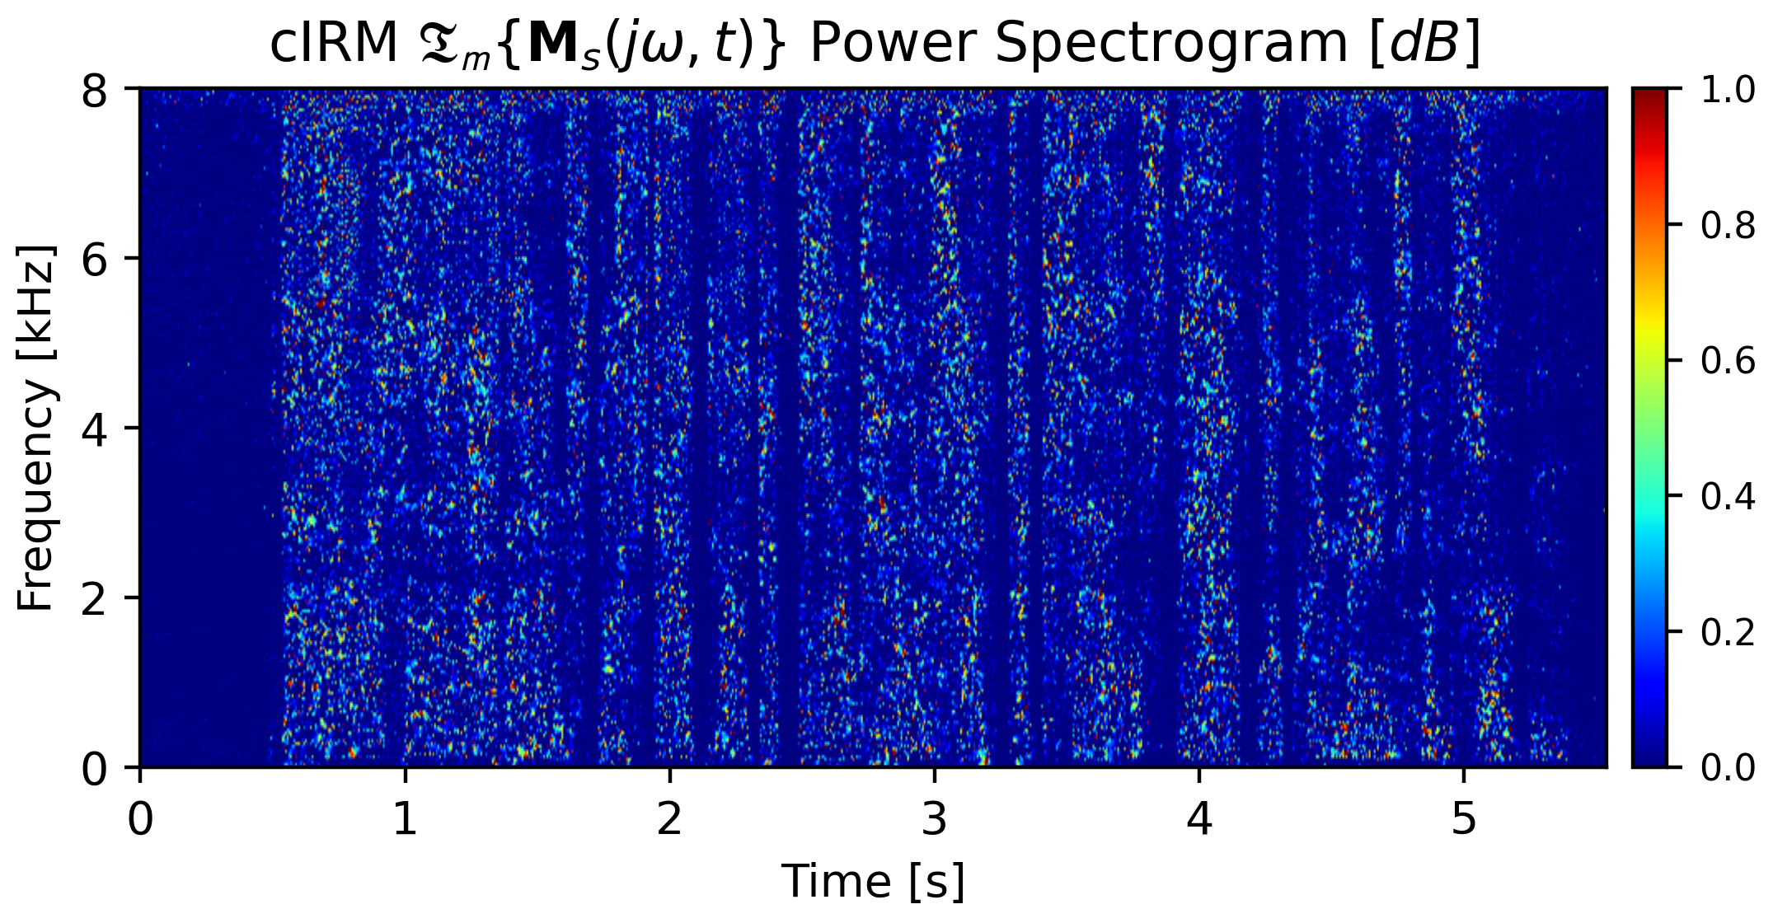

**(a)**

**(b)**

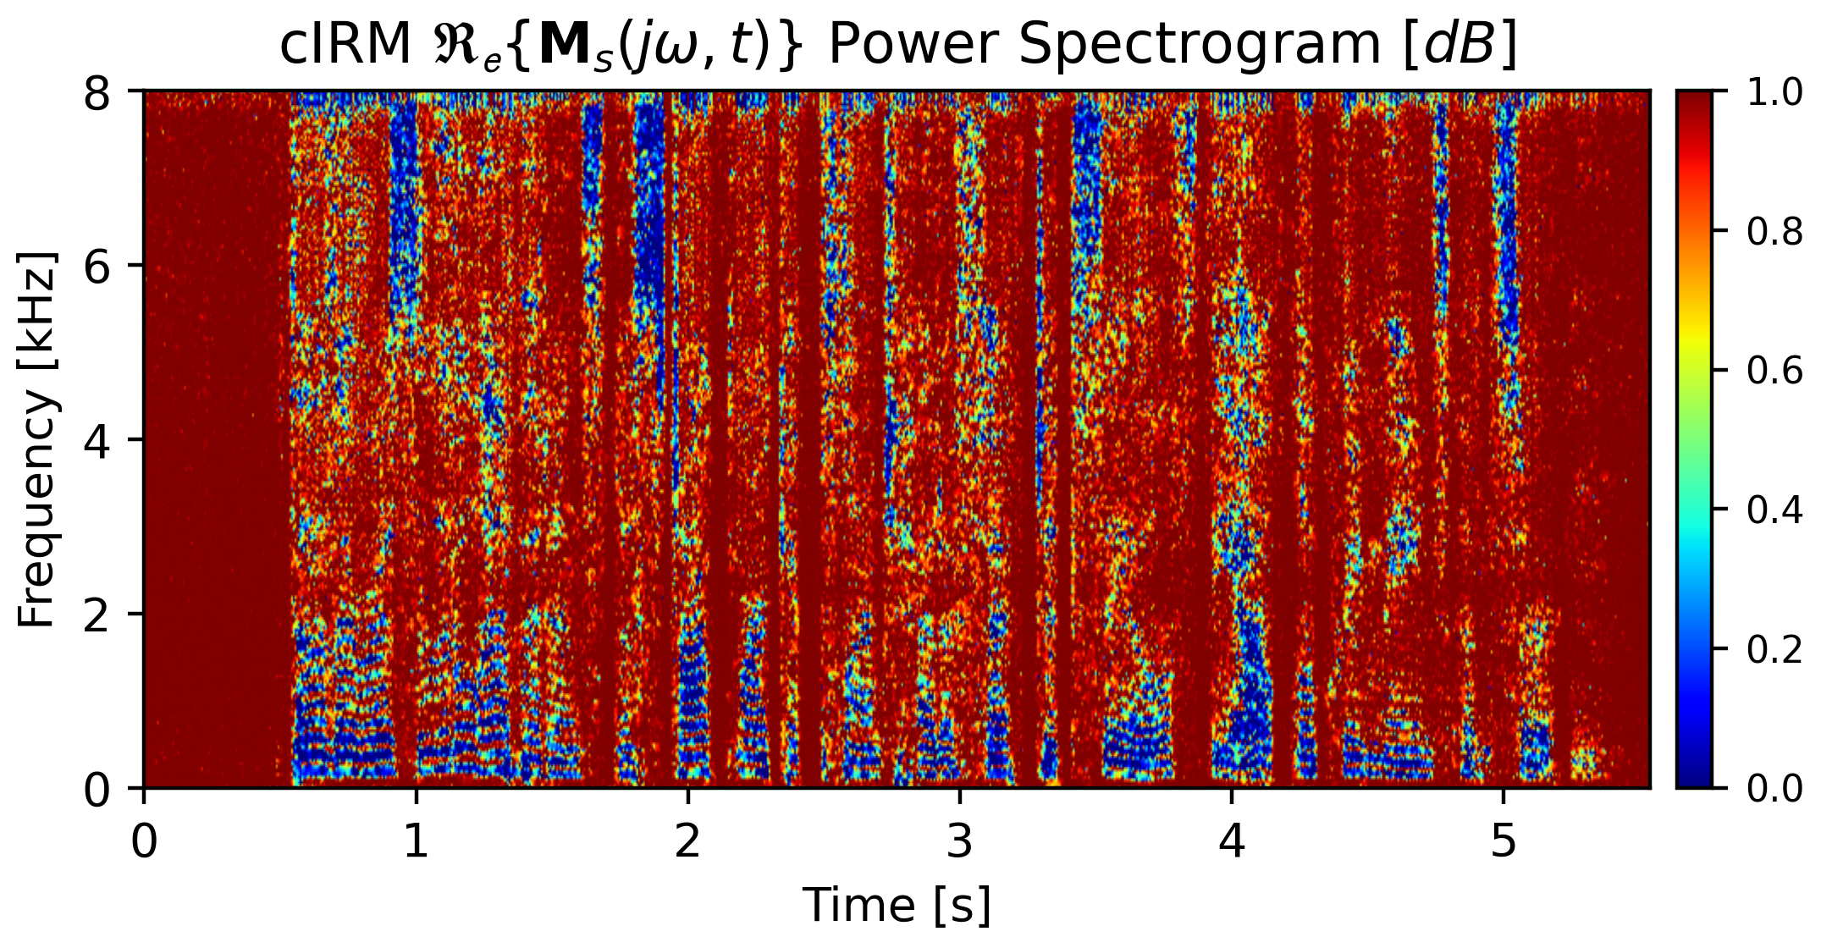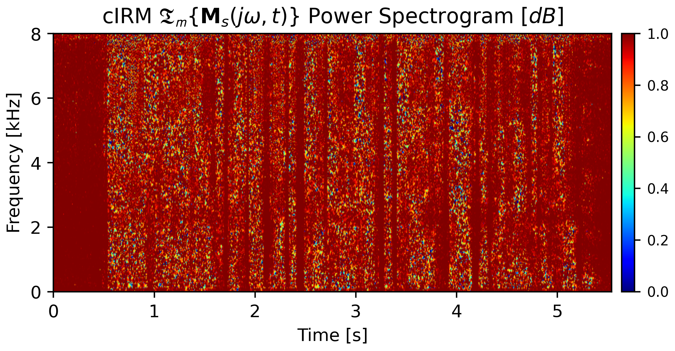

**(c)**

+

(

)

*s*

**Figure 5.12:** (a) and (b) are the cIRM real and imaginary references of the speech

**M**

,

*r*

(

**S**

+

*−*

**Y**

**S**

**Y**

**S**

**Y**

**S**

**Y**

*i*

=

+

*r*

*r*

*r*

*r*

*i*

*i*

*i*

*s*

(

)

(

)

(

)

=

+

*s*

*i*

*s*

**M**

**M**

*j***M**

*r*

*ω*

*j*

,*t*

*N*

)

(

)

(

)

=

+

*n*

*N*

(

**M**

**M**

*j***M**

*r*

*ω*

*j*

,*t*

*i*

2

*j*

(5.18)

+

+

2

2

2

Thus, the complex masks for the speech and noise are:

**Y**

**Y**

**Y**

**S**

*r*

*r*

*i*

*i*

*x*

) =

+

(

)

ˆ︂

ˆ︂

ˆ︂

∑

*x*

(

*s*

*s*

*n*

*n*

*ℓ*

*−*

*−*

*−*

1

)

(

)

(

)

(

)

2

2

*β*

*∈*

*∈*

*∈*

*∈*

**C**

**C**

**C**

**C**

,*t*

*j*

,*t*

*j*

,*t*

*j*

,*t*

*j*

,*t*

*j*

,*t*

2*N*

*ω*

*j*

,*t*

(5.21)

The proposed cIRM estimation network blocks diagram is shown in Fig-

ure 5.13.

82

**M**

*β*

**M**

,

**M**

**M**

**M**

1

**M**

(

*ω*

*ω*

*ω*

*ω*

*ω*

*ω*

*j*

*−*

∞

masks are unbounded, and have the range

,

.

A neural network cannot train for unbounded values. Hence, an alternative

presentation to the mask values is needed. One possibility is to compress the

real and imaginary masks with a hyperbolic tangent as suggested in [4]:

*−*

*·*

∞

*C*

*M*

1

*e*

*x*

=

*cIRM*

*K*

contrast to the

**Masks Estimations**

In Section 5.4,

the

*cIRM*

masks are described in Equations 5.18,

5.19.

In

[

]

(5.20)

*IRM*

masks which are bounded in the range

0, 1

, the

*cIRM*

(

)

*−*

]︃

,

*K*

, while

*C*

controls the steepness. In that way, a linear layer at the output is placed in

favor of the sigmoid layers used in the simpler IRM DNN.

Then, the cost function is defined to include both real and imaginary parts

of both the noise and speech masks.

[︃

*K*

(︂

)︂

(︂

)︂

(

)

(

)

*e*

+

*x*

*−*

*·*

*C*

*M*

1

**5.4.1**

*x*

Where

*x*

, stands for the real or the imaginary parts of the mask. By applying

[

]

*−*

this compression, the mask values are bounded in the range

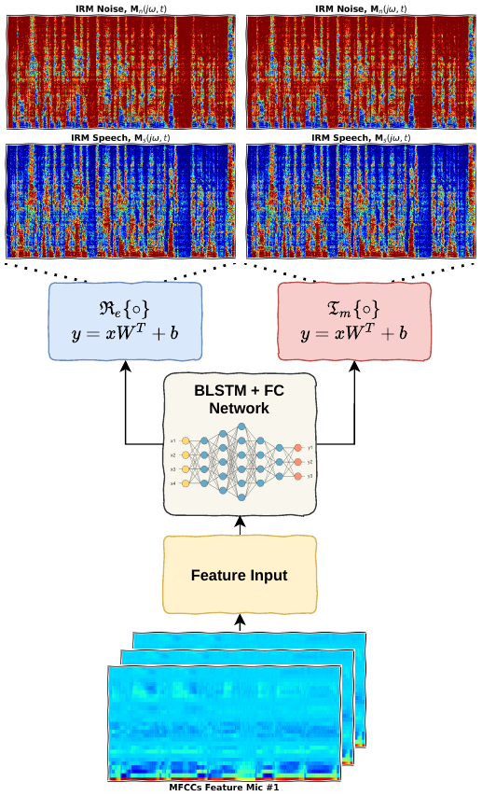

**Figure 5.13:** Proposed DNN for cIRM T-F masking estimations

83

for the evaluation dataset with a number of epochs settings set to 50.

figure, one can conclude that the model generalized correctly as the estimated

mask resembles the reference to great extent. Compared to the “IRM” DNN

[

]

*−*

performance, the cIRM model with a compression in the range of

10, 10

performs better.

**5.4.2**

**Measurements**

Due to the complexity of the cIRM DNN model, it did not generalize properly

Looking at the

The

results hence,

are not accurate as a reference nor for comparison,

unless a

retraining process is initialized with a sufficient number of epochs to let the

model generalize.

Due to the uncertainty of the impact the low number of epochs have on

the model performance and lack of time for re-evaluation of the DNN mask

estimation we decide to skip the results and to drop the cIRM measurements.

84

*r*

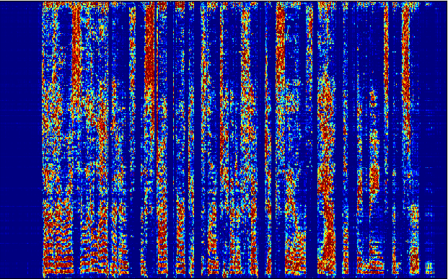

**(a)**

**(b)**

(

)

*s*

**Figure 5.14:** (a) Reference cIRM real speech mask

**M**

;

(b) The estimated cIRM real

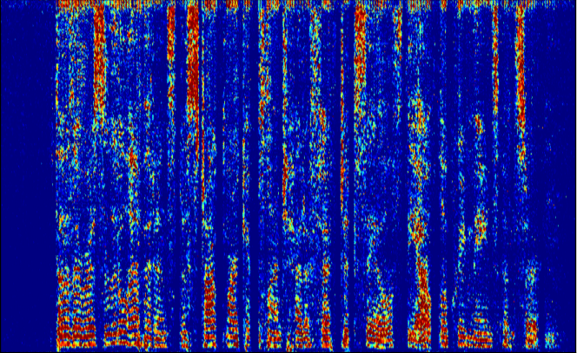

(

)

ˆ︂

*s*

speech

**M**

.

*r*

Figure 5.14 shows the reference real speech cIRM mask compared to the

estimated real speech mask predicted by the DNN model.

**5.5**

**PSM — Phase Sensitive Mask**

The PSM T-F masking makes use of the magnitude ratios and phase differences

rather than requiring a complex multiplication. In that way, the multiplication

is taken in the real domain only, while utilizing the phase contribution directly.

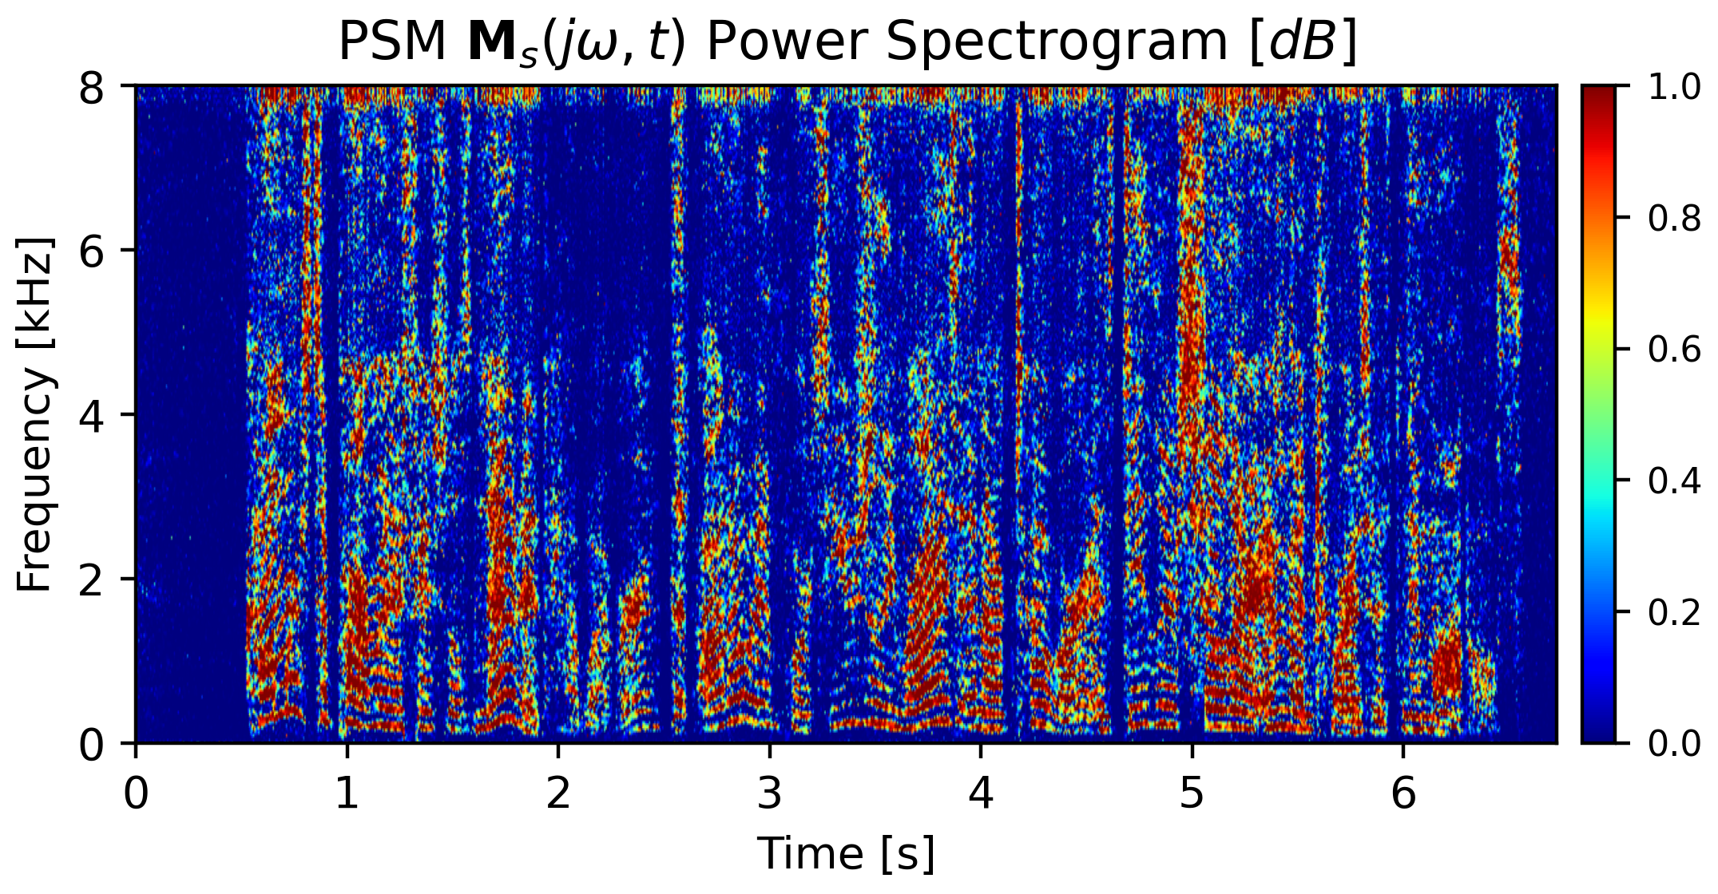

(

)

*ω*

**Figure 5.15:** PSM Speech Mask **M**

*j*

, *t*

*s*

85

*|*

***θ***

***θ***

*−*

*n*

)

(

=

*t*, *j*

**N**

)

(

*ω*

**M**

*|*

)

(

*t*, *j*

**Y**

**Y**

**S**

,*t*

*j*

*ω*

**N**

86

two are required, one for the speech mask, and the other for the noise mask

difference, that instead of branching to four outputs at the final layer, only

posed model for the cIRM masks can be reused with a small implementation

the masks are not bounded similarly to the cIRM masks. Therefore, the pro-

Unlike the cIRM complex masks, the PSM masks are real valued. However,

**Masks Estimations**

**5.5.1**

*t*, *j*

**Y**

**Y**

*|*

,*t*

*j*

*ω*

*|*

*|*

*ω*

)

(

(5.23)

cos

*s*

,*t*

*j*

,*t*

*j*

*ω*

*ω*

are given

**M**

,

**M**

The PSM masks for the reference speech and noise,

*n*

by the following equations:

)

(

)

(

*n*

, *t*

*j*

**Figure 5.16:** PSM Noise Mask **M**

*ω*

)

(

)

*|*

*ω*

)

(

(5.22)

cos

**M**

***θ***

***θ***

*−*

*s*

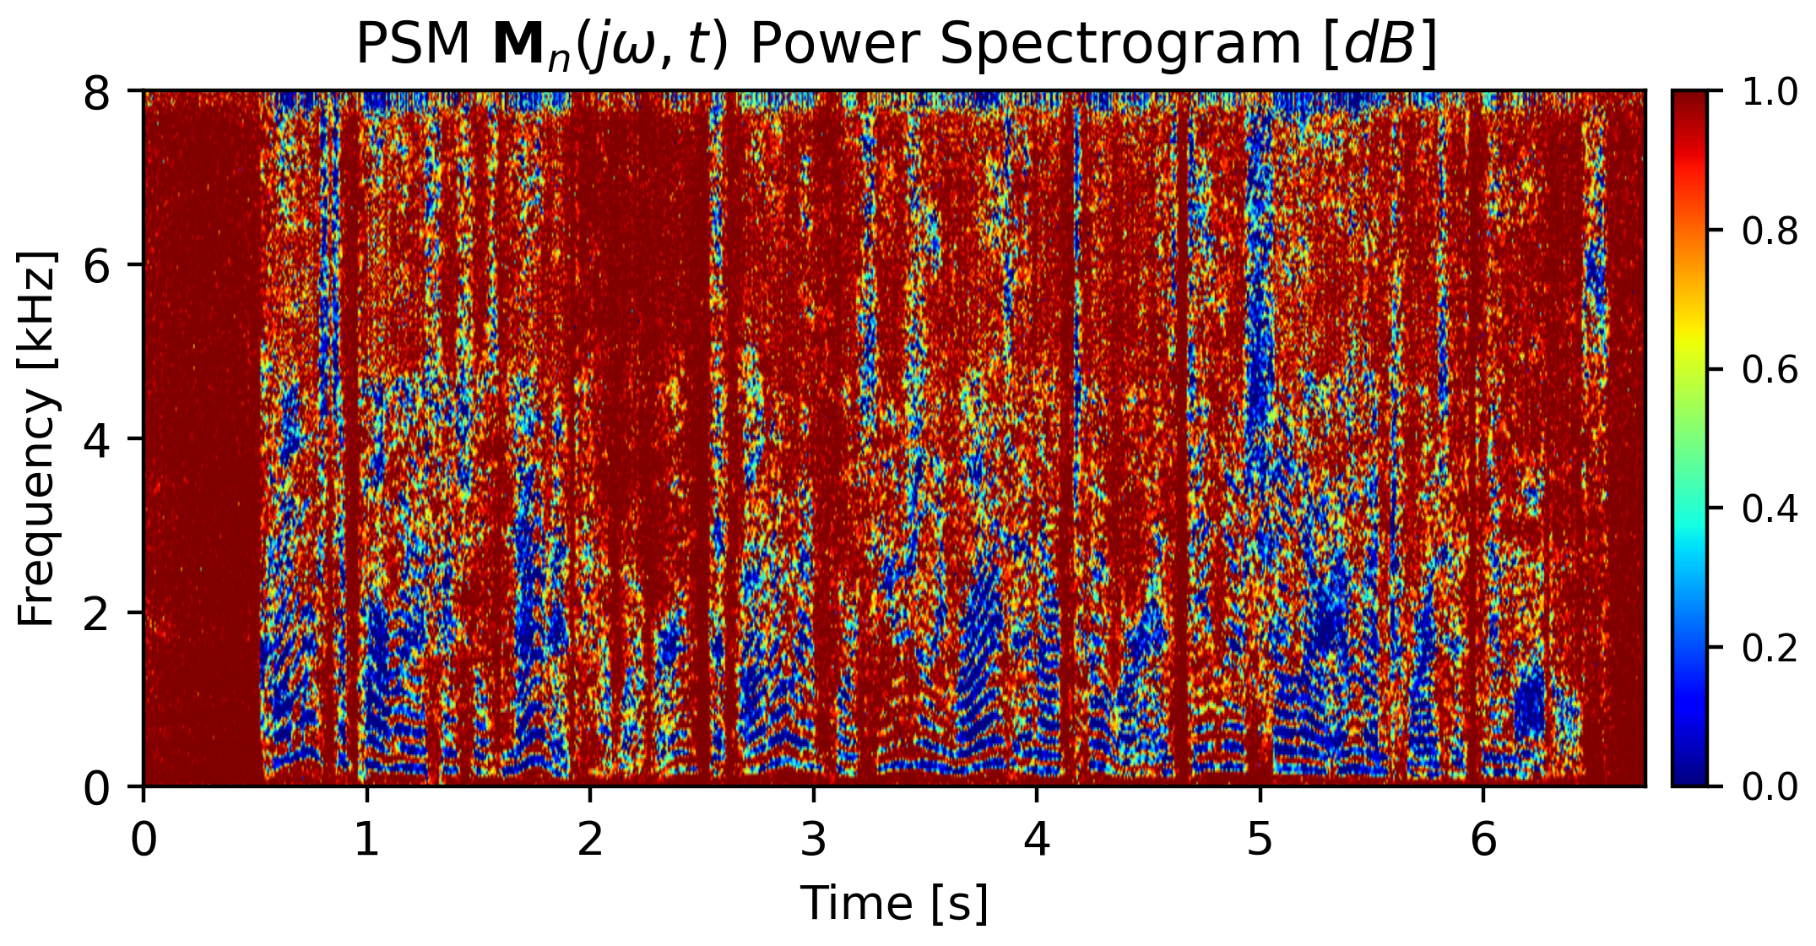

(

=

*t*, *j*

**S**

)

(

*ω*

*|*

*|*

)

(

**M**

*ω*

*ω*

,*t*

*j*

,*t*

*j*

*ω*

*ω*

**M**

*ω*

1

**M**

**M**

**M**

,

**M**

*β*

*β*

*−*

*j*

87

ure 5.17.

The proposed PSM estimation network blocks diagram is shown in Fig-

(5.24)

,*t*

*j*

*ω*

2*N*

,*t*

*−*

,*t*

*j*

,*t*

*j*

,*t*

*j*

*ω*

)︂

(

)

(

)

(

)

(

)︂

(︂

)

(︂

]︃

[︃

masks in the calculation of the error term, like with the “IRM” masks:

In accordance to this architecture, the cost function can be set to take two

compression mechanism is the same as described in Equation 5.20.

bounded range, a compression of the reference masks is needed as well. The

In addition, to deal with the un-

ˆ︂

*−*

*ℓ*

*n*

*n*

*s*

*s*

∑

ˆ︂

ˆ︂

same as “IRM” but without the Sigmoids.

)

(

+

) =

(

1

2

2

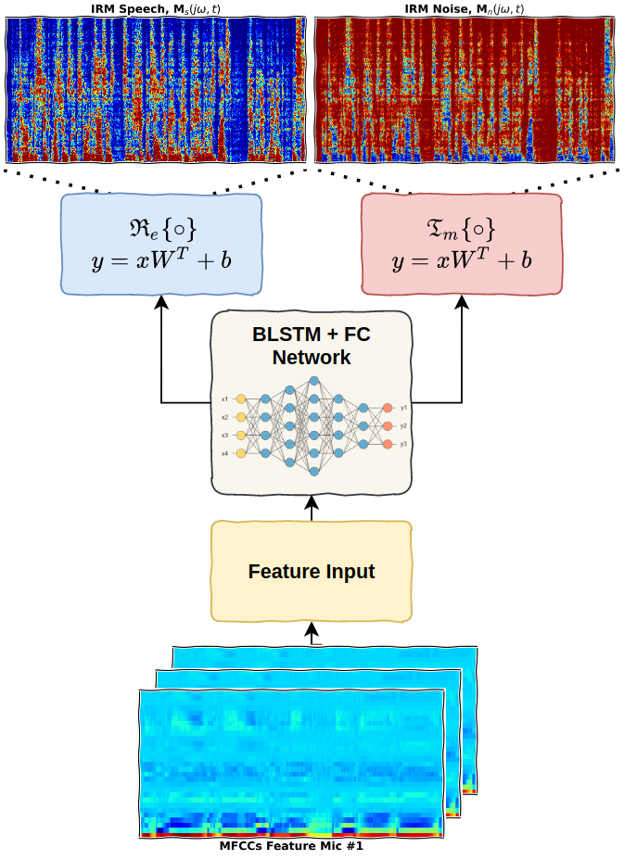

**Figure 5.17:** Proposed DNN for PSM T-F masking estimations.

88

**5.5.2**

**Measurements**

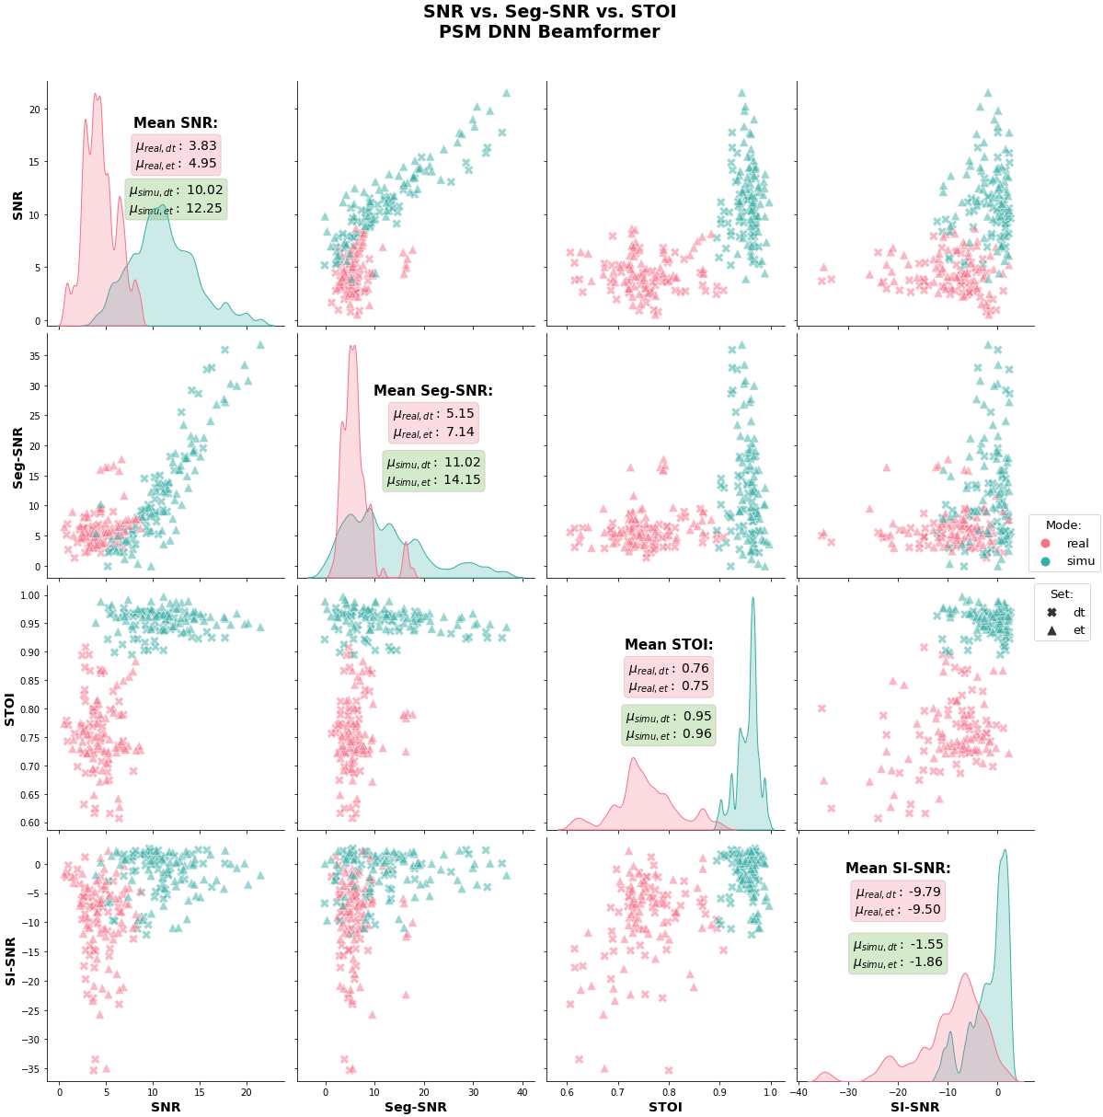

**Figure 5.18:** PSM beamformer SNR vs. Segmental-SNR vs. STOI vs. SI-SNR.

89

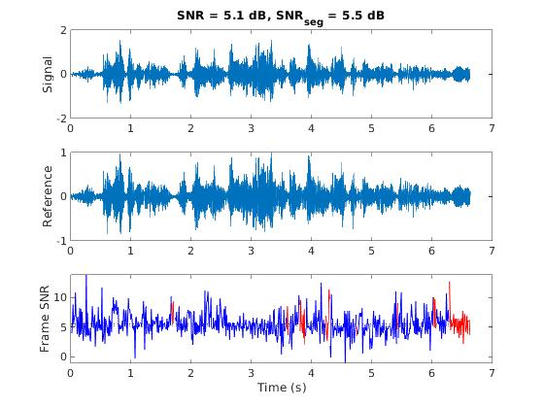

**Figure 5.19:** Ideal PSM beamformer enhancement SNR & Segmental-SNR.

**5.6**

**ORM — Optimal Ratio Mask**

The realization of the phase component importance along with the desire to

keep the masking as simple as possible in terms of number of matrices and

the simplicity of multiplication for separation, the IRM masking is further

developed.

Trying to minimize the general MSE loss function for T-F masking, same

90

(

*t*, *j*

=

*n*

*e*

**M**

(5.26)

(

)

+

**S**

)

+

(

)

(

)

*ω*

*∗*

*ω*

)

*∗*

*|*

*|*

*{*

*·*

*}*

*ω*

R

*|*

*ω*

2

(

)

**N**

*t*, *j*

**N**

*t*, *j*

conjugate noise spectrum.

*t*, *j*

2

**N**

*t*, *j*

**S**

*t*, *j*

*e*

Looking at the equation above, it resembles the IRM form but also intro-

duces the real part of the multiplication between the speech spectrum and the

**N**

**5.6.1**

**Masks Estimations**

The ORM masking in terms of the estimation process resembles the PSM

completely. Therefore, the same compression and DNN architecture are used

to estimate the ORM masks.

The proposed DNN model blocks diagram is shown in Figure 5.17, and

the cost function is given in Equation 5.24.

91

R

*|*

*|*

*|*

*{*

*·*

*}*

*ω*

*ω*

(

*ω*

*ω*

*j*

,*t*

2

2

**S**

*t*, *j*

*e*

)

**S**

*t*, *j*

**S**

*t*, *j*

**N**

*t*, *j*

=

*s*

(

**M**

(5.25)

(

)

+

(

)

+

*|*

(

)

+

(

)

(

)

*∗*

*|*

(

*{*

*·*

*}*

*ω*

R

*ω*

*ω*

2

*t*, *j*

,*t*

2

2

**S**

*t*, *j*

**N**

*t*, *j*

2

**S**

*j*

**N**

*t*, *j*

*e*

(

)

+

(

)

*{*

)

(

)

*ω*

*∗*

*|*

*|*

*|*

*|*

as with the “Weiner filter” that the IRM masking approximates we get:

*·*

*}*

*ω*

*ω*

R

*ω*

*ω*

**5.6.2**

**Measurements**

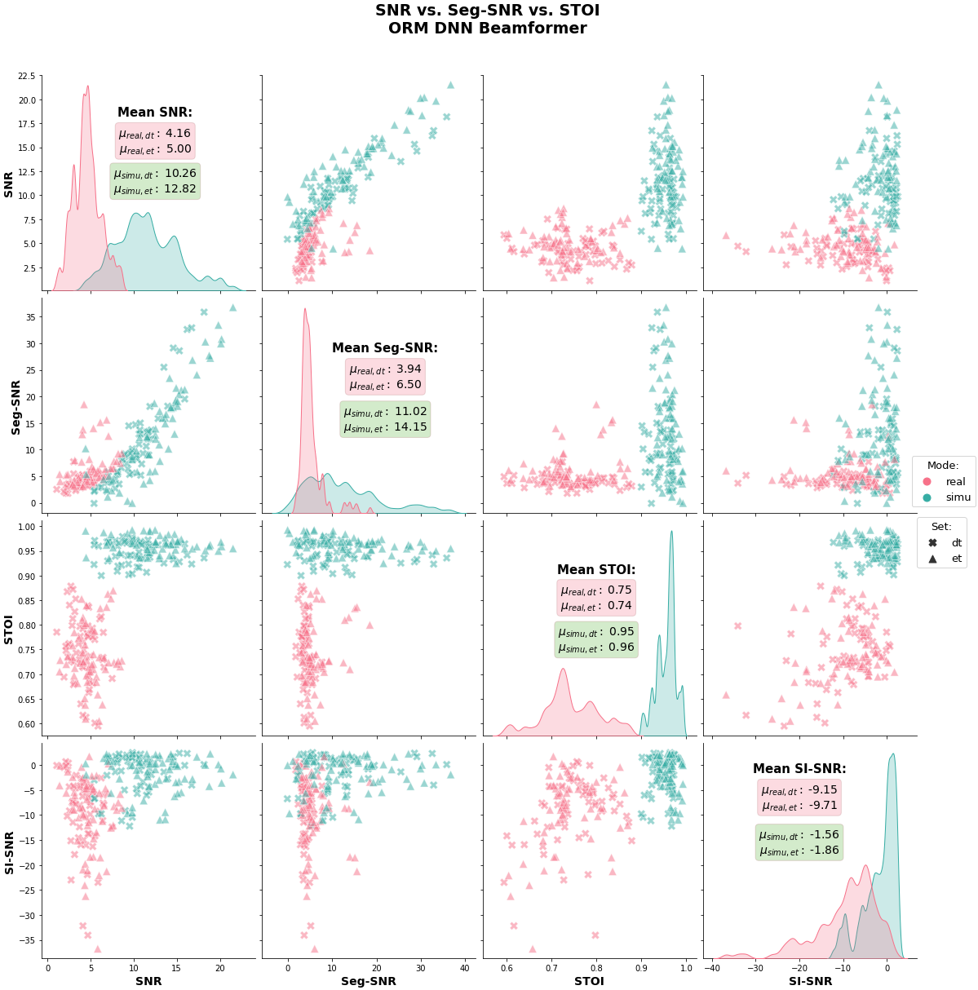

**Figure 5.20:** ORM beamformer SNR vs. Segmental-SNR vs. STOI vs. SI-SNR.

92

∆∆

93

parameters, resulting in a bigger model. Bigger models takes longer time to

the input size of the model and thus leading to larger number of learnable

features enlarges

,

Usage of the additional

features.

,

without the

∆∆

∆

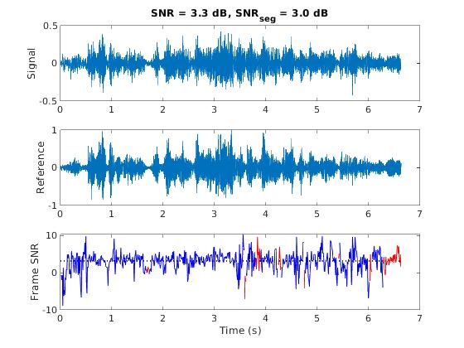

∆

bits present the fractional part. All of the tested models were trained with and

sign, the following four bits are set for the integer part and the other eleven

The MSB (most significant bit) is for the

tized to the form of signed 16 bits.

and the number of learnable parameters. The model’s parameters were quan-

In Table 5.1 are presented the model’s sizes in terms of memory requirement

**Conclusions**

**5.7**

**Figure 5.21:** Ideal ORM beamformer enhancement SNR & Segmental-SNR.

95.9

60.1

5.99

3.76

cIRM

74.8

39.0

4.67

2.44

IRM

94

**Table 5.1:** T-F Masks models learnable parameters vs. Required memory size

91.8

56.0

5.74

3.50

ORM

)

91.7

55.9

5.73

3.49

PSM

∆

∆∆

∆

**Learnable Parameters [Mil]**

**Targets**

not excluded from the feature set.

features were

,

memory size requirement has been observed when the

∆∆

∆

22% in

A less severe increase of

features.

,

set does not include the

∆∆

∆

*∼*

43% larger memory space compared to the IRM masks, when the feature

*∼*

presenting better results in audio metrics, the PSM and ORM masks require

performance in the design phase of T-F masks based applications. Although

tradeoff decision can be made with respect to the memory size and desired

A

,

W/ (

)

,

W/o (

)

,

W/ (

)

,

W/o (

train and are more complex to fit in resource limited hardware devices.

∆∆

∆

∆∆

∆

**Quant. (S16.11) Mem [Mb]**

∆∆

Ratio Masking for Monaural Speech Separation”. In: *IEEE/ACM Transac-*

*2013 International*

*Conference Oriental*

*COCOSDA held jointly with*

*2013 Conference on Asian Spoken Language Research and Evaluation (O-*

10.1109/ICSDA.2013.6709849

*COCOSDA/CASLRE)*. 2013, pp. 1–5.

:

DOI

(cit. on p. 64).

[4]

Donald S. Williamson, Yuxuan Wang, and DeLiang Wang. “Complex

In:

*tions on Audio, Speech, and Language Processing* 24.3 (2016), pp. 483–492.

10.1109/TASLP.2015.2512042

:

(cit. on pp. 79, 82).

DOI

[5]

Shasha Xia, Hao Li, and Xueliang Zhang. “Using optimal ratio mask as

training target for supervised speech separation”. In: *2017 Asia-Pacific*

*Signal and Information Processing Association Annual Summit and Confer-*

*ence (APSIPA ASC)* (2017), pp. 163–166 (cit. on pp. 65, 79).

95

DOI

[1]

Guy J. Brown and Martin Cooke. “Computational auditory scene analy-

sis”. In: *Computer Speech & Language* 8.4 (1994), pp. 297–336.

: 0885-

ISSN

https://doi.org/10.1006/csla.1994.1016

https:

2308.

:

.

:

**References**

URL

//www.sciencedirect.com/science/article/pii/S0885230884710163

(cit. on p. 64).

[2]

Wenbin Jiang, Fei Wen, and Peilin Liu. “Robust Beamforming for Speech

Recognition Using DNN-Based Time-Frequency Masks Estimation”. In:

*IEEE Access* 6 (2018), pp. 52385–52392 (cit. on p. 67).

[3]

Madhab Pal et al.

“Blind source separation: A review and analysis”.

as interferences, are eliminated while the desired component of the signal

96

input signal or the model to be generalized to a great end, hence the filter’s

To that end, the coefficients should be set dynamically to suit the

enough.

so on, setting the filter’s coefficients statically won’t be sufficient and robust

pitch, formant’s frequencies and

Since speech signals can vary in tone,

characteristics of the desired output signal.

multiplication with weighted coefficients that are set according to desired

filter, the discrete signal samples are tapered as a result of a convolutional

Filter can be in the form of an analog or digital circuit. In the sense of digital

remains.

**Chapter 6**

referred

form a given signal in such way that the unwanted components,

The motivation is to

is applying some kind of filtering.

of speech signals,

and also in the case

processing in general,

part of signal

A fundamental

**Introduction**

**6.1**

**Beamformers**

The Beamforming principle relies on the acknowledgment that a desired

97

to “form” a given signal by the properties of constructive and destructive

manipulate each sensor’s input signal in a multi sensor array gives the ability

the ability to

In other words,

eventually summed with the other sensors.

signal. Each sensor’s input can be filtered, delayed, amplified and so on, and

all the signals can be processed to give an enhanced filtered version of the

between the received signals from all the sensors, the manipulated sum of

from each other. By the extraction of the differences in magnitudes and phases

are spread in space in a special dedicated form and are set in a known distance

interferences. The sensors, or microphones in the case of speech beamforming,

signal is absorbed and received by multiple sensors along with unwanted

performance would be suitable to a wide range of inputs rather than a sin-

the ASR model.

accuracy of the model when a beamformer is placed at the front-end before

that in E2E-ASR systems, this translates to higher detection results and better

all the sensors to maximize, in most cases, the SNR. In this research, we show

guideline of Beamforming is the optimization of the received signal utilizing

*spatial filtering* in the presence of multiple sensors is called *Beamforming*. The

all the receiving elements in the array, set to maximize the filtering effect. That

is introduced such that the filtered signal is the outcome of a combination of

In a case that multiple sources are present as a sensors array, a *spatial factor*

*filtering* where the coefficients are computed once and are set statically.

input or the use case is called *adaptive filtering*. In opposed to the case of *static*

gularity case scenario. Changing the filter’s coefficients in accordance to the

*ω*

(

)

(

)

(

)

*ω*

*ω*

)

*ω*

*H*

*H*

**A**

*j*

, **u**

**U**

*j*

)

*ω*

*ω*

*H*

**A**

*j*

, **u**

**A**

*j*

, **u**

(

) =

√︁

*E*

**u**

(6.3)

(

*ω*

**6.2.1**

**Sum-and-Delay**

1

(

) =

(

)

*ω*

**Types**

**W**

*j*

**A**

*j*

(6.5)

*M*

98

)

**U**

*j*

**A**

*j*

, **u**

The DOA with the maximum power is selected as the DOA of sound:

=

(

(

**u**

*argmax*

*E*

**u**

(6.4)

*max*

**u**

**6.2**

(

The time difference of arrival between microphone 1 and

*m*

can be esti-

mated using the Generalized Cross-Correlation with Phase Transform (GCC-

PHAT) with the following expression:

∫︂

(

)

(6.1)

)

+

*∗*

*π*

*ω*

*ω*

*X*

*j*

*ω*

Beamforming is applied in the frequency domain:

(

) =

(

)

(

)

*H*

*X*

*ω*

*ω*

*Y*

*j*

**W**

*j*

**X**

*j*

*X*

*|*

*||*

*|*

*ω*

*ω*

*X*

*j*

*m*

*j*

*−*

*π*

*m*

1

The power corresponds to:

(

)

*argmax*

*j*

=

*ωτ*

*m*

1

*j*

*τ*

*ω*

interferences.

*e*

*d*

(6.2)

*τ*

(

)

(

)

**GEV**

)

(

)

(

) =

(

)

(

*ω*

**6.2.3**

*XX*

*j*

**A**

*j*

**R**

*j*

*j*

99

*SS*

*NN*

(6.7)

*j*

**W**

*j*

**R**

**A**

**W**

*j*

**R**

*ω*

*ω*

*λ*

*ω*

*ω*

*XX*

) =

(

*j*

**A**

*j*

**R**

*ω*

*ω*

1

*−*

)

(

)

(

**MVDR**

(

*H*

*ω*

*ω*

*ω*

1

*−*

)

**6.2.2**

)

(

)

(

(6.6)

*j*

**W**

ASR systems make use of numerous algorithms and techniques to conduct

100

properly given that the environmental conditions are not static and change.

bustness of the system, which means how well the system can still function

Some other algorithms are used to increase the ro-

described in Chapter 4.

*CER* and *PER* as

and higher detection ratios measured with *WER*,

ments,

Some algorithms aim for precision improve-

the speech to text translation.

**Chapter 7**

Recognition).

by a computer machine or a software is known as ASR (Automatic Speech

referred as Speech-to-Text (STT). Speech recognition that is done automatically

and translate it to readable text named transcript. Often speech recognition is

Speech recognition (SR) stands for the ability to recognize natural speech

**Introduction**

**7.1**

**Recognition**

**ASR — Automatic Speech**

Traditional ASR engines are usually built of several stages, where each

101

the number of words in a common language cross the tens of thousands

phonemes instead of entire words by the ASR engine, relies on the fact that

The motivation of detecting

together in the way it is actually pronounced.

to differentiate between words. A word is a sequence of phonemes chained

A phoneme is a discrete and distinctive unit of language that can be used

construct words.

translates a speech waveform to a transcript by chaining *phonemes* together to

structure of an ASR system is shown in Figure 7.1a. This type of ASR system

ASR engine is a chain of these modules connected in a pipeline. A common

stage contains a module or several modules designated for specific task. An

Natural spoken speech has inherent variabilities depending on many fac-

for an ASR system.

SNR scenarios and multiple reverberations due to room acoustics, is crucial

endurance to these artifacts, especially high background noise levels in low

Due to the dependency the natural speech has on so many factors, high

and introduces some degree of variability.

emotional state or health conditions, they all have an impact on spoken speech

characteristics but social or geographically related, as to accent, style of speech,

ances in the vocal range, pitch, and formant frequencies. Gender-independent

have the same gender, and are at the same age ranges still may present vari-

male or a female, and also the speaker’s age. Moreover, different speakers who

tent. Natural speech heavily depends on the speaker’s gender, whether it is a

tors, that make a speech signal to be classified as a non-stationary and inconsis-

(b) End-to-end ASR system

102

The next module is the decoder, which responsibility is to take the features,

set of features that represent the speech as MFCCs, FilterBanks and others.

characteristics to a stationary signal, and lastly the extraction of the individual

and framing of the speech to sub-frames where the speech is more close in

the speech analysis as to noise cancellation, speech enhancements, windowing

These two modules account for

emphasis and features extraction modules.

The system presented in Figure 7.1a shows a pipeline that starts with a pre-

blocks diagram.

and sometimes is larger than hundreds of thousands.

**Figure 7.1:** (a) Traditional ASR system blocks diagram;

**(b)**

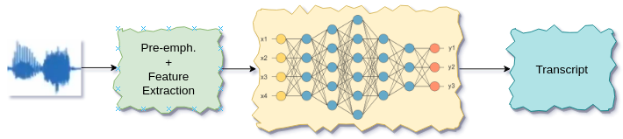

**(a)**

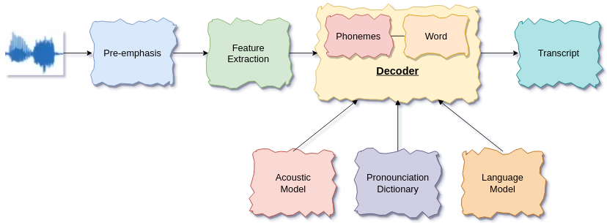

the vocabulary utilizing a simpler training dataset requirement.

that way, the much smaller set of dedicated phonemes can be used to construct

vocabulary. On the contrary, most languages have 20-60 phonemes[1, 3]. In

training dataset requirement that contains most of the words in the language

Implying a very big

to be in the output transcript.

103

That leads to another advantage of E2E ASR systems over traditional ASRs,

to the learning process of mapping acoustic features to corresponding letters.

be expensive. Instead, character probabilities are given at the output according

acquiring new pronunciation models or maintaining an existing one which can

Sparing the need of

nor complex models of chaining phonemes to words.

With this architecture, there is no more a need of expert derived dictionaries

structure is presented in Figure 7.1b.

An E2E ASR system

some kind that maps acoustic features to characters.

replaces the conventional decoder structure with a deep neural network of

This approach

Speech Recognition (E2E ASR) has been proposed in [4].

A newer more modernized approach known as End-to-End Automatic

convert them to a set of phonemes and chain them together to detectable words

temporal context. The words or N-Grams with the highest scores are selected

phoneme sequences and how likely is to this word to occur given the recent

(LM) calculates the likelihood a given word is detected based on the perceived

the Language Model

Lastly,

links between phoneme sequences to words.

expert linguistic and tailor-made to each language explicitly. This dictionary

module, named the pronunciation model, that is a dictionary, handcrafted by

intermediate representation in the process of word decoding. An additional

These phonemes are an

to phoneme sequences with probabilistic weights.

Model (AM) which maps the acoustic features extracted in earlier module

sub-models which are tied together to work in harmony. The first, Acoustic

A decoder is built from three

in order to give the transcript at the output.

performance degradation, several algorithms can be applied for improving a

104

Another paradigm presented by Chan et al. in [2] more known as Seq2Seq

**Figure 7.2:** Maas et al. [5] phonemes vs characters graphs

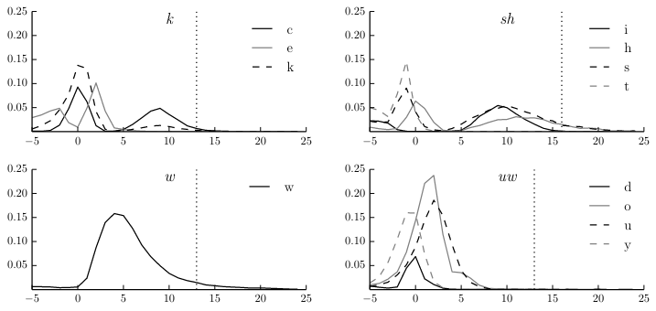

selected.

in Figure 7.2. Therefore, by utilizing a *beam-search* more accurate letters can be

for certain phonemes which characters get the highest probability as shown

Temporal Classification) presented by Maas et al. in [5]. This method shows

certain aspect of the model. One useful technique called CTC (Connectionist

that is an E2E model can be retrained with new dataset of annotated speech

To overcome the

work as expected and comparably with traditional ASRs.

estimations of characters and later the construction of a full transcript doesn’t

However, despite training E2E systems with very large datasets, the direct

do, a larger training dataset is required.

comparable detection ratios in terms of WER and CER as the traditional ASRs

hand, using E2E systems means that, in order to generalize and to maintain a

in different languages without changing the architecture at all. On the other

evaluated.

105

To-Sequence) Transformer (self-attention) based.

Joint CTC (Connectionist Temporal Classification) + Seq2Seq (Sequence-

based transformer, implying an Encoder-Decoder infrastructure.

Table 7.1 is constructed with an CNN front-end connected to a self-attention

The proposed general architecture for the suggested ASR engines listed in

**The ASR Engine**

**7.2**

(Sequence-to-Sequence) or alternatively Attention Encoder-Decoder (AED)

used in this work in the construction of the different ASR engines that were

A sophisticated measured combination of these techniques all together is

Encoder-Decoder architecture.

in [7] which also make use of the

was later suggested by Vasawani et al.

model called transformer which is known for its self-attention mechanism

networks. This approach is based on an LSTM transducer. A more advanced

**7.2.1**

**Front-End**

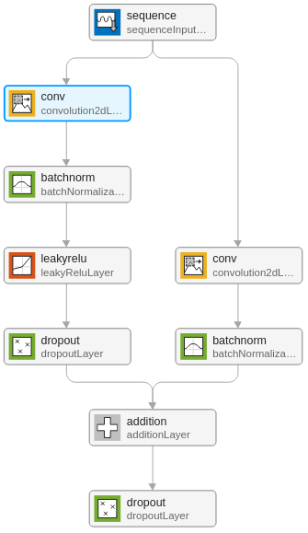

**Figure 7.3:** CNN front-end general ConvBlock architecture.

**7.2.2**

**Transformer**

A transformer is a self-attention Encoder-Decoder based model that its archi-

tecture is shown in Figure 7.4. Where the left side is the Encoder and the right

side is the Decoder.

106

)

107

tion or in Multi-Head Attention. The transformer backend used in this work is

respectively can be implemented in Scaled Dot-Product Atten-

*V*

,

*K*

pairs

)

(

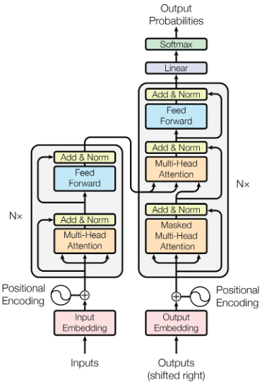

(

, and the keys-values

*Q*

The attention function that translates the Query

)

(

**Source:** Adapted from “Attention Is All You Need” [7]

**Figure 7.4:** Transformer

*n*

*ℓ*

) =

(

*meanbatch*

*red*

,

*L*

∑

=

{︄

The kldiv loss also can be reduced over the mini-batch size, as follows:

*n*

*batch*_*size*

*n*

*n*

(7.3)

*x*

*y*

log

*y*

*−*

*ℓ*

]

)

(

)

108

*ctc*

*ctc*

*ctc*

*seq*

(7.5)

1

*ω*

*ω*

*· ℓ*

*−*

*ℓ*

*ℓ*

[

+ (

=

function used for training is as follows:

the engine’s loss

Combining both the CTC and the Seq2Seq components,

*sum*

*red*

*L*,

∑

=

(7.4)

*x*, *y*

(

*p*

*arg* min

*θ*

*π*

*θ*

*i*

*|*

*−*

ˆ

∑

∑

=

)

*x*

*N*

)︂]︂

(︂

[︂

character are minimized to a single character.

is then collapsed, that is, the repeated characters not separated by the “blank”

The CTC loss is the negative logarithm if the probability. The generated label

**CTC**

**7.2.3**

the *GELU* (Gaussian Error Linear Unit).

numbers of four to eight. The activation function used with the transformer is

coder and decoder parts consist variable number of linear layers between the

*ℓ*

=

1

*N*

2

(7.2)

, ...,

,

*L*

*x*, *y*

*}*

*{*

*ℓ*

*ℓ*

a Multi-Head Attention based utilizing 8 heads in the attention model. The En-

*ℓ*

=

) =

(

**Seq2Seq**

**7.2.4**

1

*i*

=

*θ*

(7.1)

;

146.0M Bark

28

18

∆

∆∆

#7(22)

MFCC,

,

Bartlett

28

18

∆

∆∆

#8(23)

∆

#5(70)

MFCC,

,

146.2M Mel

Bartlett

80

20

∆∆

#6(72)

MFCC,

,

146.0M Mel

Bartlett

26

∆

∆∆

#10(101)

MFCC,

,

, Context(3, 3)

78.8M Mel Approx.

Bartlett

26

26

**Table 7.1:** ASR Engines Table

ASR engines 100, 101 were heavily optimized in terms of the neural net-

works structures leading to smaller models, having two times less learnable

parameters. For comparison, the differences between ASR engines 101 and 72

are summarized in Table 7.2.

109

MFCC,

,

146.0M ERB

Gammatone

28

18

∆

∆∆

#9(100)

MFCC,

,

, Context(3, 3)

78.8M Mel

Bartlett

26

**Root Mean Cepstral Coefficients**

∆

∆∆

#1(5)

RMFCC(0.1),

,

146.2M Mel

Bartlett

80

20

∆

∆∆

#2(15)

RMFCC(0.08),

Where

is set to 0.3 and a greater weight of 0.7 is given to the Seq2Seq loss

*ctc*

*ℓ*

.

*seq*

**Id(seed)**

**Feature(s)**

,

**Params**

**Scale**

**Fbank**

**#Filt.**

**#Coeff.**

28

∆∆

#4(13)

RGFCC(0.1),

,

146.0M ERB

Gammatone

∆

18

**Conventional Cepstral Coefficients**

∆

∆∆

146.2M Mel

Bartlett

80

20

∆

∆∆

*ω*

#3(12)

RBFCC(0.1),

,

146.0M Bark

Bartlett

28

18

Filters [#]

26

28

Coeff. [#]

2048

3072

Dec. layers

4

6

**Implementation Settings**

features, utilizing the

table, with a minibatch size four for each iteration.

The engine was trained

=

*γ*

∆

∆∆

against the RMFCCs, when

0.1, with the

,

recordings

Log-Mel scale. A preprocessing STFT enframing block was set with 80 Bartlett

filters for each T-F bin. Overall the number of features per T-F unit is 20 cep-

stral coefficients plus the first and second derivatives. Figure 7.5a shows ASR

engine #5 training results for the test and validation subsets.

In Figure 7.5b

we present the evaluated WER and CER measures that were taken every five

epochs during the training process.

110

**7.2.5**

Precision

U16/8

FP64

**Table 7.2:** ASR engines #101, #72 comparison table

**Trained Engines**

∆

∆∆

**7.2.5.1**

**ASR Engine #5 — RMFCC(0.1),**

,

ASR engine #5 had been trained over fifteen epochs, along a 400

*K*

CNN Blocks [#]

3

3

CNN Shapes

[64, 100, 128]

[128, 200, 256]

**Engine #72**

**Parameter**

**Engine #101**

**CNN Settings**

Input size

2560

3584

Enc. layers

8

12

**Transformer Settings**

FFN layers

2048

3072

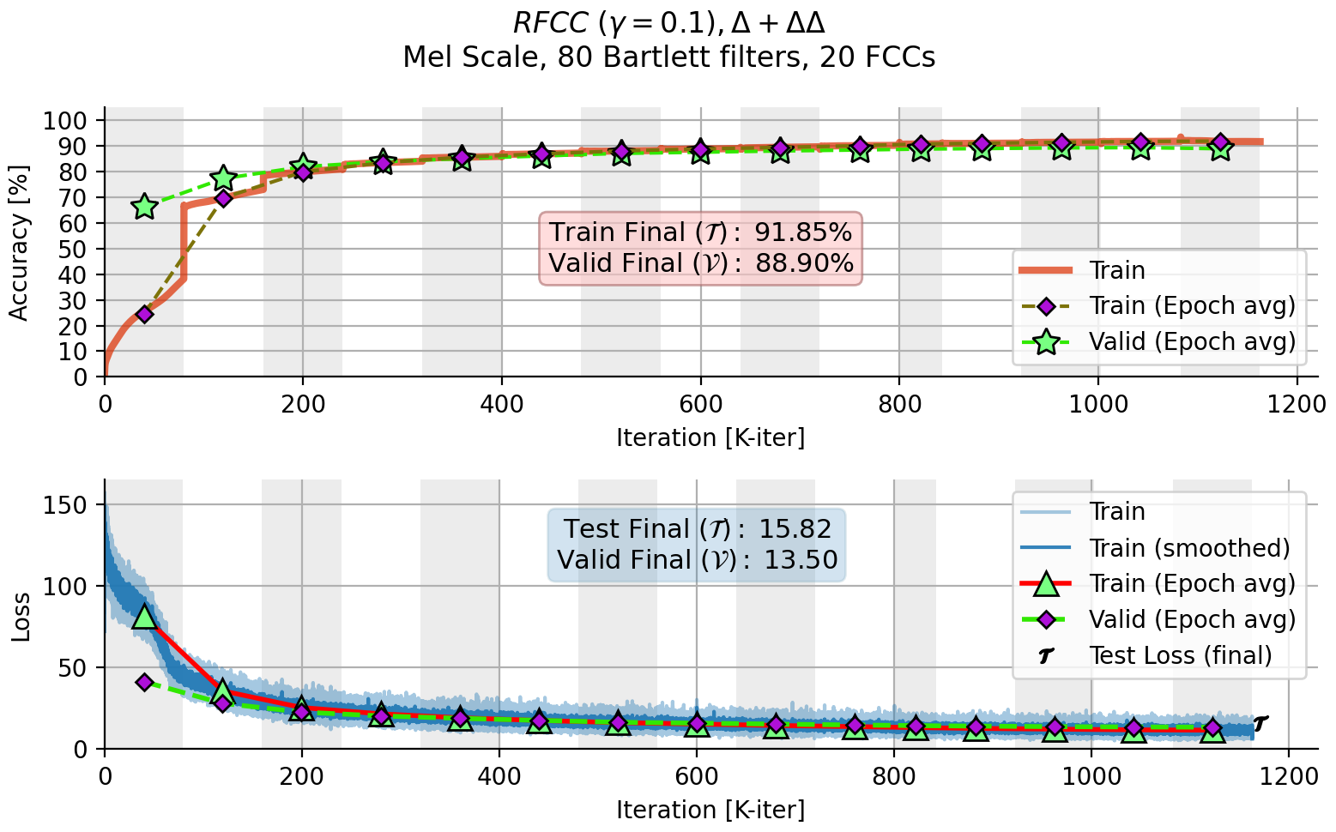

**(a)**

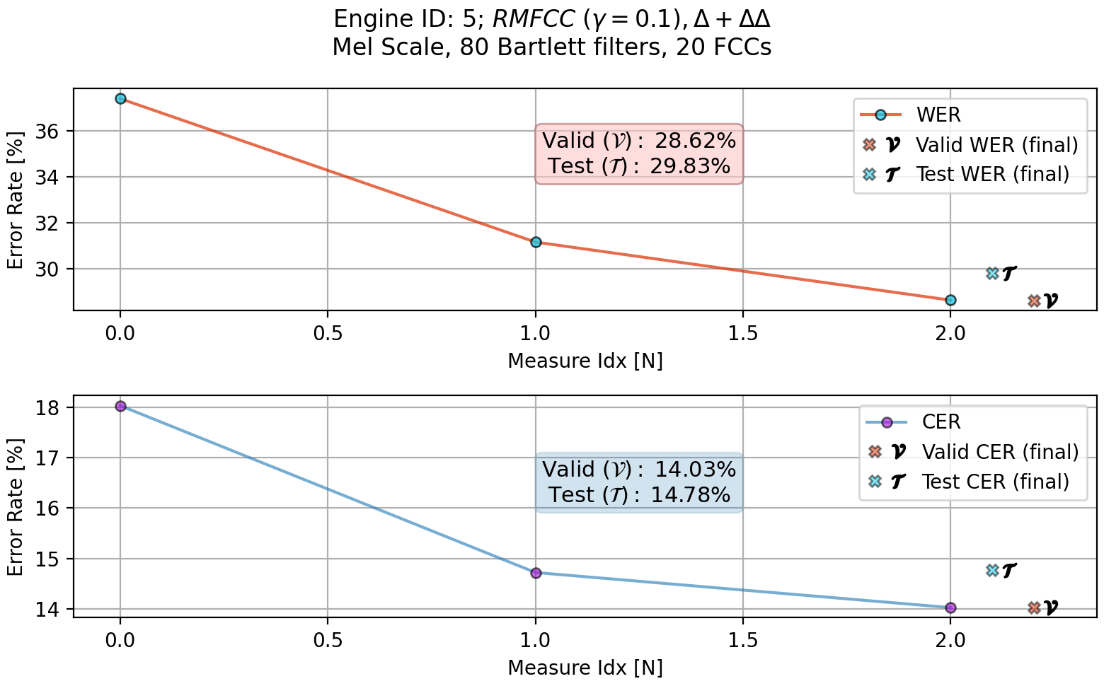

**(b)**

**Figure 7.5:**

(a) ASR #5 training accuracy and loss plot;

(b) ASR #5 WER,

CER

evaluation plot.

111

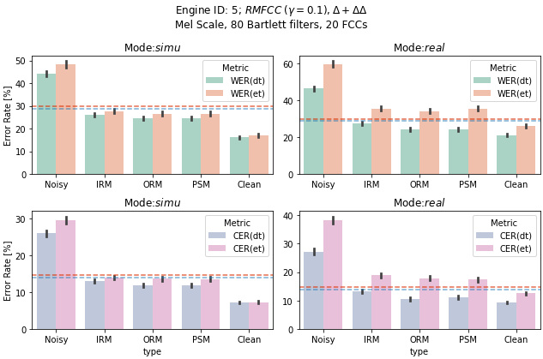

**Figure 7.6:** ASR #5 WER, CER vs. T-F masks, noisy and clean inputs

In Figure 7.6, we present the engine’s results in terms of WER and CER per

each subset of the multi microphone CHiME dataset. This figure emphasizes

the comparison between the four T-F masking algorithms. Results are plotted

side by side with the evaluated noisy mixture and clean speech metrics as

reference. Two horizontal lines, red and blue, are stretched across the x-axis of

each plot. These lines mark the plot’s metric, whether it is WER or CER, taken

from the training evaluations of CommonVoice datasets validation and test

subsets.

The red line is for the test metric measurement while the blue line

marks the validation one.

112

∆∆

113

WER and CER measures for the validation and test subsets.

Figures 7.7a, 7.7b shows the training results of ASR engine #15 and its

value as stated in [6]. The rest of the settings are the same as in ASR engine #5.

0.08, as this setting proved to be the optimized

Gamma has been set to

*γ*

=

features, utilizing the Log-Mel scale.

,

against the RMFCCs, with the

∆

∆

The engine was trained

table, with a minibatch size four for each iteration.

recordings

*K*

ASR engine #15 had been trained over fifteen epochs, along a 400

,

**ASR Engine #15 — RMFCC(0.08),**

**7.2.5.2**

∆∆

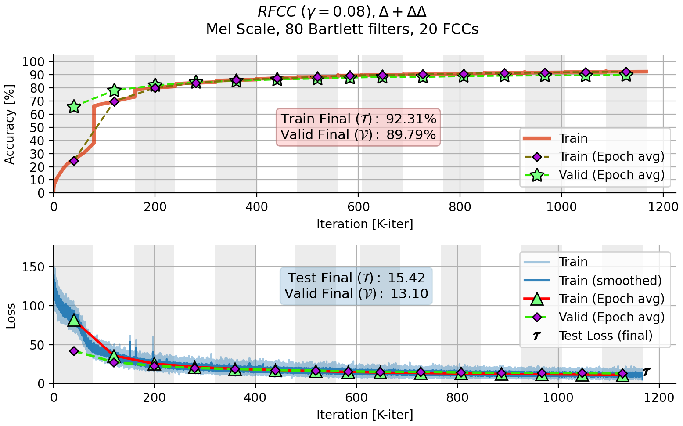

**(a)**

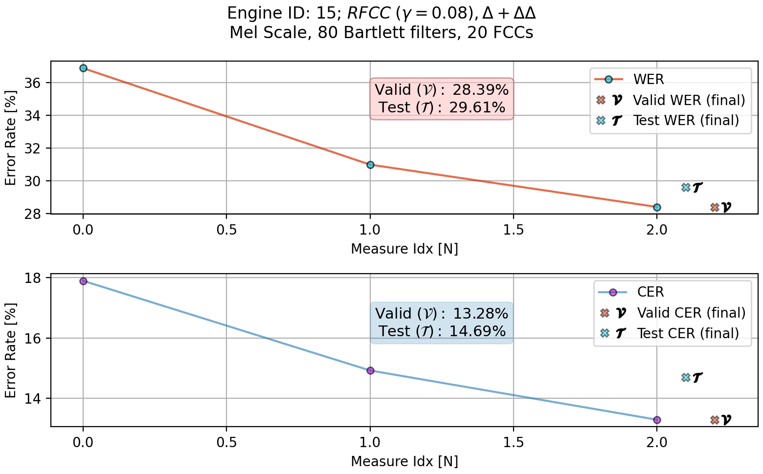

**(b)**

**Figure 7.7:**

(a) ASR #15 training accuracy and loss plot;

(b) ASR #15 WER, CER

evaluation plot.

In Figure 7.8 presented the T-F mask based beamformed enhanced record-

ings evaluations.

114

with some distinctions.

115

clean speech references.

beamforming effect per T-F algorithm, compared to the noisy mixture and the

Figures 7.9a, 7.9b show the training results, and Figure 7.10 presents the

unit had been set to 28 instead of 80.

coefficients had been reduced to 18. The number of Bartlett filters for each T-F

and the number of extracted cepstral

the previously used Log-Mel scale,

The feature set utilizes the Bark scale instead of

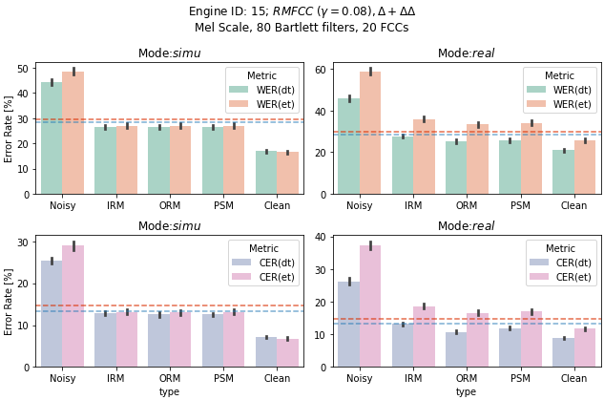

#5 and #15 but

ASR engine #12 trained similarly to the previous engines,

,

**ASR Engine #12 — RBFCC(0.1),**

**7.2.5.3**

∆∆

∆

**Figure 7.8:** ASR #15 WER, CER vs. T-F masks, noisy and clean inputs

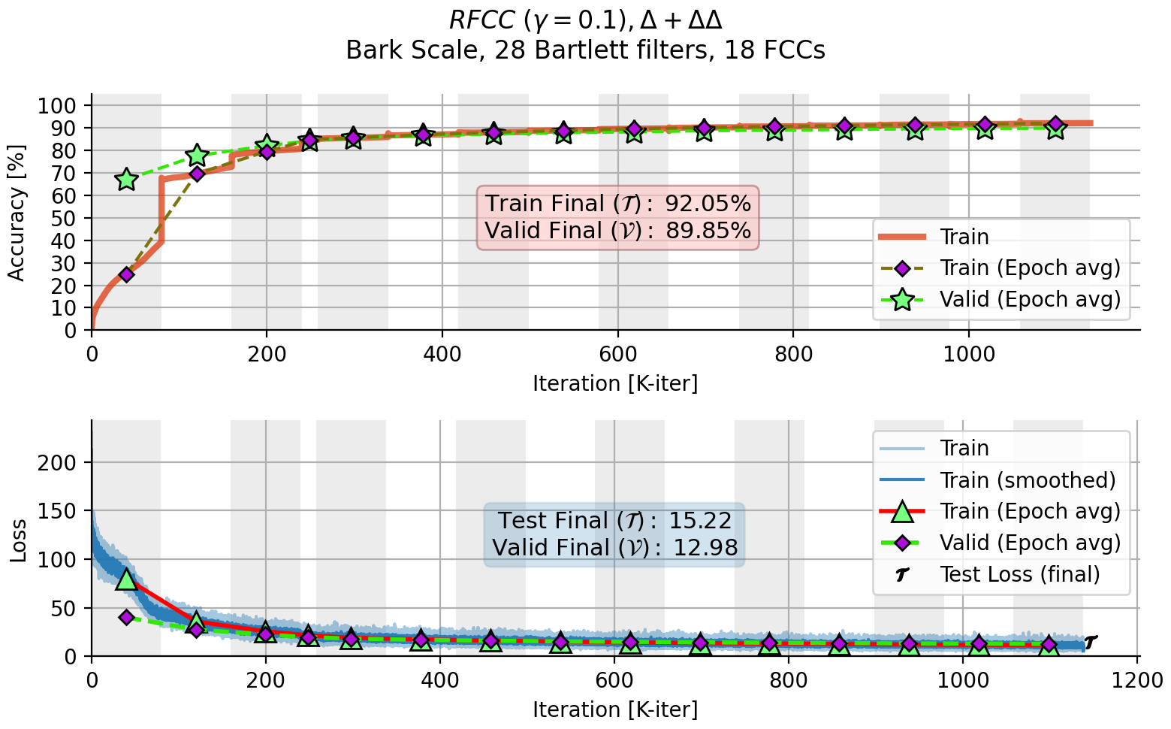

**(a)**

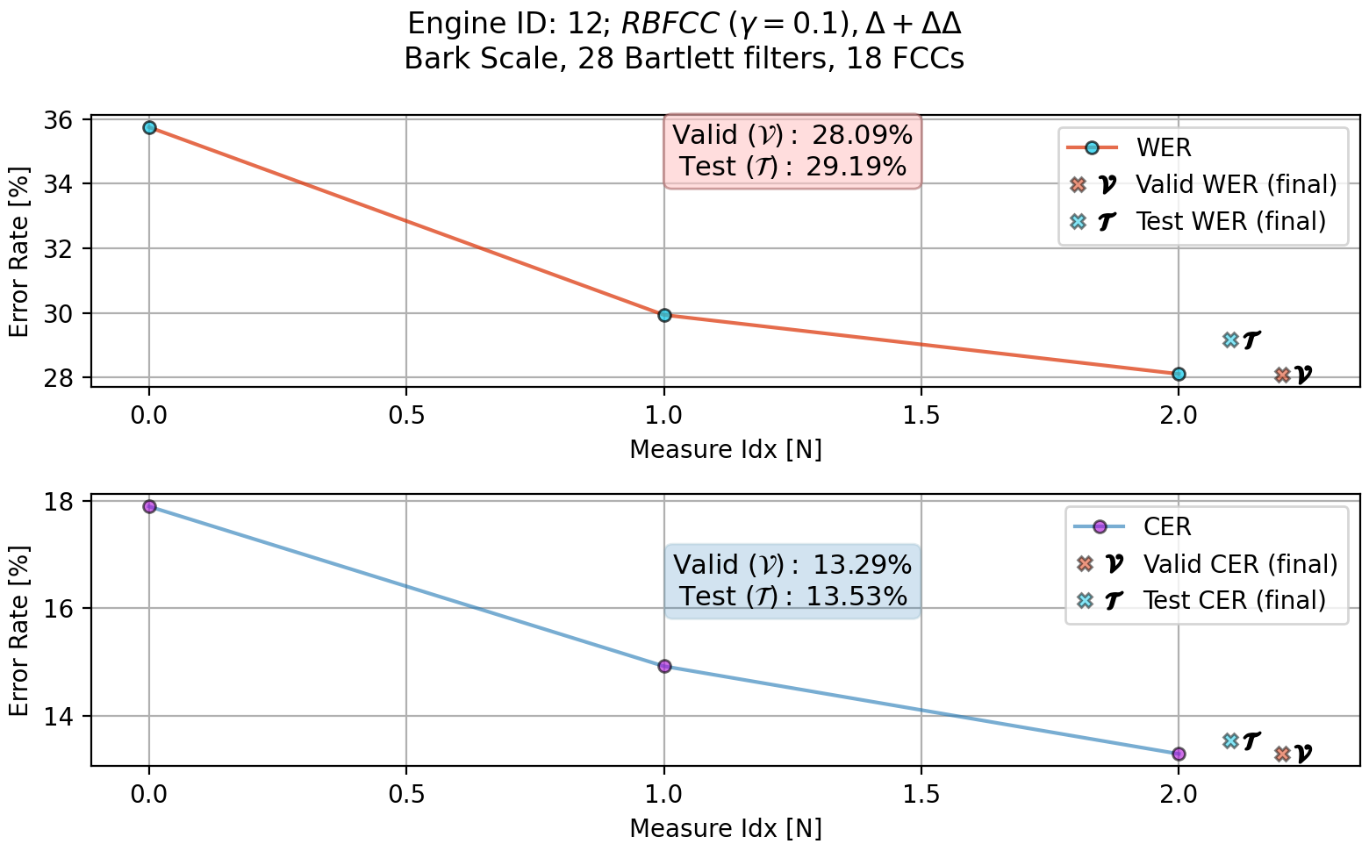

**(b)**

**Figure 7.9:**

(a) ASR #12 training accuracy and loss plot;

(b) ASR #12 WER, CER

evaluation plot.

116

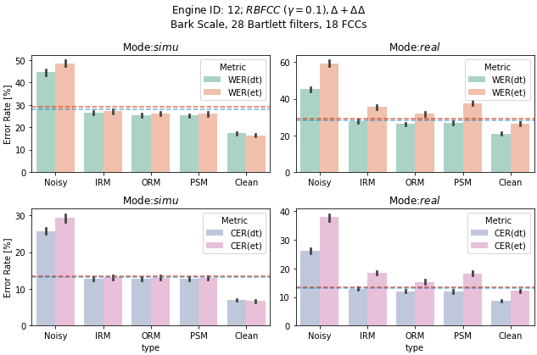

**Figure 7.10:** ASR #12 WER, CER vs. T-F masks, noisy and clean inputs

∆

∆∆

**7.2.5.4**

**ASR Engine #72 — MFCC,**

,

ASR engine #72 as opposed to ASR engine #12, had been trained against the

Mel cepstral coefficients. All the other settings were retained.

Figures 7.11a, 7.11b, and 7.12 present the training, evaluation, and the T-F

based beamforming results respectively.

117

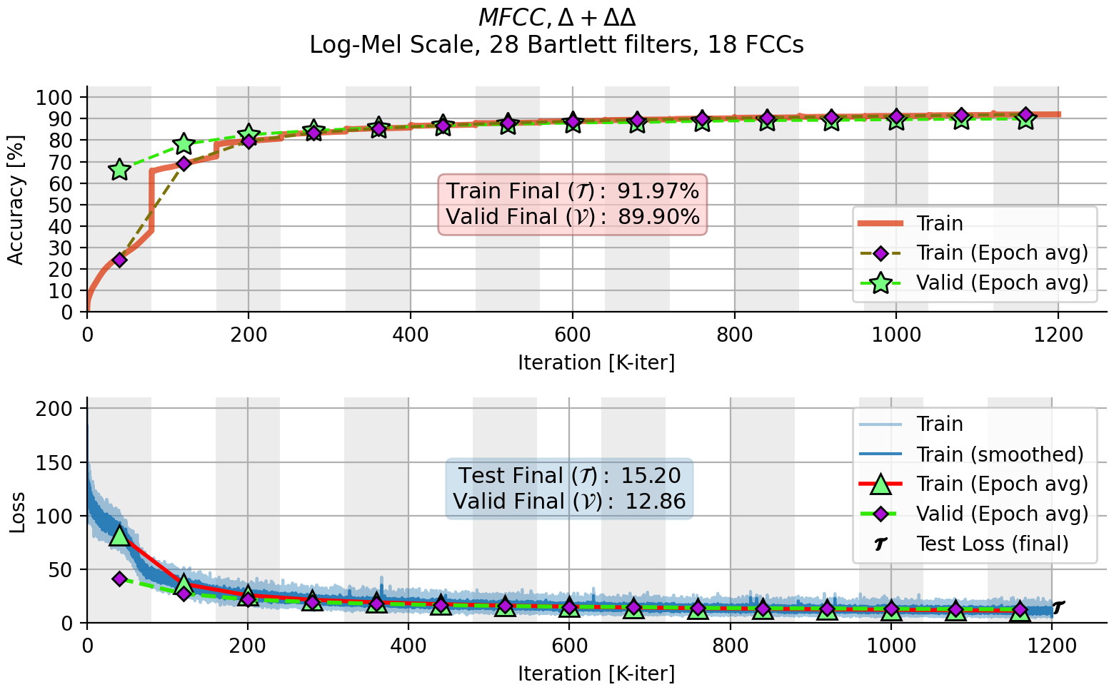

**(a)**

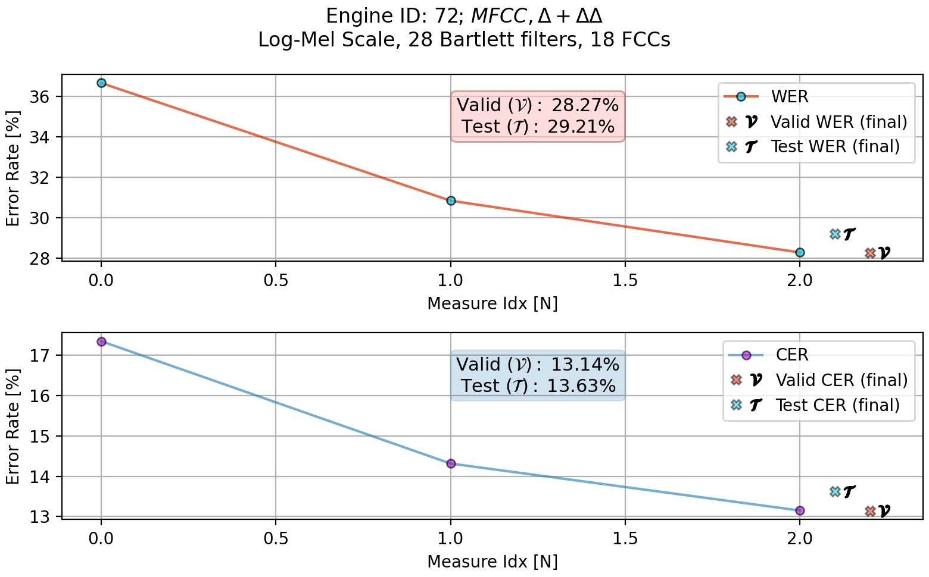

**(b)**

**Figure 7.11:**

(a) ASR #72 training accuracy and loss plot;

(b) ASR #72 WER, CER

evaluation plot.

118

tives. These extracted features were also taken from six additional adjacent

119

floating point which is the default.

learnable parameters were quantized to the U16/8 format from the 64bit

the engines

In the process,

optimization to fit a target hardware device.

In contrast to the other previous engines, engine #100 undergone heavy

filters covering the spectrum of each T-F bin.

number of extracted coefficients is set to 26 same as the total number of Bartlett

T-F units, three prior and another three past the currently analyzed unit. The

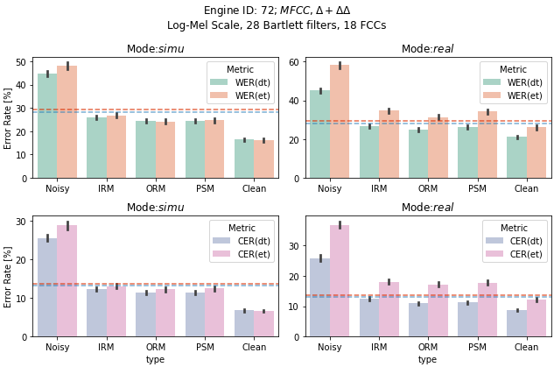

trained against the Mel cepstral coefficients with their first and second deriva-

ASR engine #100 is an optimized Log-Mel scale based engine that had been

**, Context(3, 3)**

,

**ASR Engine #100 — MFCC,**

**7.2.5.5**

∆∆

∆

**Figure 7.12:** ASR #72 WER, CER vs. T-F masks, noisy and clean inputs

The training process also changed to train over 40 epochs with 100

*K*

ran-

domly selected recordings out of the entire CommonVoice dataset. The mo-

tivation behind the these changes in the training process is to let the model

better generalize in a reasonable training time, due to the introduction of the

temporal context additional features vectors and the quantized architecture.

Figures 7.13a, 7.13b, and 7.14 present the training, evaluation, and the T-F

based beamforming results respectively.

120

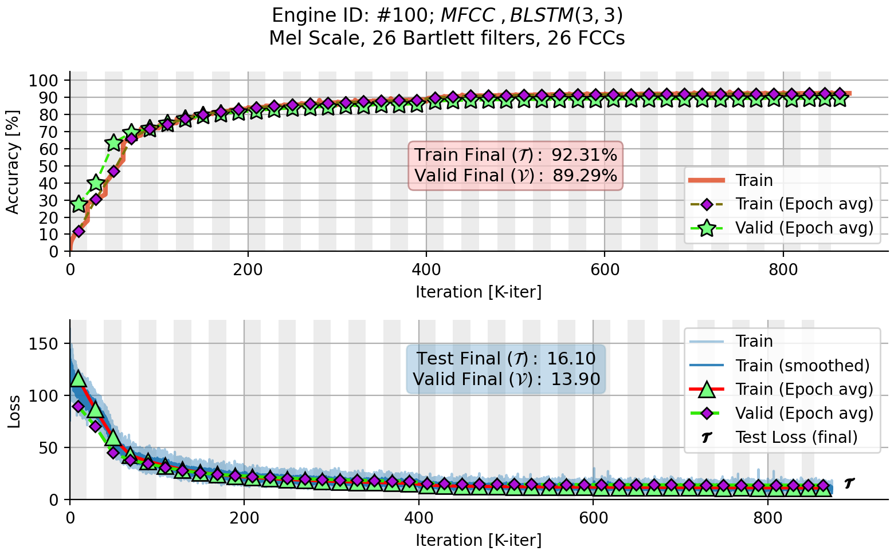

**(a)**

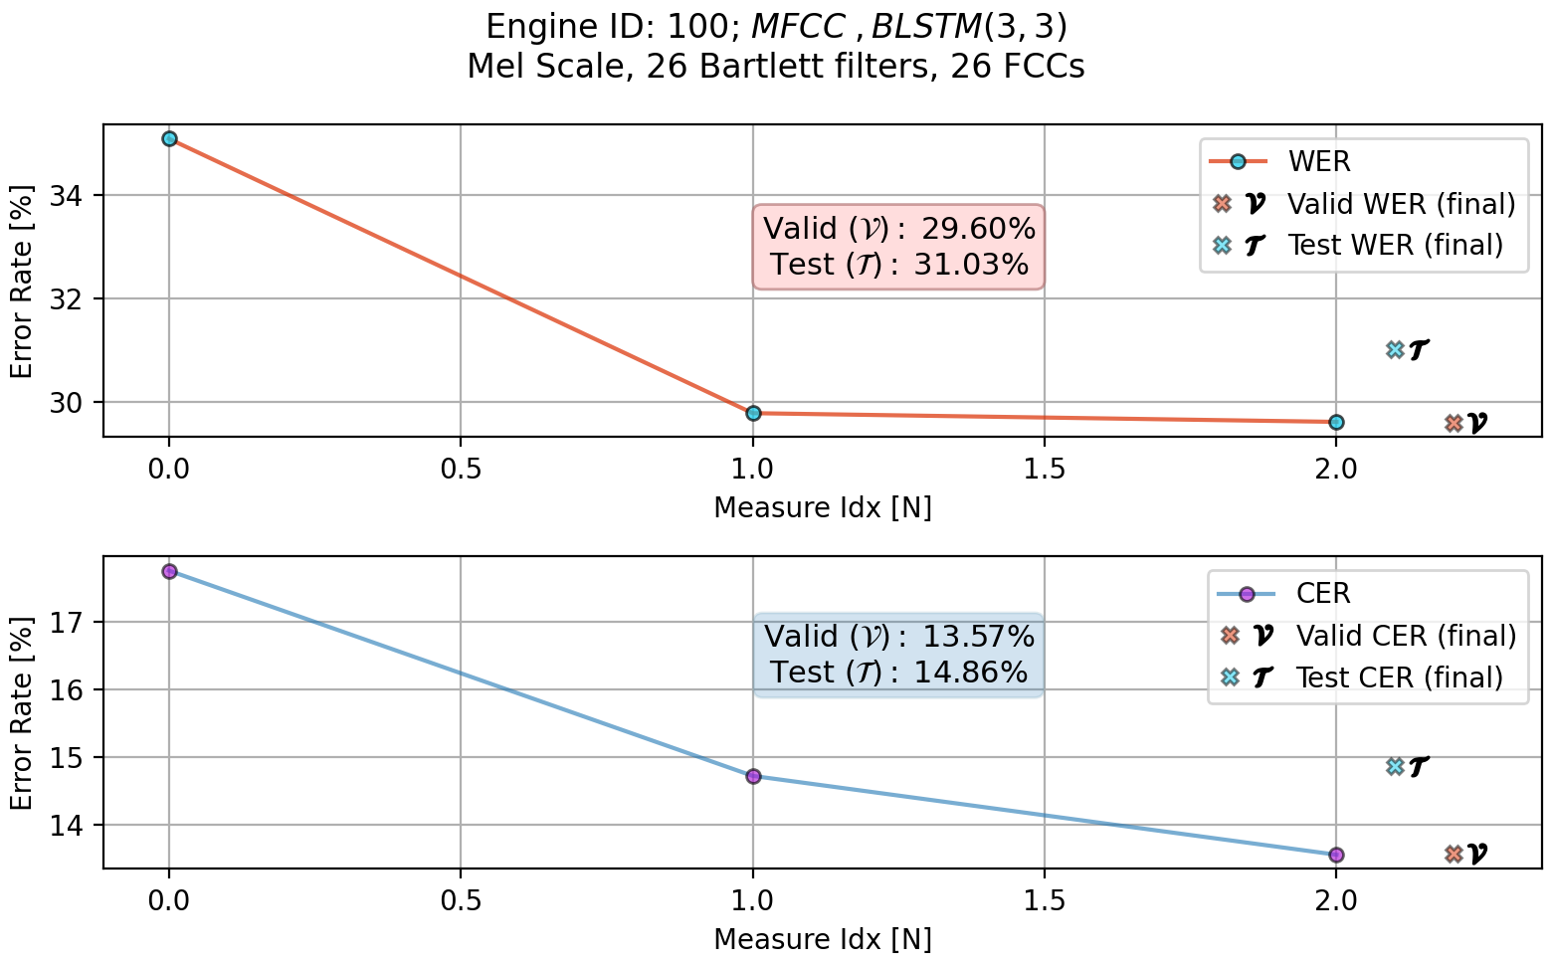

**(b)**

**Figure 7.13:** (a) ASR #100 training accuracy and loss plot;

(b) ASR #100 WER, CER

evaluation plot.

121

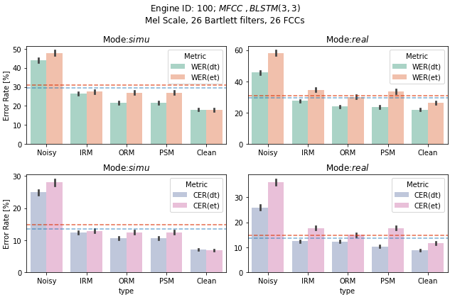

**Figure 7.14:** ASR #100 WER, CER vs. T-F masks, noisy and clean inputs

∆

∆∆

**7.2.5.6**

**ASR Engine #101 — Approx. Mel-FCC,**

,

**, Context(3, 3)**

ASR Engine #101 is identical to ASR engine #100 except the actual implemen-

tation of the Mel scale. This engine had been trained against the same features

utilizing the linear approximation of the Mel scale as described in Chapter 3.

Figures 7.15a, 7.15b, and 7.16 present the training, evaluation, and the T-F

based beamforming results respectively.

122

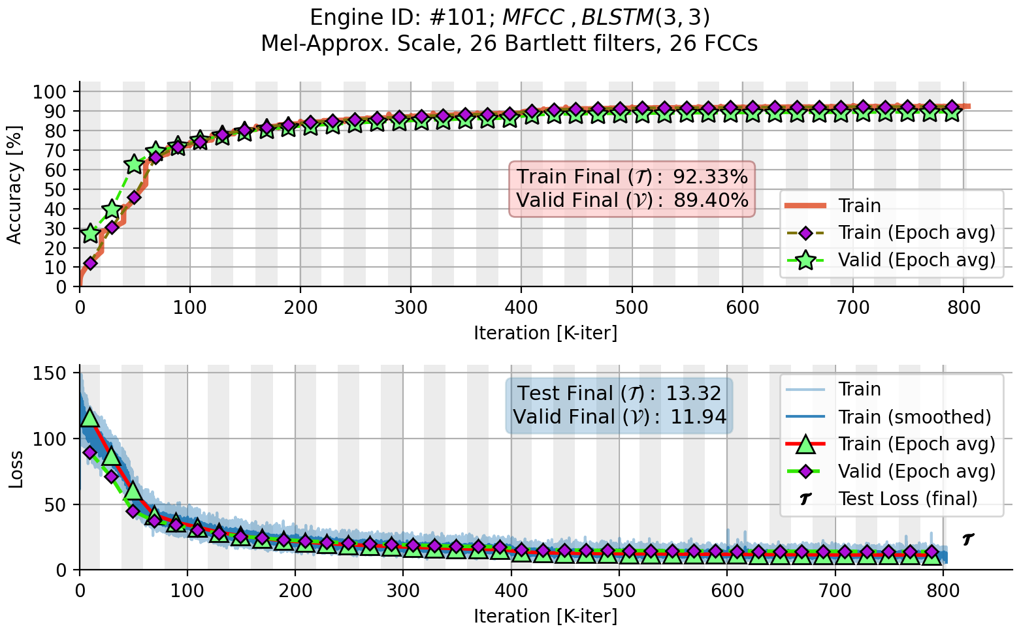

**(a)**

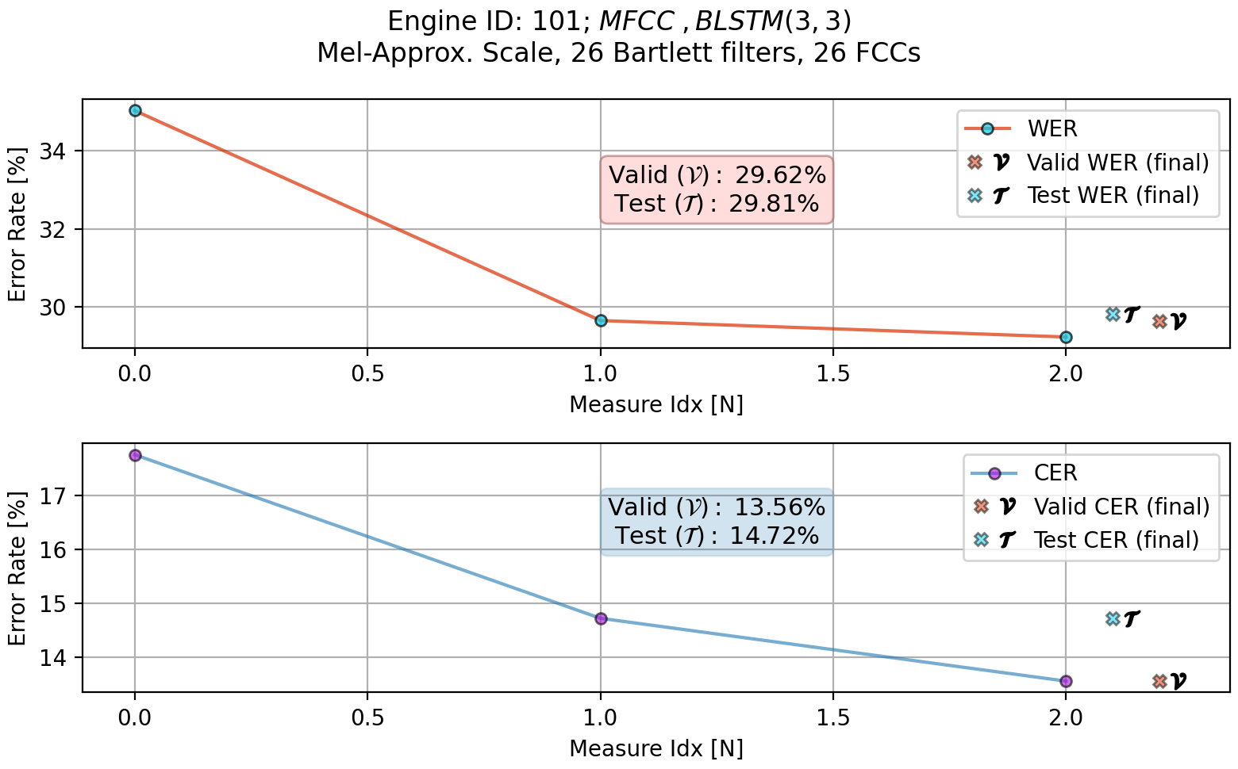

**(b)**

**Figure 7.15:**

(a) ASR #12 training accuracy and loss plot;

(b) ASR #12 WER, CER

evaluation plot.

123

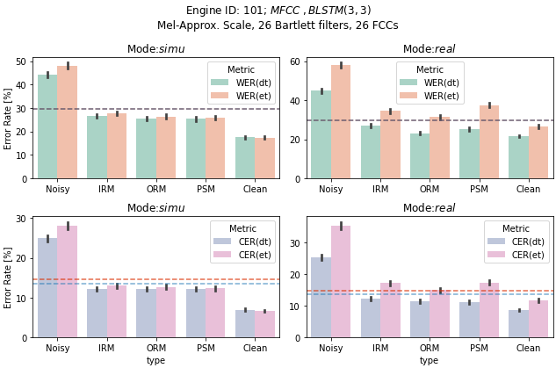

**Figure 7.16:** ASR #101 WER, CER vs. T-F masks, noisy and clean inputs

**7.2.5.7**

**Other ASR Engines**

ASR engines #13, #70, #22, #23 were not tested with the enhanced beamformed

recordings.

The reason is that the performance of these ASR engines is de-

graded compared to the previous described ASR engines. For completeness

however, we present their training results and some WER, CER measures for

the training, validation and test subsets of the CommonVoice dataset.

Figures 7.17, 7.18 present the training results and the WER and CER met-

rics measures for ASR engine #22.

124

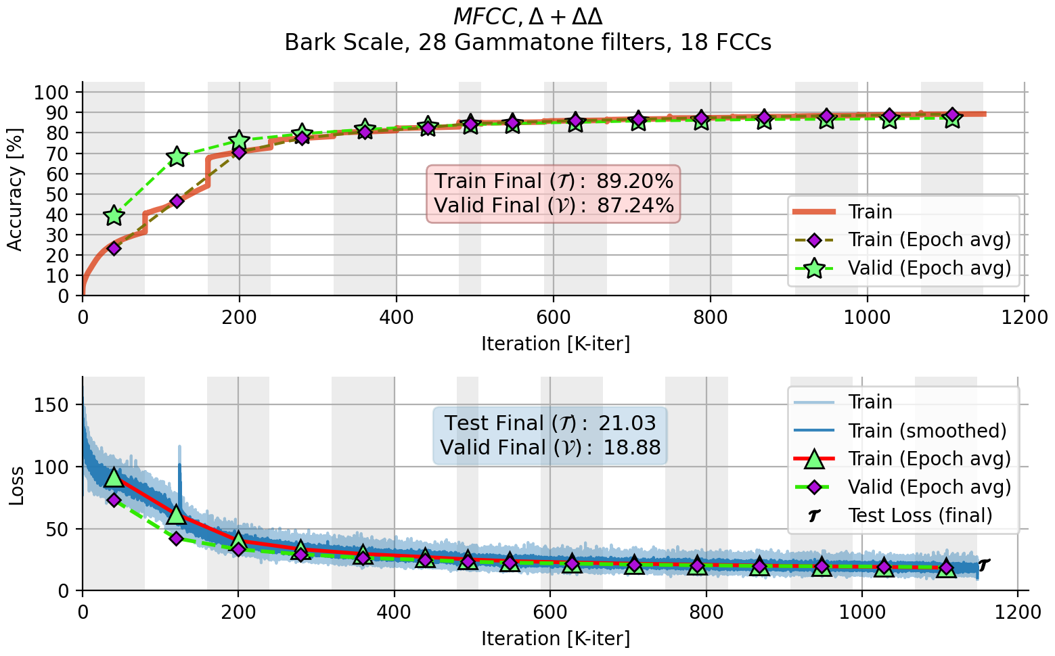

**Figure 7.17:** ASR #22 training accuracy and loss plot

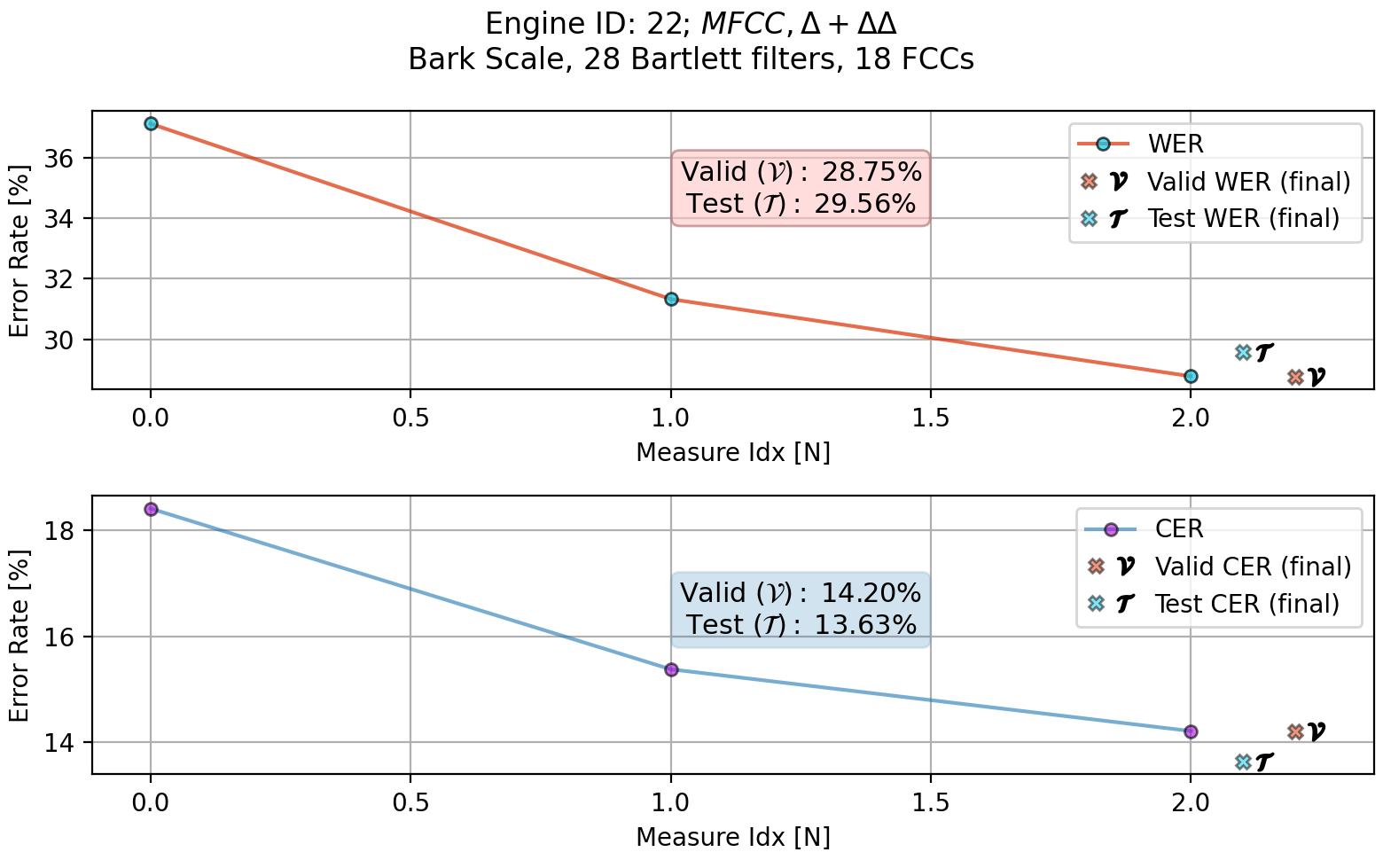

**Figure 7.18:** ASR #22 WER, CER evaluation plot

125

Figures 7.19, 7.20 present the training results and the WER and CER met-

rics measures for ASR engine #23.

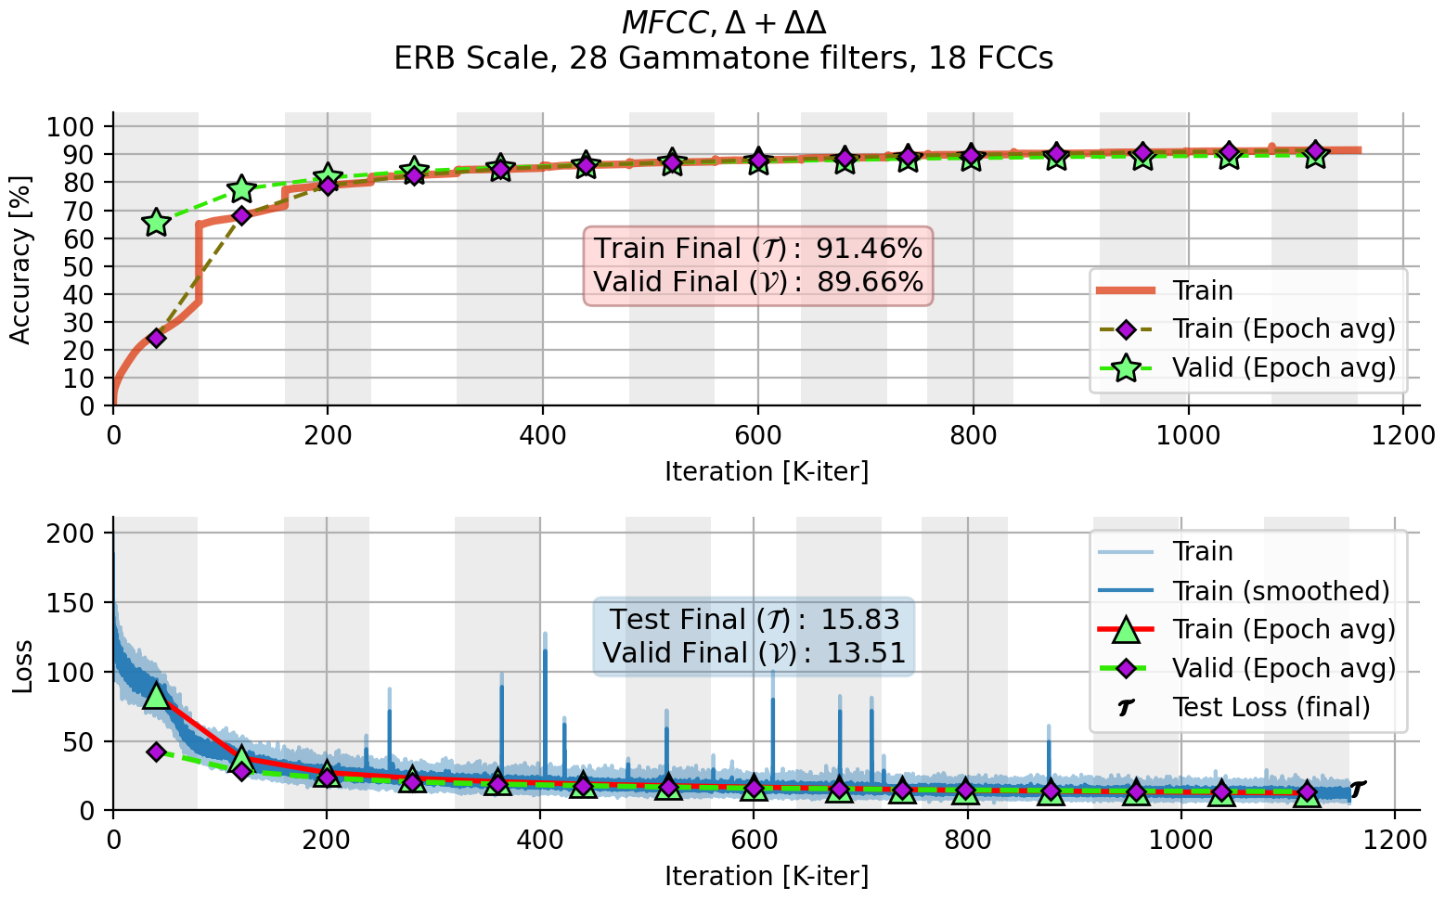

**Figure 7.19:** ASR #23 training accuracy and loss plot

126

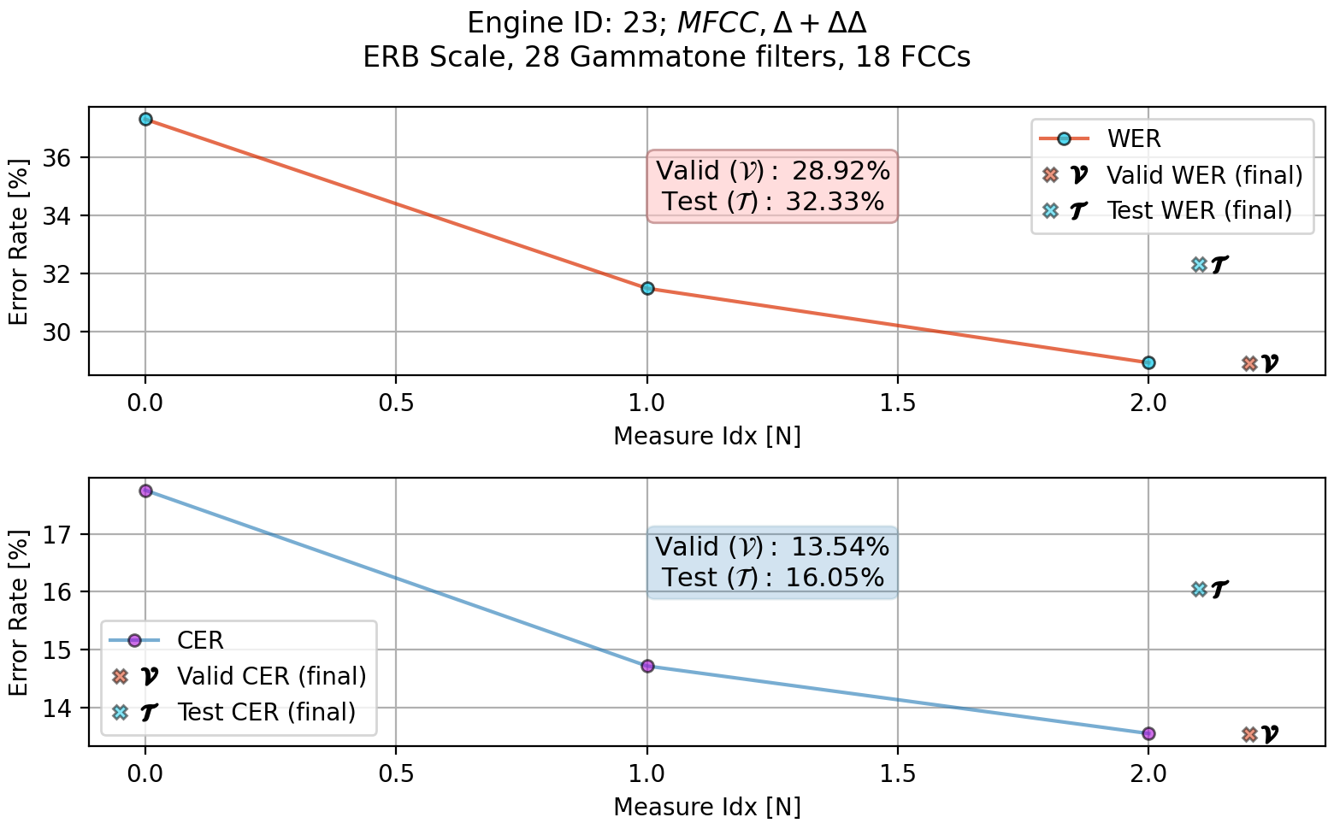

**Figure 7.20:** ASR #23 WER, CER evaluation plot

Figures 7.21, 7.22 present the training results and the WER and CER met-

rics measures for ASR engine #70.

127

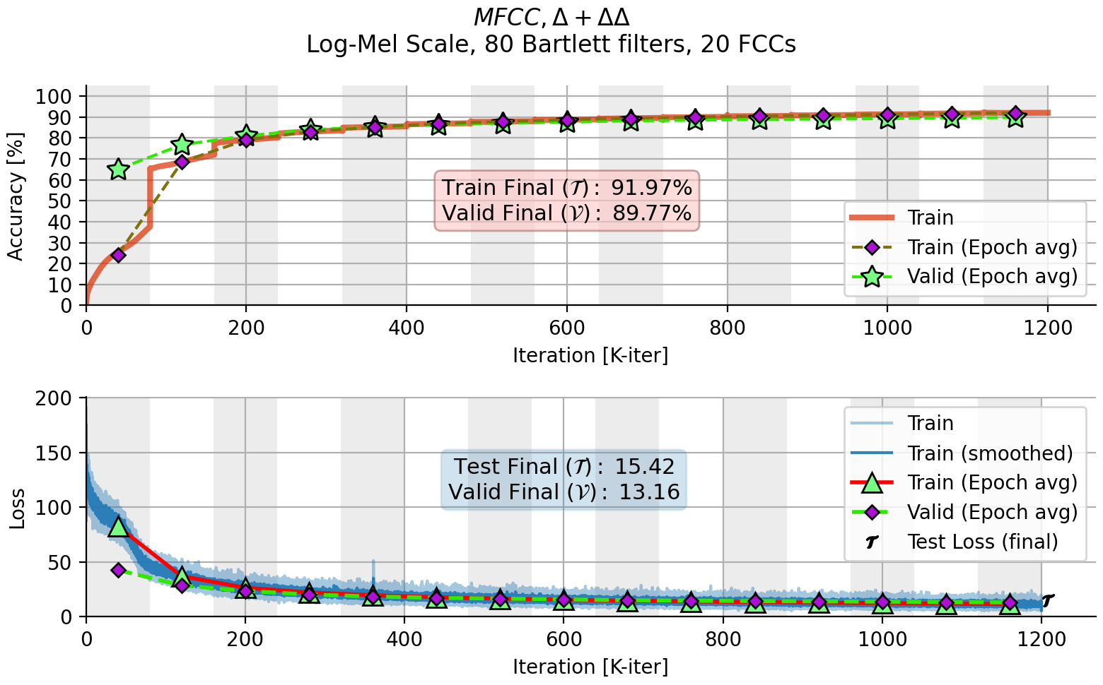

**Figure 7.21:** ASR #70 training accuracy and loss plot

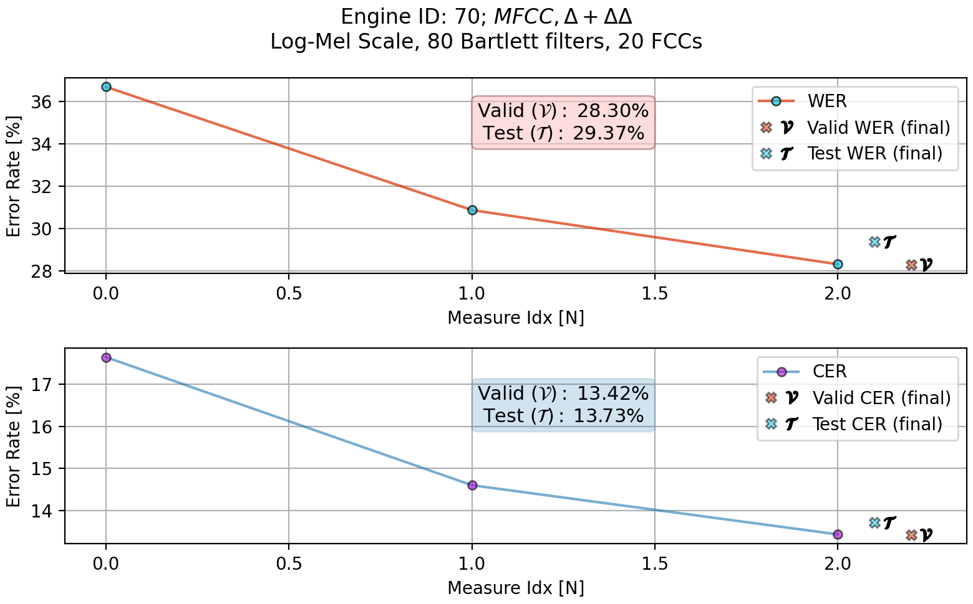

**Figure 7.22:** ASR #70 WER, CER evaluation plot

The training statistics were not gathered for ASR engine #13, so only the

128

WER and CER measures for the validation and test datasets are presented in

Figure 7.23.

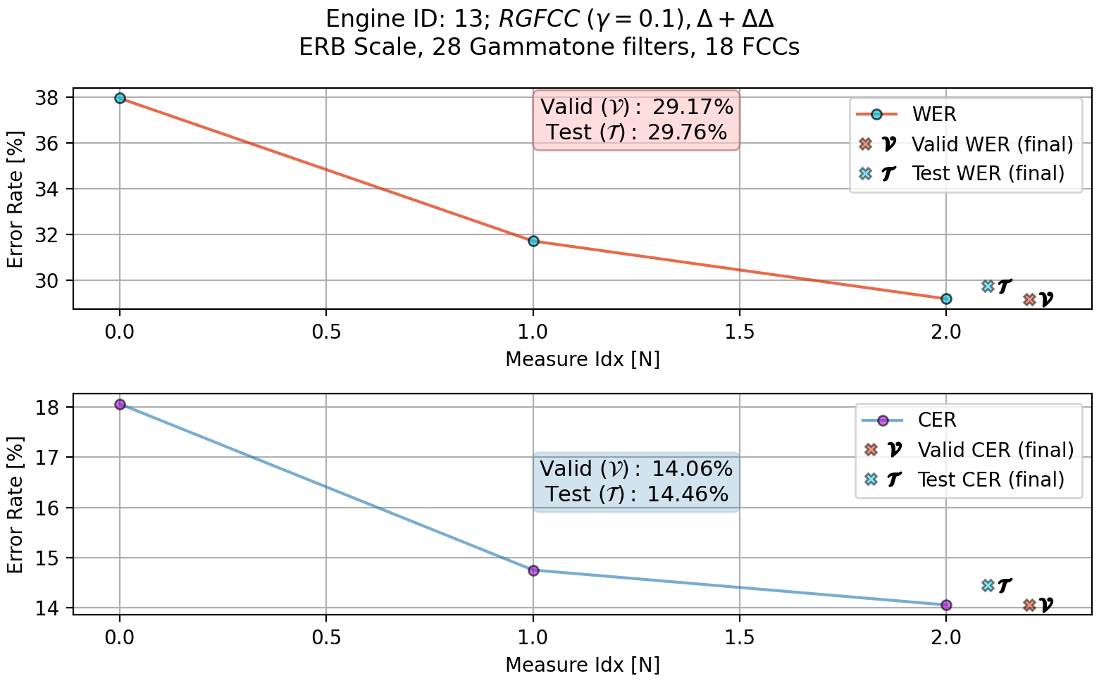

**Figure 7.23:** ASR #13 WER, CER evaluation plot

129

URL

(cit. on p. 103).

[5]

Andrew Maas et al. “Lexicon-Free Conversational Speech Recognition

with Neural Networks”. In: *Proceedings of the 2015 Conference of the North*

*American Chapter of the Association for Computational Linguistics: Human*

*Language Technologies*. Denver, Colorado: Association for Computational

10.3115/v1/N15-1038

https:

Linguistics, 2015, pp. 345–354.

:

.

:

DOI

press/v32/graves14.html

//aclanthology.org/N15-1038

(cit. on p. 104).

[6]

Ruhi Sarikaya and John Hansen.

“Analysis of the root-cepstrum for

acoustic modeling and fast decoding in speech recognition.” In: 2001,

pp. 687–690 (cit. on p. 113).

1706.03762

[7]

Ashish Vaswani et al. *Attention Is All You Need*. 2017. arXiv:

[cs.CL]

(cit. on pp. 105, 107).

130

(cit. on p. 104).

[1]

Robert Blust. “Terror from the Sky: Unconventional Linguistic Clues to

the Negrito Past”. In: *Human biology*. 2013 (cit. on p. 102).

[2]

William Chan et al. “Listen, Attend and Spell: A Neural Network for

Large Vocabulary Conversational

Speech Recognition”.

In:

*ICASSP*.

http://williamchan.ca/papers/wchan-icassp-2016.pdf

2016.

:

URL

**References**

[3]

R. M. W. Dixon. *The Rise and Fall of Languages*. Cambridge University

Press, 1997 (cit. on p. 102).

[4]

Alex Graves and Navdeep Jaitly. “Towards End-To-End Speech Recog-

nition with Recurrent Neural Networks”. In: *Proceedings of the 31st In-*

*ternational Conference on Machine Learning*. Ed. by Eric P. Xing and Tony

Jebara. Vol. 32. Proceedings of Machine Learning Research 2. Bejing,

https://proceedings.mlr.

China: PMLR, 2014, pp. 1764–1772.

:

URL

used in various noisy environments.

131

The close-talking microphone is referenced as the clean speech channel.

daisy-chained to the multi-microphone recording device.

additional close-talking microphone is recorded by another recording device,

an

Besides those six microphones,

a high-resolution multi-track recorder.

Six microphones are mounted on a tablet device and are recorded with

**Chapter 8**

The challenge is to build an ASR model for multi-microphone device being

The CHiME-4 dataset is provided as part of the CHiME challenge.

**Overview**

**8.1.1**

**CHiME 4/5**

**8.1**

**Datasets**

**8.1.1.1**

**CHiME Recording Scenarios**

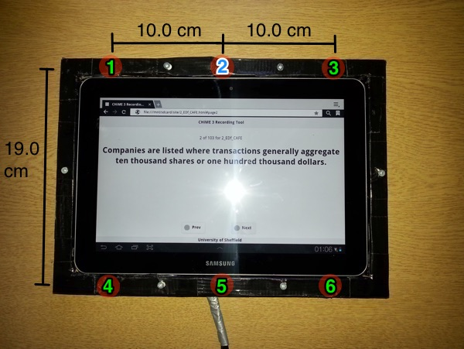

**Figure 8.1:** CHiME-4 microphone-array

**Source:** Adapted from [1]

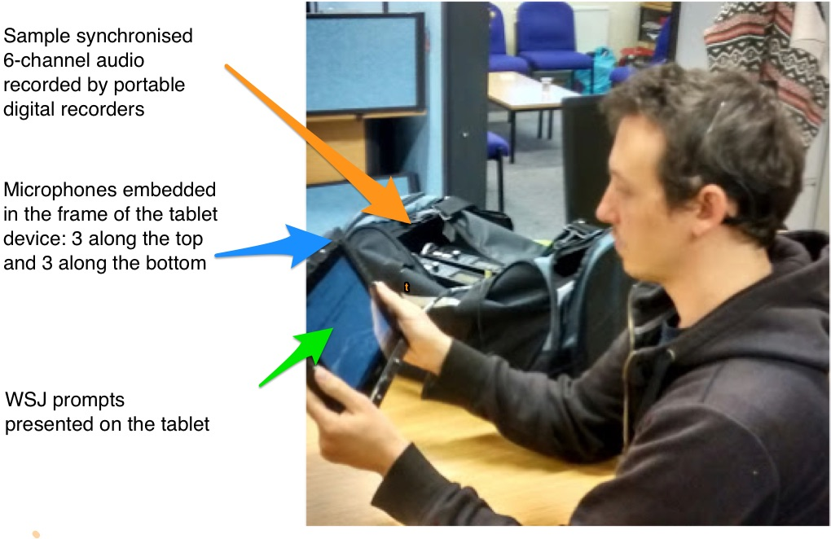

**Figure 8.2:** CHiME-4 recording setup

**Source:** Adapted from [1]

132

Four different noisy environments were selected. A Cafe, street junction, bus

and a pedestrian area.

The CHiME-4 dataset stats are shown in Figure Table 8.3

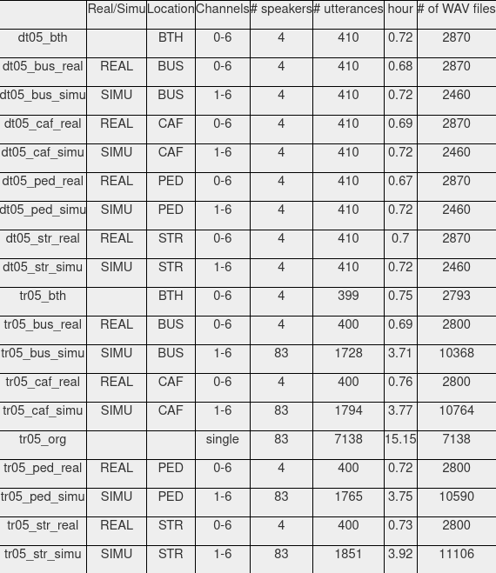

**Figure 8.3:** CHiME-4 recording setup

**Source:** Adapted from [1]

**8.2**

**CommonVoice**

The CommonVoice dataset is an open-source free dataset that is supplied by

Mozilla.

133

Age

4% 60-69

4% 50-59

1% 70-79

6% <19

10% 40-49

13% 30-39

24% 19-29

134

As a result of ommiting recordings longer

RAM, nor the server’s memory.

cause the feature vector to be so large it cannot fit in either the GPU’s dedicated

This is due to the fact that the dataset contains open-mic recordings which

During training, recordings that are longer than ten seconds were removed.

**Table 8.1:** CommonVoice dataset statistics

40% Unknown

15% Female

Gender

45% Male

38% Unknown

3% Canadian English

7% India and South Asia

8% England English

3% Australian English

23% United States English

Table 8.1

Statistics and distributions for the CommonVoice dataset are shown in

is constructed by 79, 398 different voices.

ings, where 2185 hours of them were validated by the community. The dataset

51% Undeclared

1% Irish English

This dataset for the English corpus contains overall 2886 hours of record-

1% Southern African

1% New-Zealand English

2% Scottish English

Accent

In Table 8.2, summarized the CommonVoice dataset subsets and the num-

135

**Table 8.2:** CommonVoice sets utterances distribution

16,236

Test

16,264

Dev/Valid

759,546

Training

Utterances [*N*]

Set

ber of recordings each subset contains.

than the ten seconds threshold, some recordings, although being valid are

fluctuations presented in the bar plots in Chapter 7.

ducing only a slight impact on the mean value, but can be seen in the variance

measures are sparse compared to the validated recordings measures, intro-

However, these faulty

recordings in the test and validation measurements.

performance degradation in terms of WER and CER due to non validated

We have seen some

validation or the testing phases had been cut to half.

the number of non validated recordings participating in the training,

fore,

recordings is very cumbersome and would take long time to complete. There-

ings were not validated, and thus could be corrupted. Filtering out of those

Another issue we faced with the CommonVoice dataset is that some record-

marked as open-mic and also dropped from the dataset.

**References**

[1]

*Zynq UltraScale+ MPSoC Product Tables and Product Selection Guide*. Tech.

https://http://spandh.dcs.

rep. University of Sheffield, 2016.

:

URL

shef.ac.uk/chime_challenge/CHiME4/overview.html

(cit. on pp. 132,

133).

136

We also present the magnitude of influence that different scaling methods

137

slim models for the beamformer, masking or the ASR engine would be ranked

account and affect the ranks that different configuration sets get. For example,

power consumption and wise utilization of limited resources are taken into

low

the requirements for computation efficiency,

In such cases,

solution.

implementation is targeted for a hardware device rather than a software based

have on ASR system’s performance and requirements, especially when the

**Chapter 9**

metrics.

PESQ, and STOI leading to an improvement in WER and CER whom are ASR

rates. This provided insights into a correlation between improvements in SNR,

T-F masking algorithm can improve an existing E2E ASR system detection

seen how a multi-channel microphone array beamformer combined with a

We also investigated the impact of speech enhancement where we have

along an E2E ASR system.

direct links between several metrics that are measured in different stages

In this research we have investigated some possible explicitly or implicitly

**Conclusions**

In accordance,

Delta, Deltas-Delta

,

and the companion cepstral coefficients, over the

increase in the number of filters and coefficients, or the usage of only Filter-

Banks. Adding temporal context to the mixture, resulted in a slightly better

ASR performance.

These insights reflected mainly in the effort of model’s

simplifications.

∆∆

simplifications such as approximations for

the scaling methods and the reduction in filters and coefficients were made

possible while maintaining equal detection rates and sometimes even better

than highly dense FilterBank based ASR systems.

On the other hand, root

cepstral coefficients extraction did not yield any gain in performance over the

natural or log based coefficients, nor the suggested approximations.

138

During experiments, multiple ASR engines were trained against different

memory resources.

Alternatively, when storage memory is not considered

an issue, a better performing algorithm would be more preferable for higher

detection rates.

To evaluate the End-to-End speech enhancement plus the ASR engine

performance, we divided the effort into two sections, where each has been

evaluated separately. Later, the two sections were connected together and the

evaluation was taken from input to the ASR output.

higher than heavy and larger models when the target device has limited scanty

carefully selected feature sets, each time alternating one parameter, whether

the features’ combination, scaling method, the computation for feature extrac-

tion or the neural network’s shape and structure. A clear advantage, in terms

of ASR performance (WER, CER), has been observed for a combination of the

(

)

∆

traded in favor of performance or higher detection ratios? In this research

139

expected gains in some metrics side by side with the improvements in WER

all together with the

Also presented in this research trade-off options,

model parameters.

in memory is anticipated to hold the beamformer’s and the T-F masking NN

cients is what left for computation. Despite saving on resources, an increase

implemented for the ASR, thus only the extraction of the beamformer coeffi-

computation overload for the FE part becomes negligible since it is already

The

tion mechanism and save on resources by reusing the same modules.

Doing so, we manage to combine the feature extrac-

the ASR engine itself.

we used the same configuration for the feature extractions in both the FE and

Those trained ASR engines were attached to a processing FE (Front-End),

in front of the ASR engine, that is what would be the cost? What could be

Some very important questions arise with regard to adding a FE stage

transcripts would be more accurate for it.

that better speech quality or cleaner speech is easier to perceive, and thus ASR

of the ASR engine to be more precise. This actually strengthen the intuition

audio domain metrics such as SNR and STOI have direct impact on the ability

analysis of the various T-F masking alogirthms yielded a conclusion that the

Deeper

compared to the ASR performance measured as a standalone unit.

extraction later attached to an ASR engine led to much improved performance

maskins. That combination between an GEV beamformer and a T-F masking

multi channel multi microphones array deep beamformers combined with T-F

that serves as a speech enhancing stage. The speech enhancing is applied by

and CER.

For systems that are not designed with limited resources,

like

memory and slow operating clock frequency, the more advanced, but complex

algorithms for T-F masking as cIRM, PSM, and ORM can be used. Leading to

higher perception rates at the ASR output as mentioned before due to higher

SNR levels. However, trading-off complex T-F masking with the simpler and

lighter IRM implementation while selecting more optimized ASR engine and

feature set can yield quietly matched WER and CER results. According to the

results presented in this research, speech to text systems can be optimized by

wise selection of configurations for certain modules and yet achieving desired

quality of performance.

140